React Course

Starting of the project

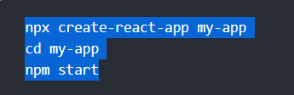

How the execution flow works?

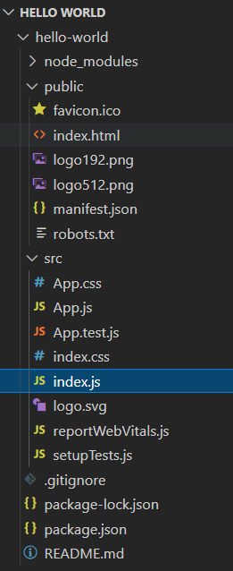

First it will go to the public directory and go to the index HTML file and there you see a root node then it automatically goes to the SRC folder and then open the index JS file and there you see what component you want to render and also it has to point the directory of the public index file.

###### Component in React

You can have multiple components in the project and one main or root component which encapsulates all the other components.

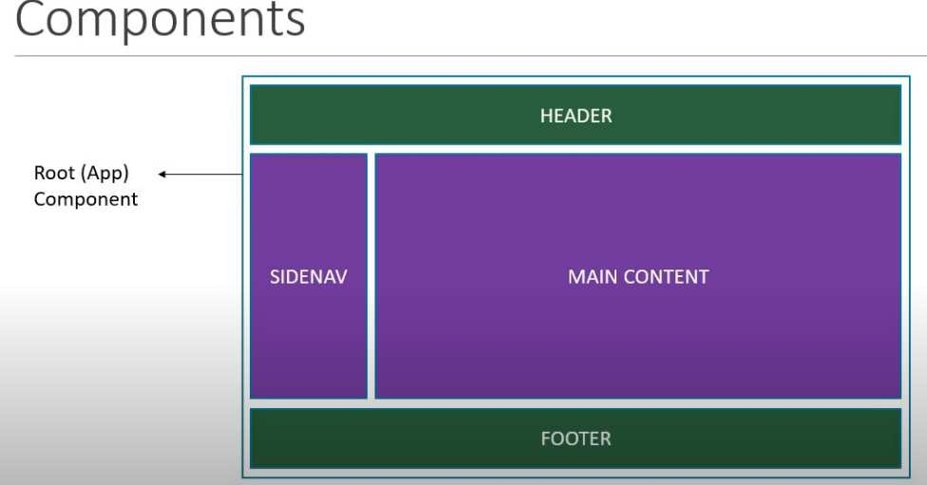

One component can have other components inside

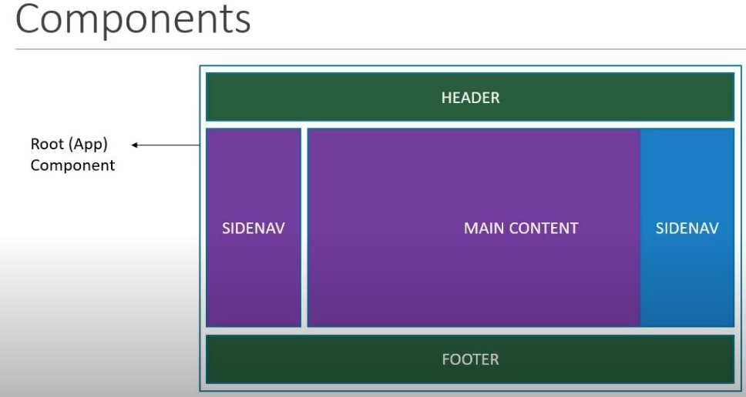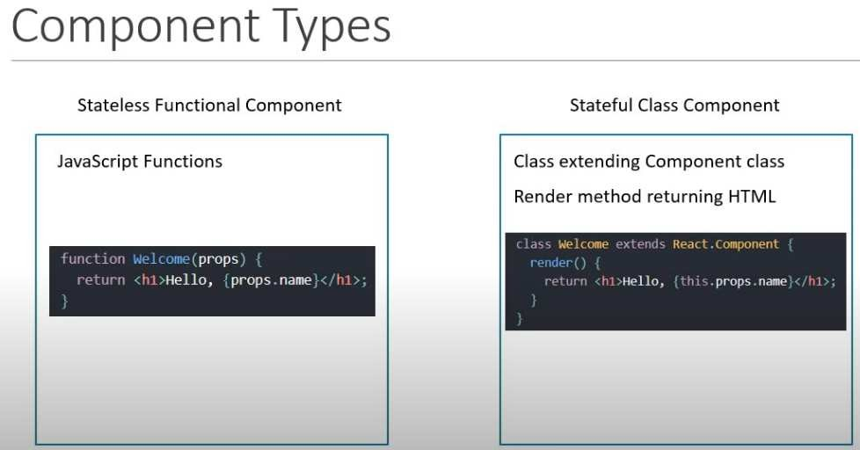

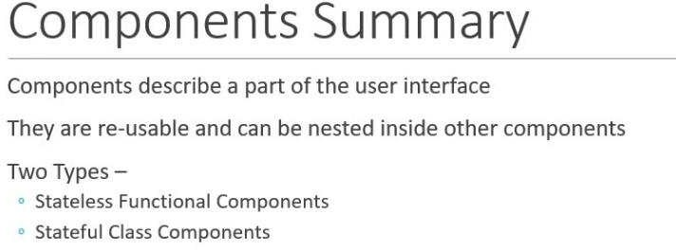

Functional Components:

Below is the demonstration of the component

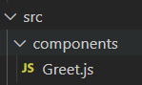

Below is the component I created which is using default namespaces.

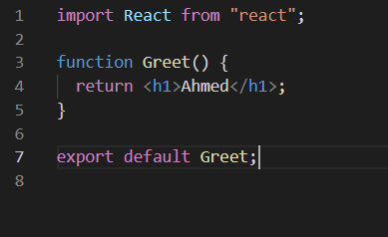

How you are going to use below is the attached image

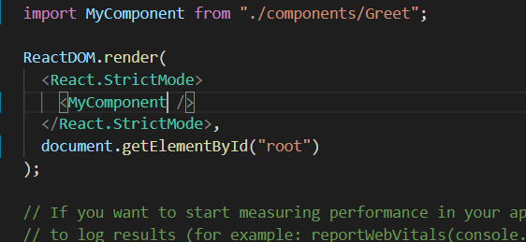

You can use any name while importing the file when you are using the export default but when you are using the const exports then you must have to put the curly braces and exact same name. One more thing we encourage to use the arrow function as it has some additional features let me rewrite the above function into arrow function.

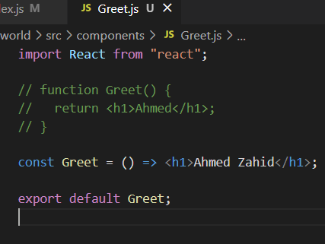

Below is the example if you are using the const export then you need to put the same name where you are using that function with the curly braces as shown in the image below

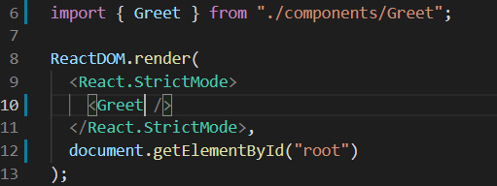

###### Class Components:

It is basically an ES6. It will save the private information to that component.

Instead of just importing the react and component we need to import and we need to specify the render function inside this as shown in the below image

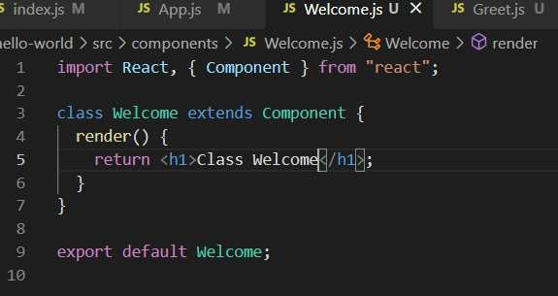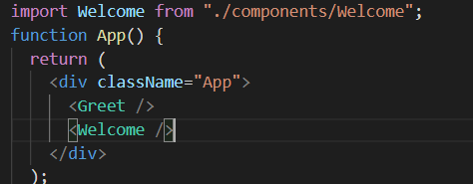

Below some of the use cases of the class based and function-based views

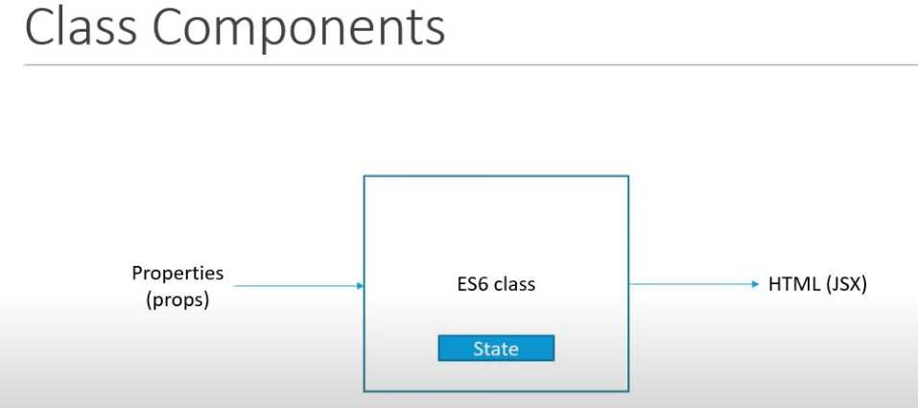

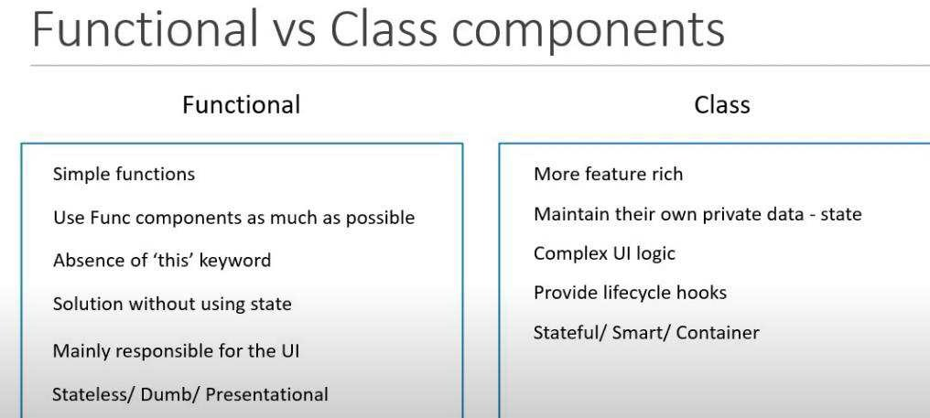

###### Hooks

It will contradict what we learn about functional views.

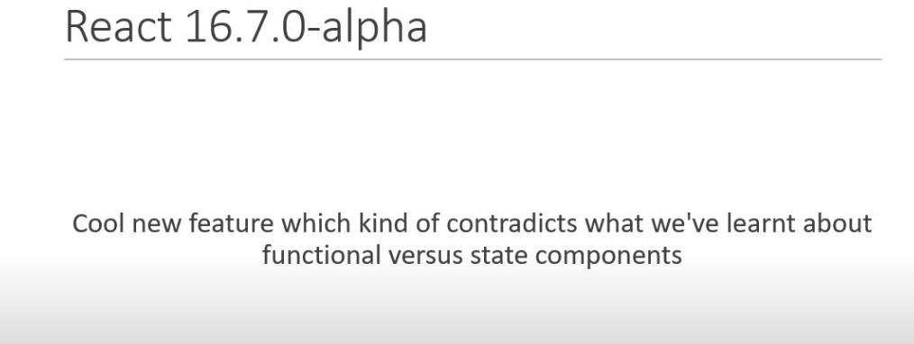

It is the feature that you can write the stateful features without writing a class.

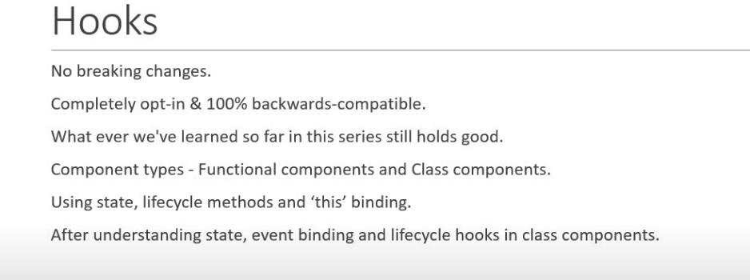

How **this**, keyword will help you out and removes the mess which you will be seen in the class-based components.

###### JSX

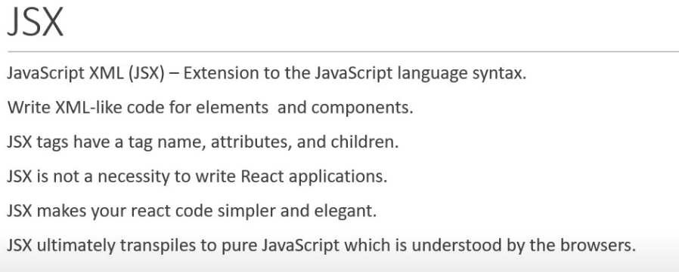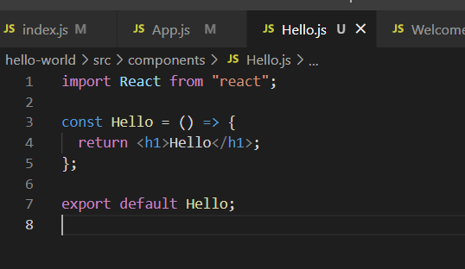

If you are using the JSX, then you can simply do the above code and if you don’t want to use the JSX then

the image after that image will display that thing.

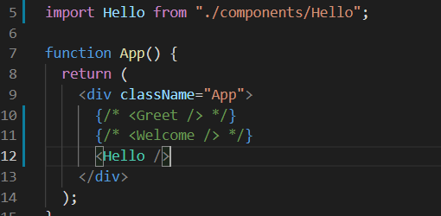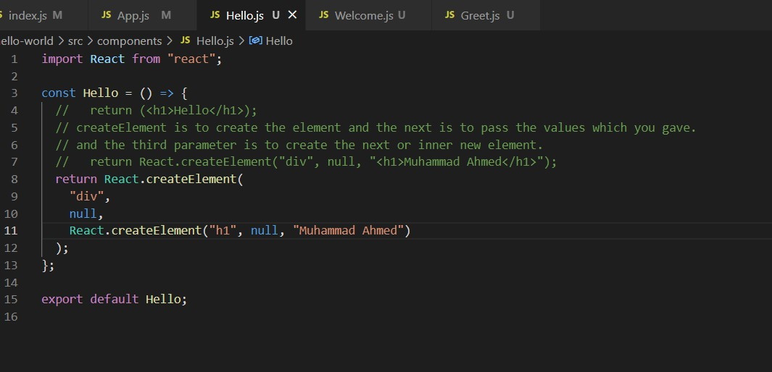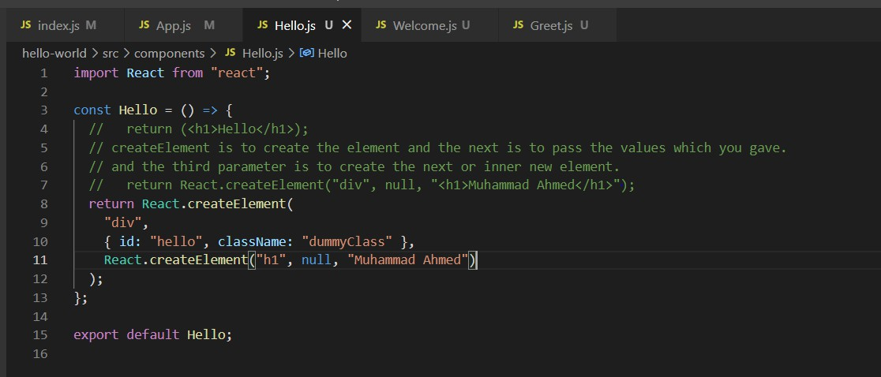

The above code is the property we used inside that div for example we want to add the id and the class name we want to add inside that div.

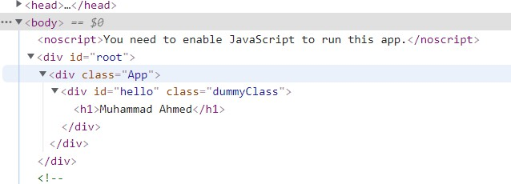

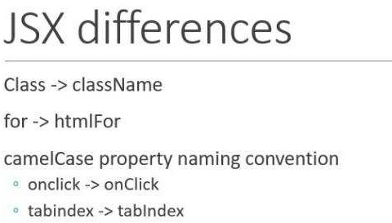

###### Props

The Number 1 thing is props are immutable which means you cannot change the property of the variables inside this.

In functional base components you pass the value from the rendering component towards the component where the value is to be used. While on the class-based components you use **this** keyword and with the props you can access these values inside that and one thing if you have more than one property then you can also pass but make you have one parent element present because the render button needs one main div in order to pass the values.

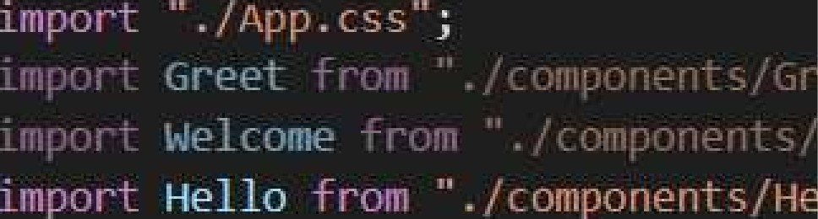

c has sName=" -”•.ç›':"

!fl-.jl-'j name=”!i'‹i,‹!:'ria!"

E/-2ÌL' Háme=l;rlH< ”

.-2Ìo name= ”Zi,

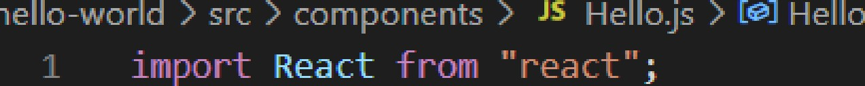

HeÎlo = (props)

console. log(props) ;

(

5

FEt U l*n

HeTîo, props . name)

;

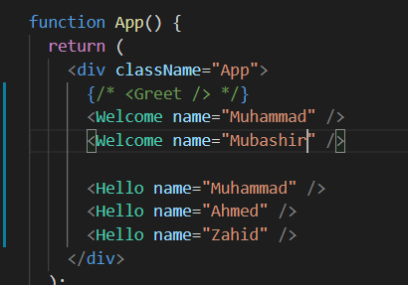

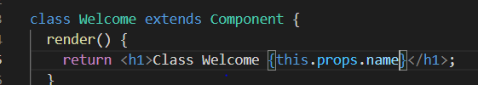

And if there is a scenario that you don’t know how many of the properties are passing you can do this as follows:

Props and then with dot it is called children attribute.



className=”-L.”

. This is the children



JS - r '

Hello.js U

1s ”'

".": He1 o = (props)

console. IDg(props) ;

[- .: . ! i' I”:

{

Heb to,

props . narie

';:props . ch1ldren|,

###### State

Now, let’s talk about the state as we know that the props are those properties that cannot change its

values.

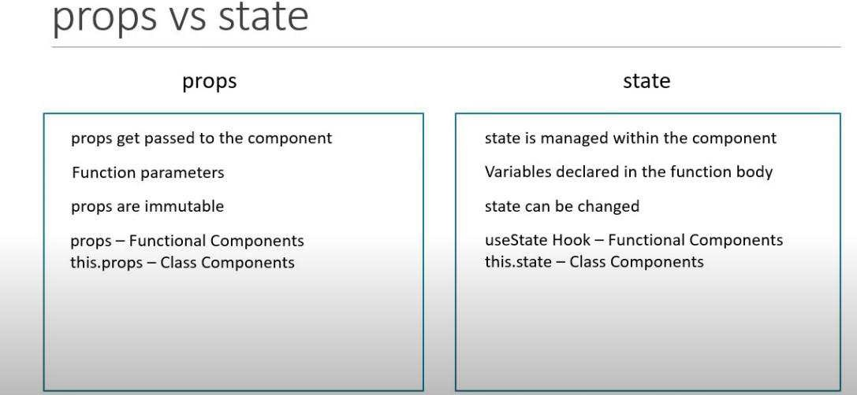

We can do by using the below code

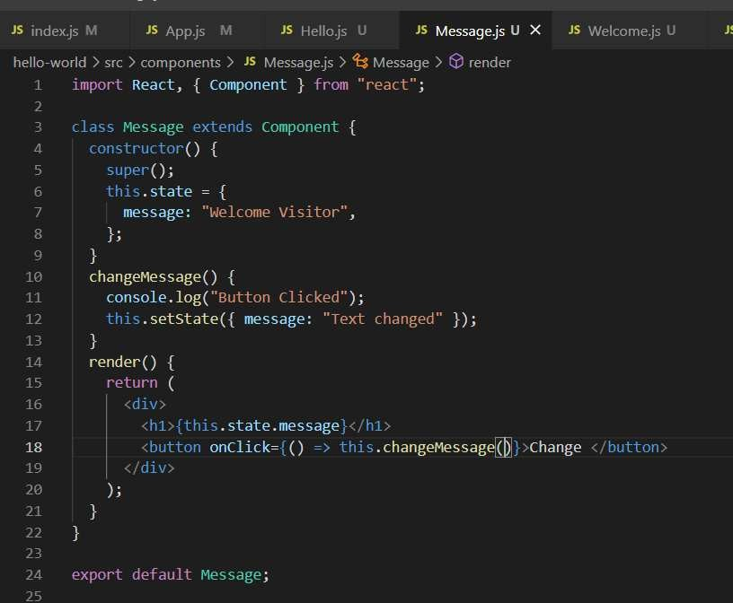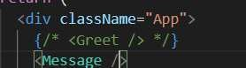

###### Set State

Extension ES7, React, Redux in visual studio code. **Rce** then tab it will create the all the code snippet. **Rc** the react constructor.

Never change the value of the state directory instead use the set state function because the set state function will update the UI if you just update the value, it cannot change the value inside the UI.

Important thing to note, console value is one is less behind then the webpage value.

Sometime you want to call a function when a particular state is changed so how you can do this you can pass a call back function which is an arrow function in it. Then the callback value and the display value are one.

If you want to increment the value based on the previous value then, you can the arrow function if you don’t want to use that then the value which you are going to increment does not do that because it is updating the values in parallel.

You can use the prop inside that function also.

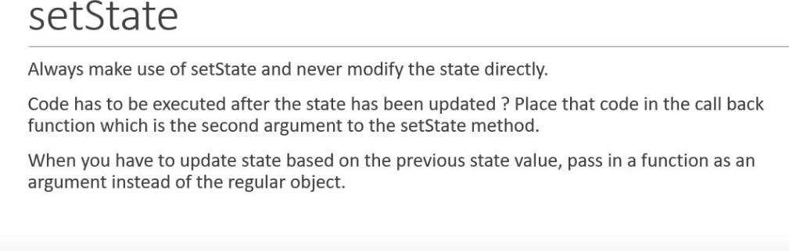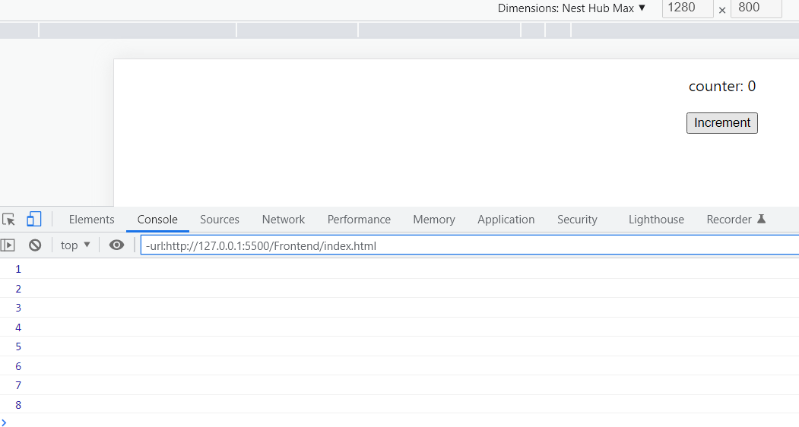

No value is incremented using the below code instead we have to use the set state function if you want to update the value in the UI.

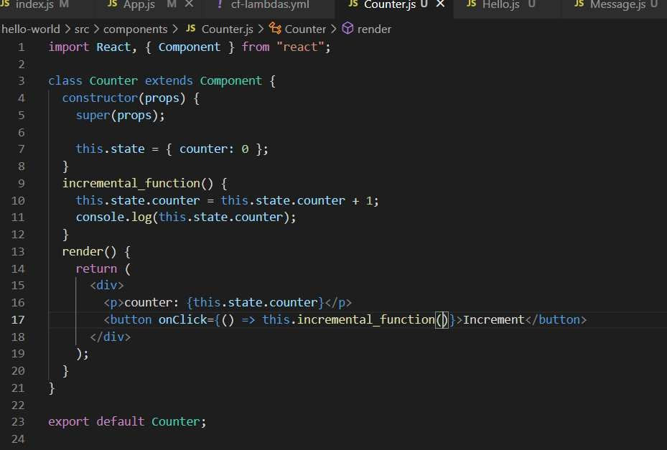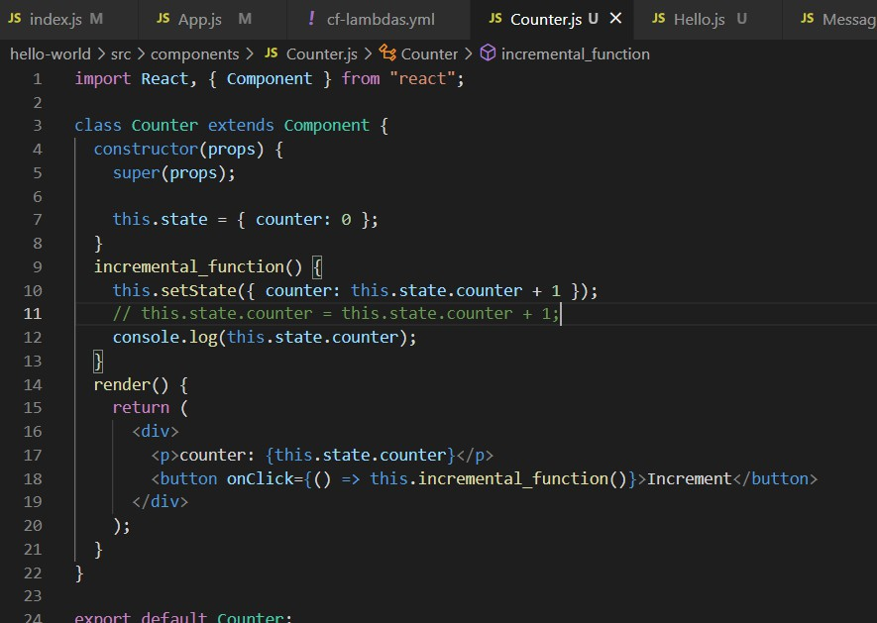

As we described earlier when we are using the previous and incremental into the next then we need to use the arrow function.

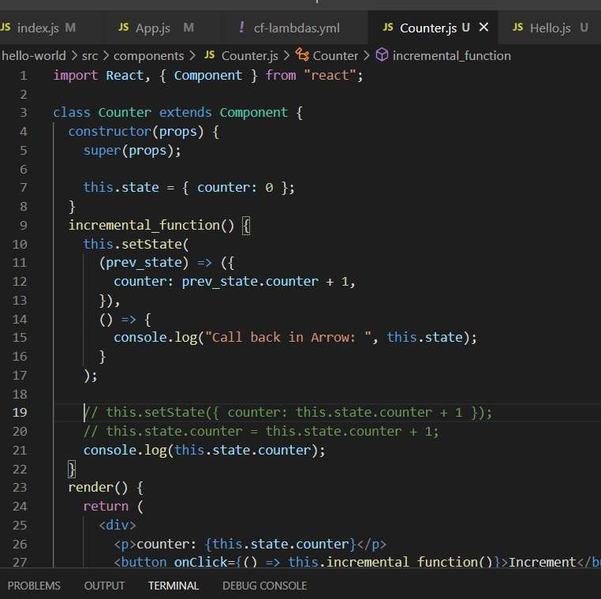

This is the right method of doing this. One thing to note that when you referring or changing the value then you need to put the parenthesis and then you can access this value and put the value used.

###### De structuring props and states:

There is an ES6 feature which helps to de structure the array properties into individual elements. We use curly braces for unpacking the data.

You can have two different ways of de structuring the props in functional component. Class Based usage:

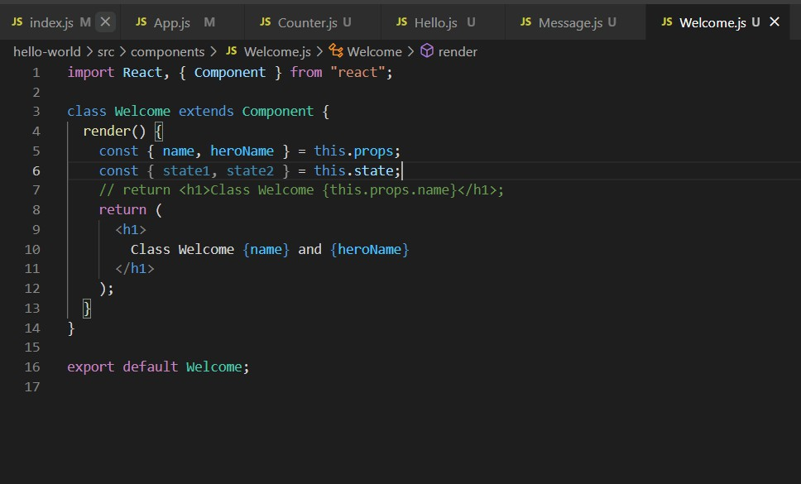

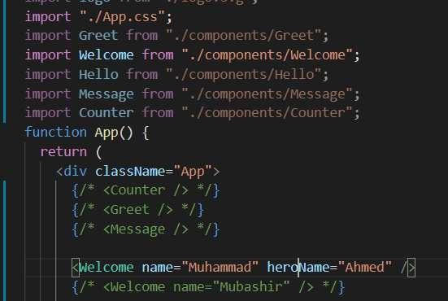

###### Functional based components:

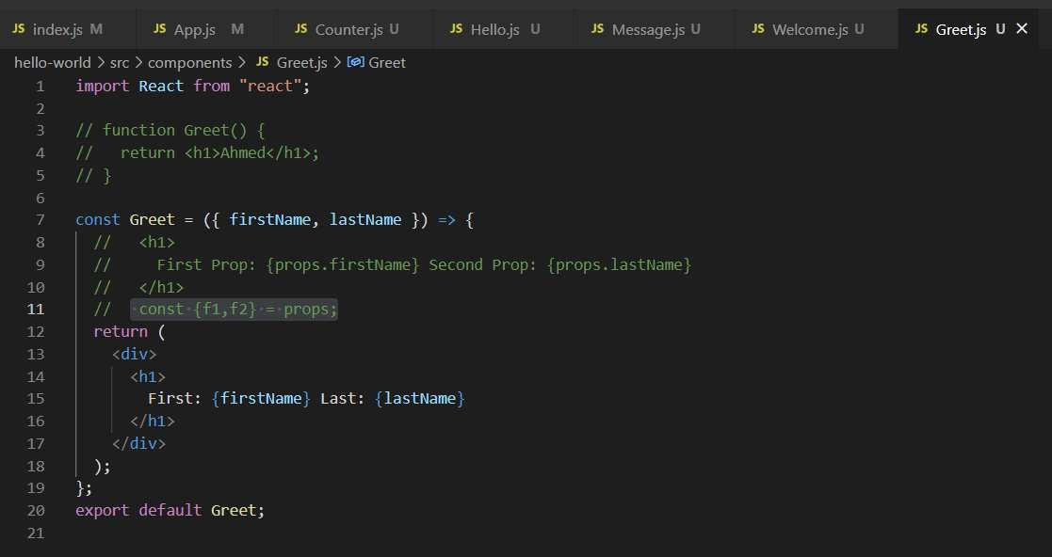

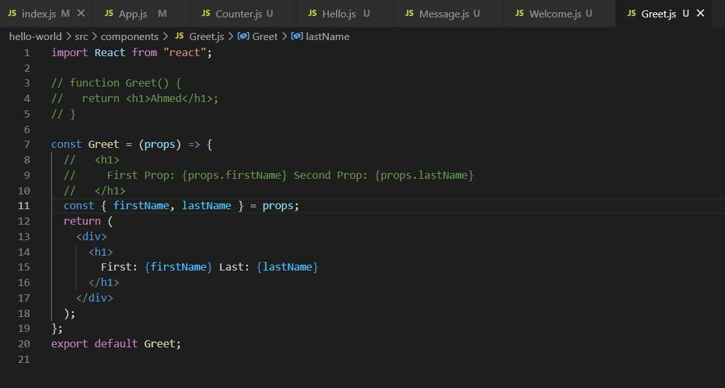

**Event** **Handling**:

* Event handler is a function, not a function class so you cannot use the parenthesis.

We can put the event handler function inside a class-based component and function-based component also.

Function based components

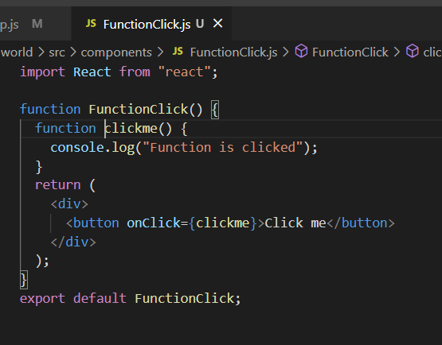

Class based components

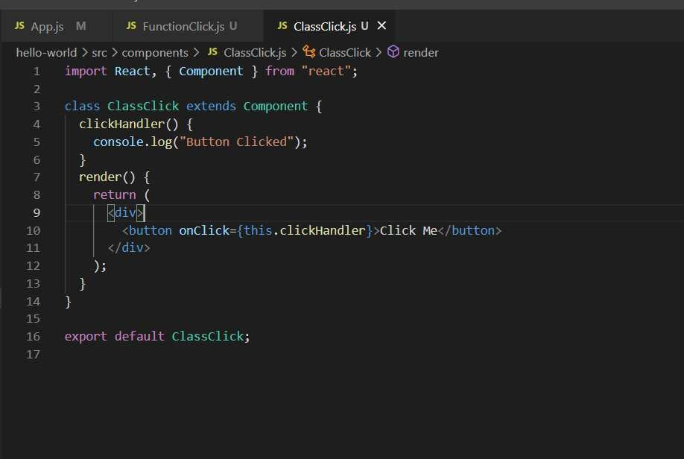

###### Binding Event Handlers:

Simple Method with the bind keyword Second you can use arrow function

Both the above methods have performance issues.

Third one to use bind the event handler inside the constructor instead of button component.

Binding in the constructor is just for one and if you bind in the button component then it will generate each time new binding so the lesson is it is a good approach binding in the constructor.

Or you can have the fourth approach where you can write down the arrow function inside the class. First approach

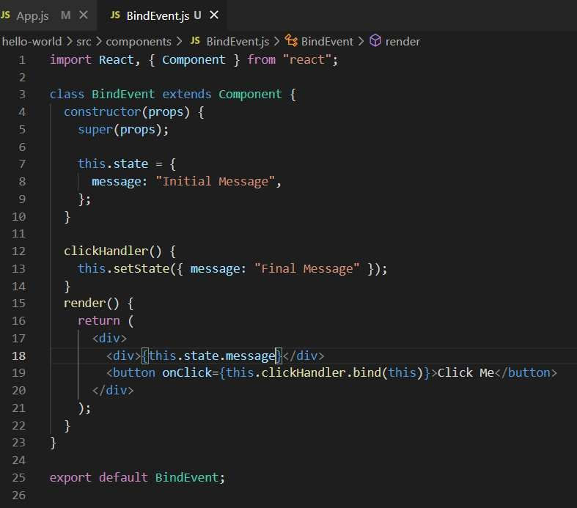

Second approach

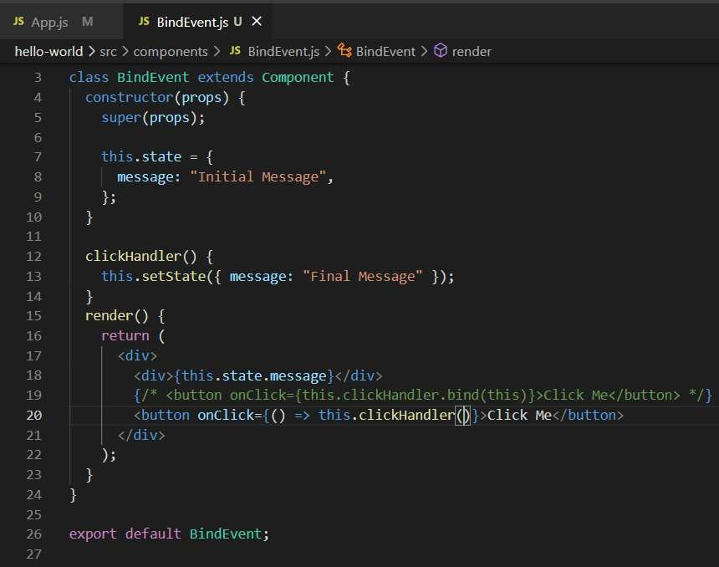

Third approach

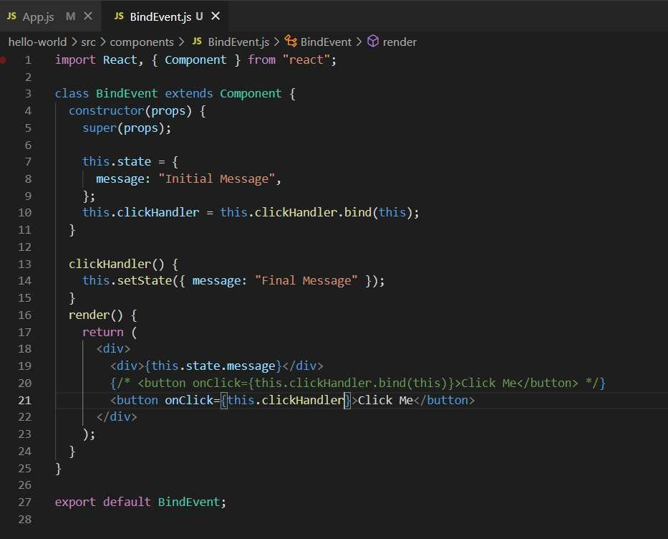

Fourth approach

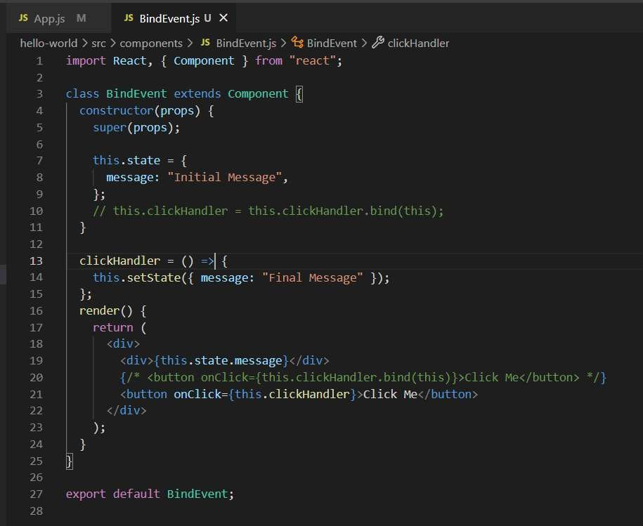

###### Methods as Props

If you want to pass the data from the parent to the child component then you can do it using the properties and what if you want to pass the values from the child values to the parent component.

Something we want to build that when the component of the child clicks then it will call the parent component and display the result.

You can also pass the variable instead of the function. We can use the arrow function and pass as many parameters as you want to the parent component.

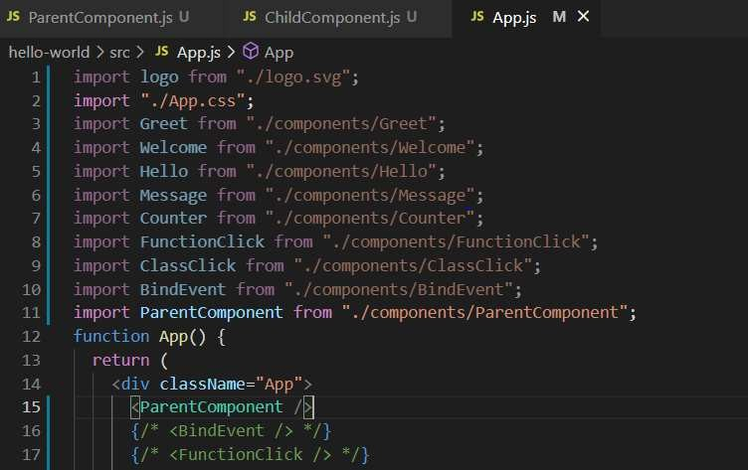

###### Parent Component

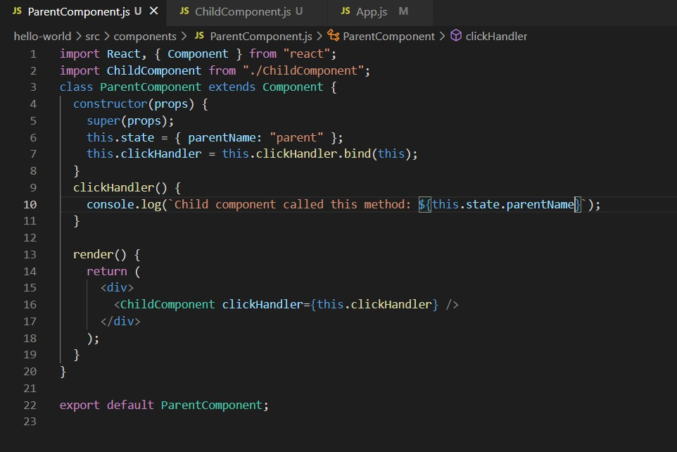

**Child** **Component**

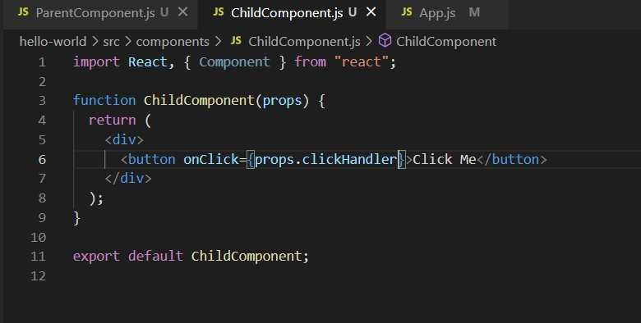

Now what If we want to pass the values inside that function for that we use arrow function and pass the value inside that.

**Parent** **Component**

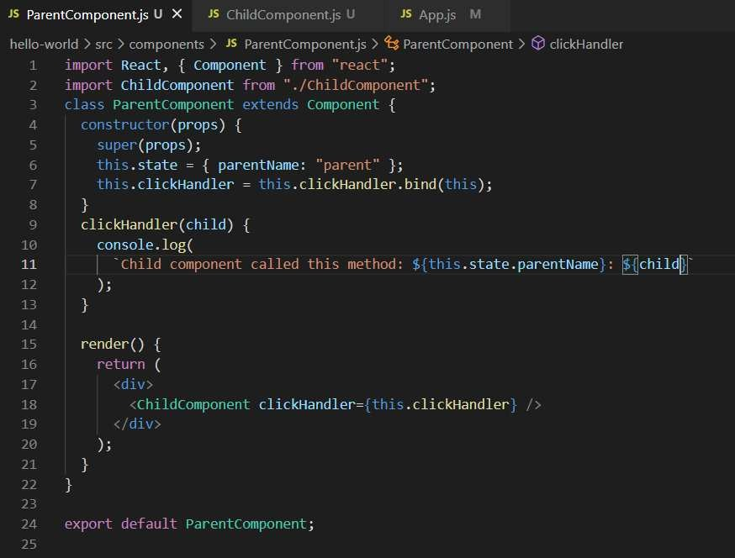

**Child** **Component**

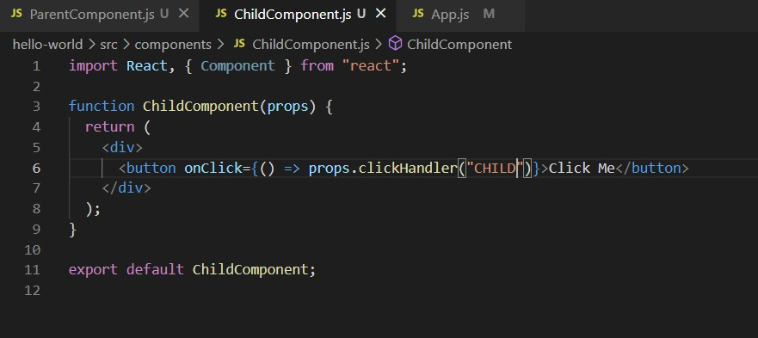

**Conditional** **rendering:**

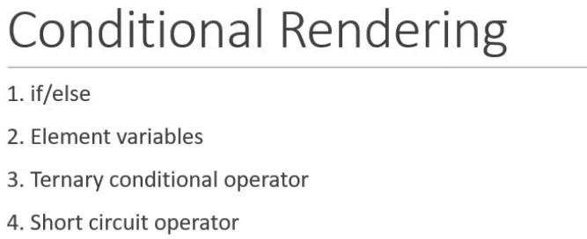

If and else condition:

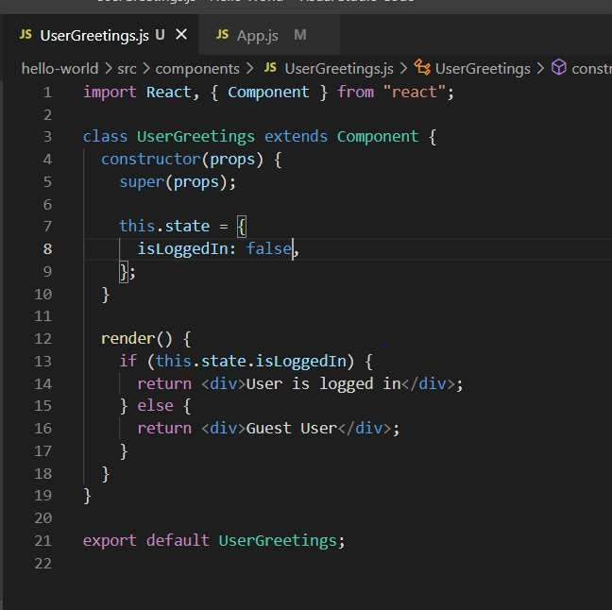

**JSX** is just the syntax sugar but it cannot used as a conditional statement.

**Element** **Variable**:

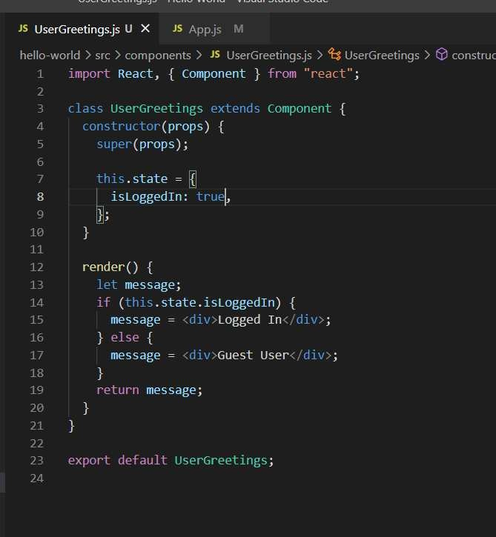

**Ternary** **conditional** **operator:**

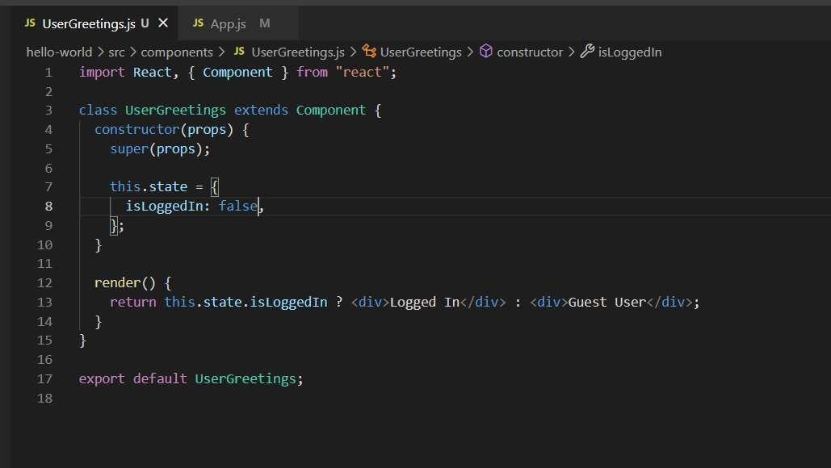

**Short** **circuit** **operator**

If you need something like this to render the value or don’t render the value for that we use short circuit

operator.

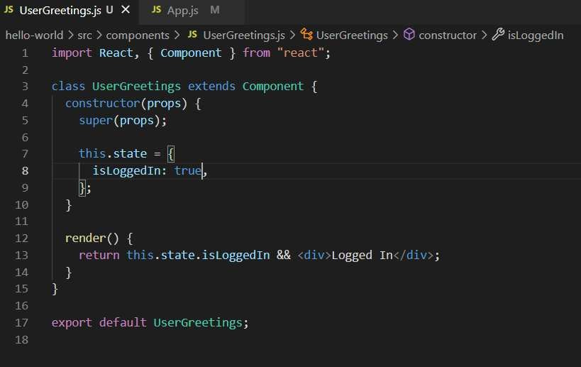

###### List rendering

It is similar as working as the **map** function in the JavaScript. Curly braces are used for evaluating the JavaScript.

1st approach

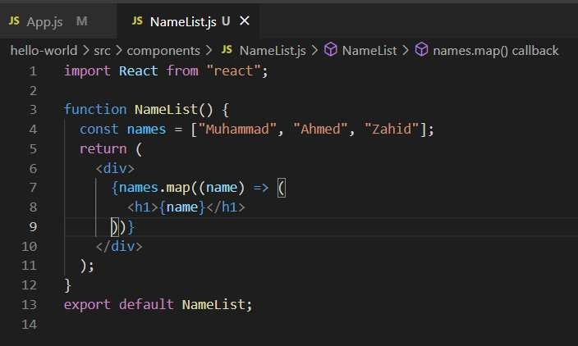

2nd approach

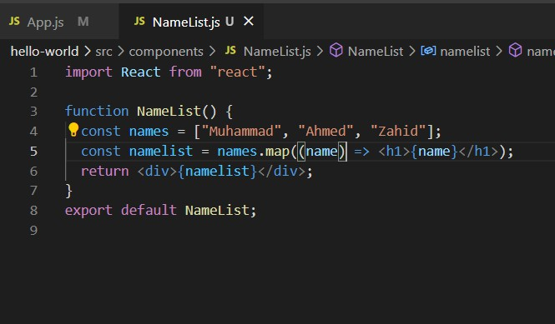

If you have array of the object, then what you can do

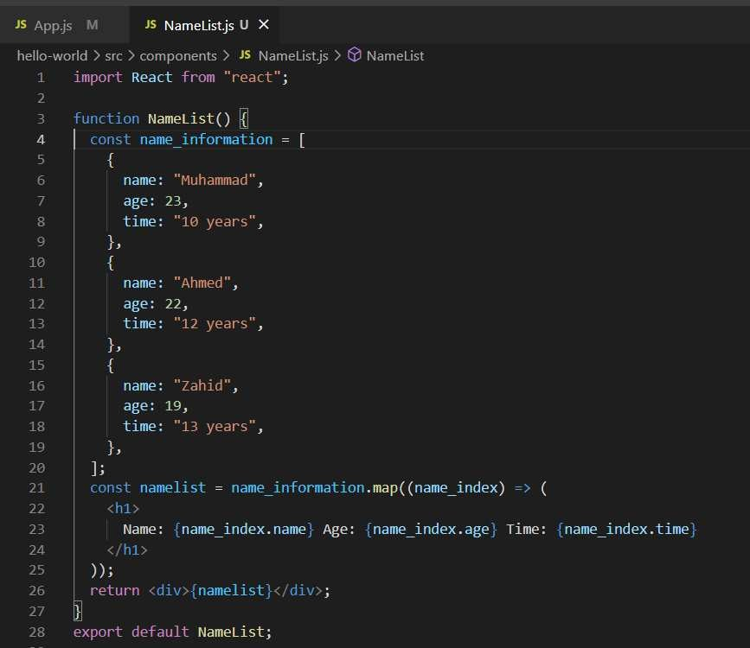

But the true method is to use separate component for that. By doing this we can separate out the Name List and then Person component so the main component is responsible for rendering the list and other component is responsible for rendering the items inside that component.

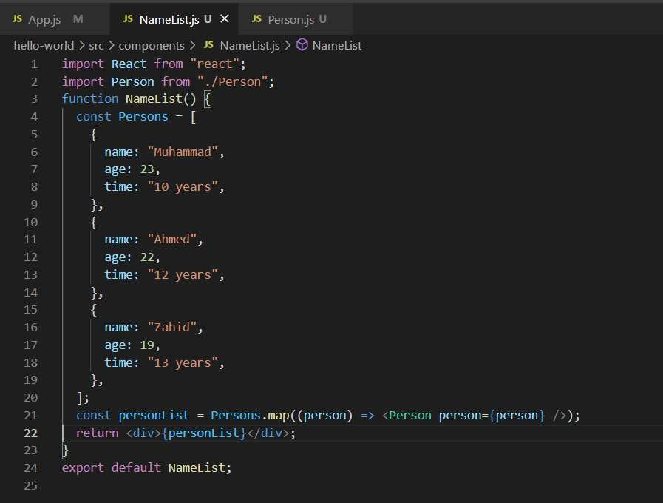

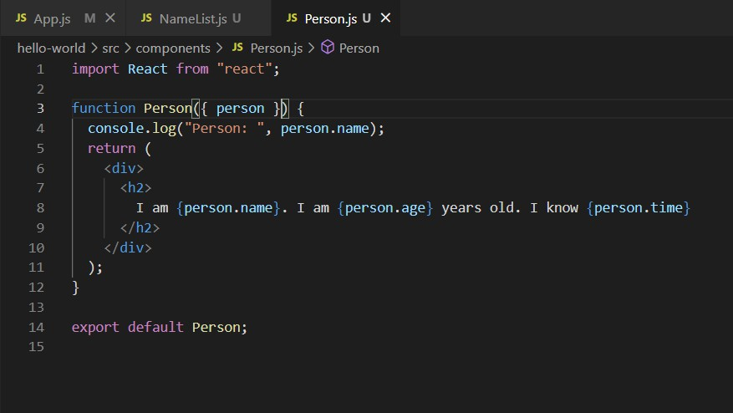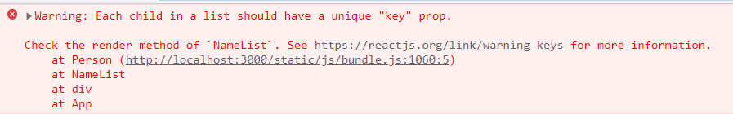

We are facing the above issue while working with the List so how we can solve that is listed below:

###### List and keys:

To, remove the above error we need to something like passing a key to the list which is unique.

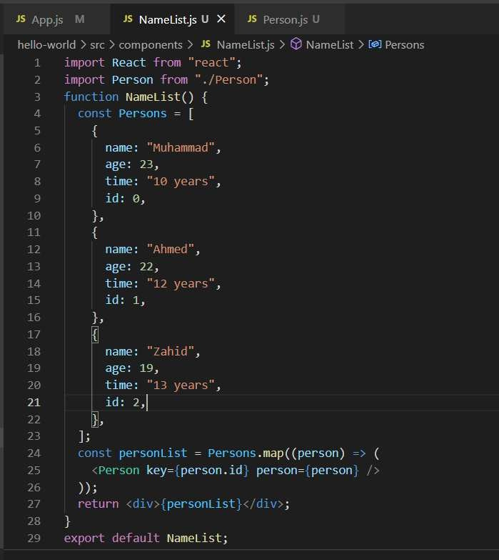

Now if you see the above error is gone.

**Important:** Don’t use the key component for rendering the key on the console.

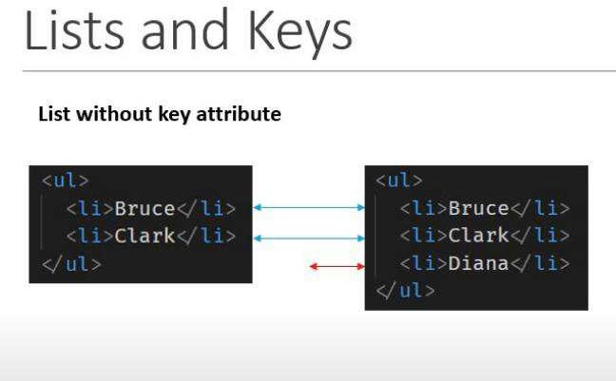

React will check each entry inside the list and if there is a change in the list it will update that item.

If you seethe below change then it will check the list sequentially and it will change all the list items as it does not come to know which item is to be changed. That is why the react supports the **Key** attribute.

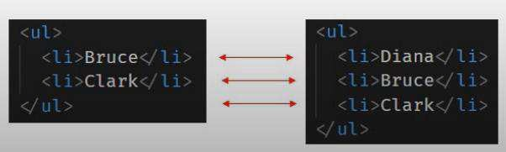

After using the key value

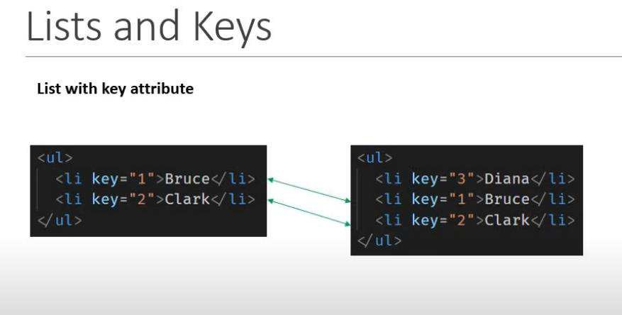

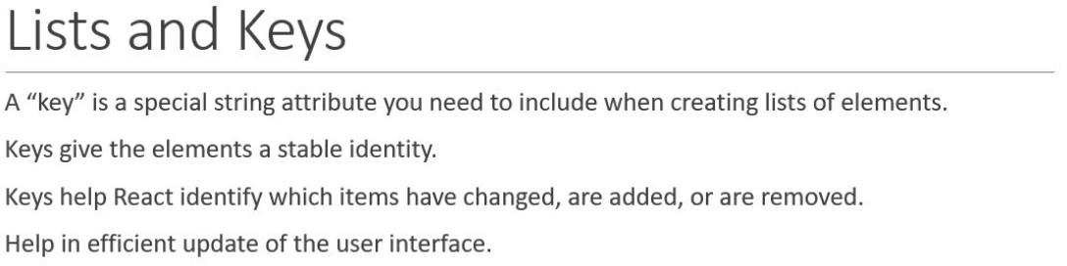

Stylesheet in CSS:

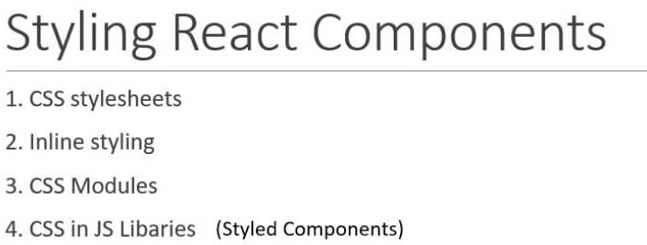

###### CSS stylesheets

You can use camel case if you want to use the properties inside the element in the UI.

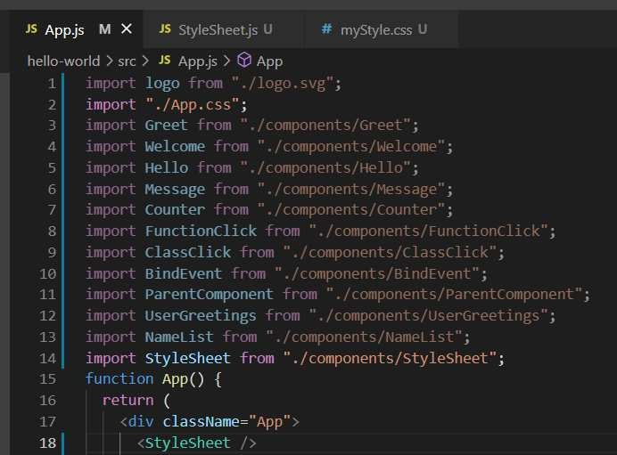

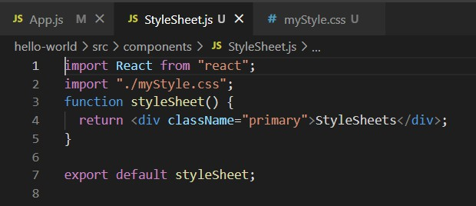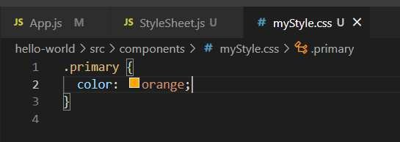

And if you want to pass the props into the elements.

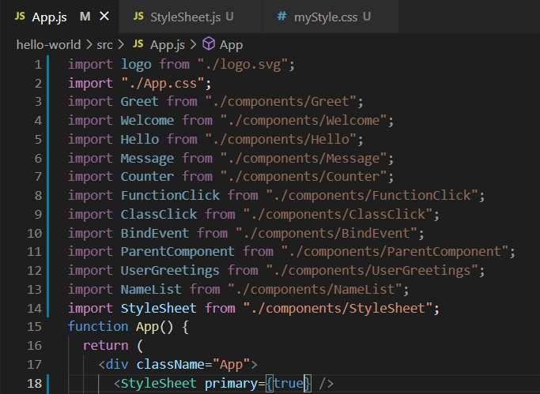

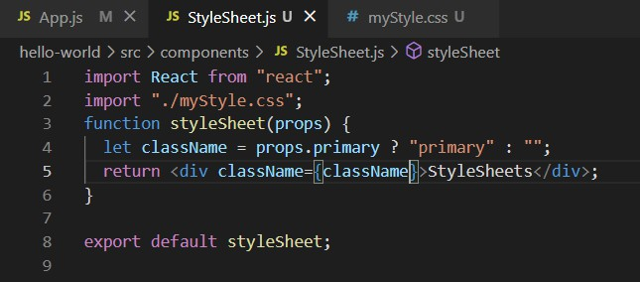

And let say you want to add one more property than what you can do is below

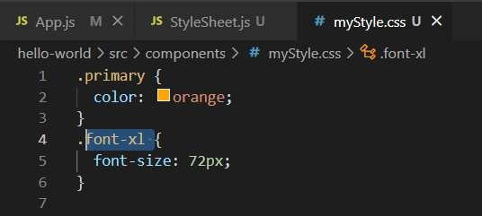

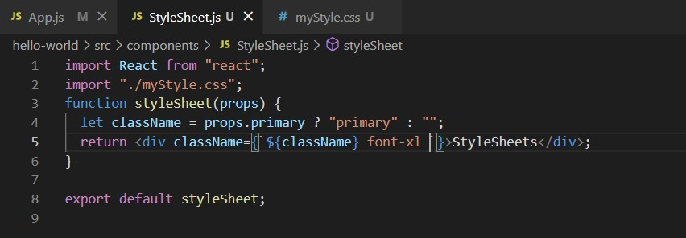

###### Inline styling

If you want to add the inline styling then what you can do is listed below

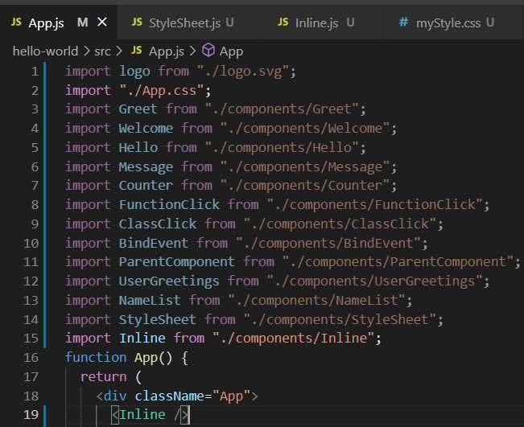

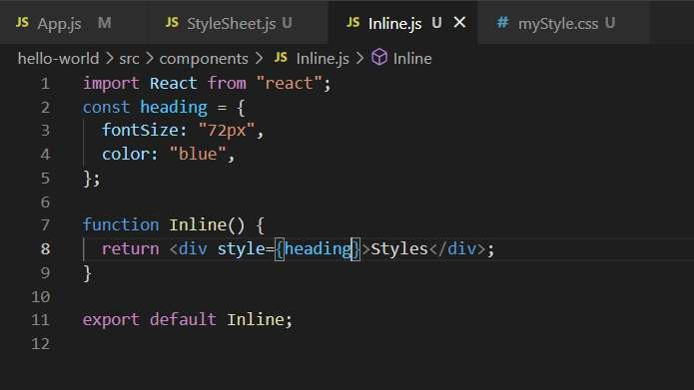

Remember one thing which is you can create properties which are camel case.

###### CSS Module

In this case, we can avoid by having a conflict in the class because we are accessing the variable using the class reference. On the other hand, when we using the class to the simple CSS file then we may be the conflict of naming convention.

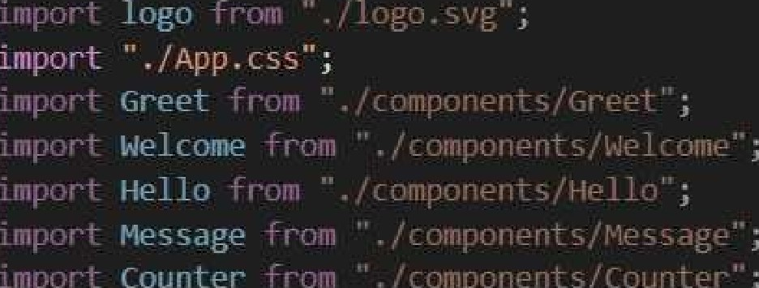

App( )

22

className=”npp”

className=”v. !r” Error ’’i className=^styles success : success



JS

.error (

2 co lor : O i‘ ü'.:

’"



appstyle.module.css U X

Basics or Ioím Ha⭲dli⭲g

If the value of the form is controlled by react is known as controlled component.

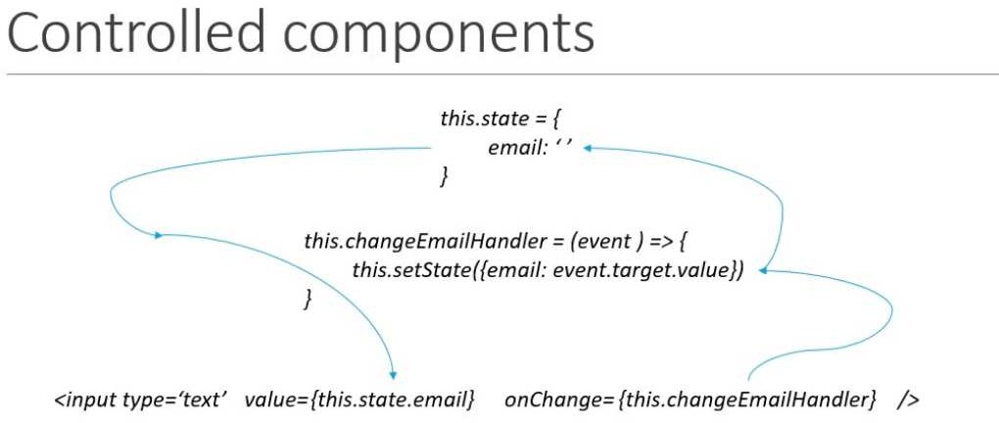

There are two steps there:

1. Setting the state
2. On change where we provide the arrow function Normally, the submit button is to handle inside the JavaScript.

You can also create the same functionality with the button with that function attached to it the benefit of using the **submit** button is to add the enter functionality.

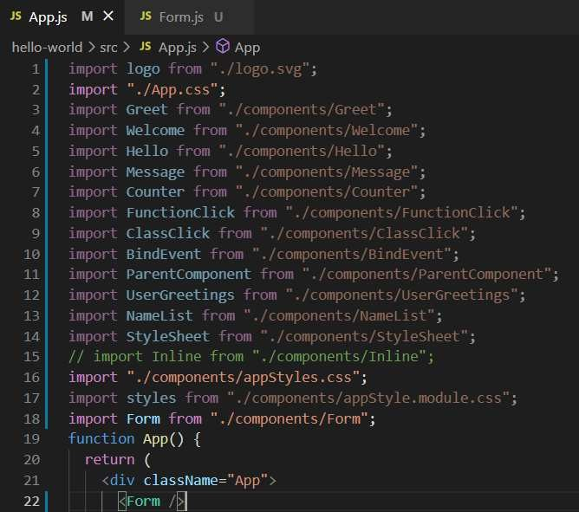

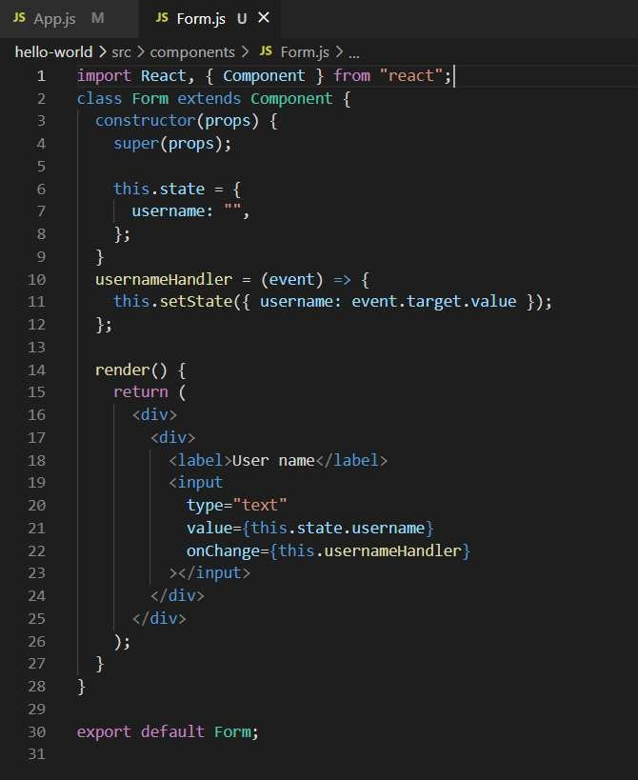

So, if you can see we are setting the two functionalities one is to set the state and the other is the function which handle the values inside the field.

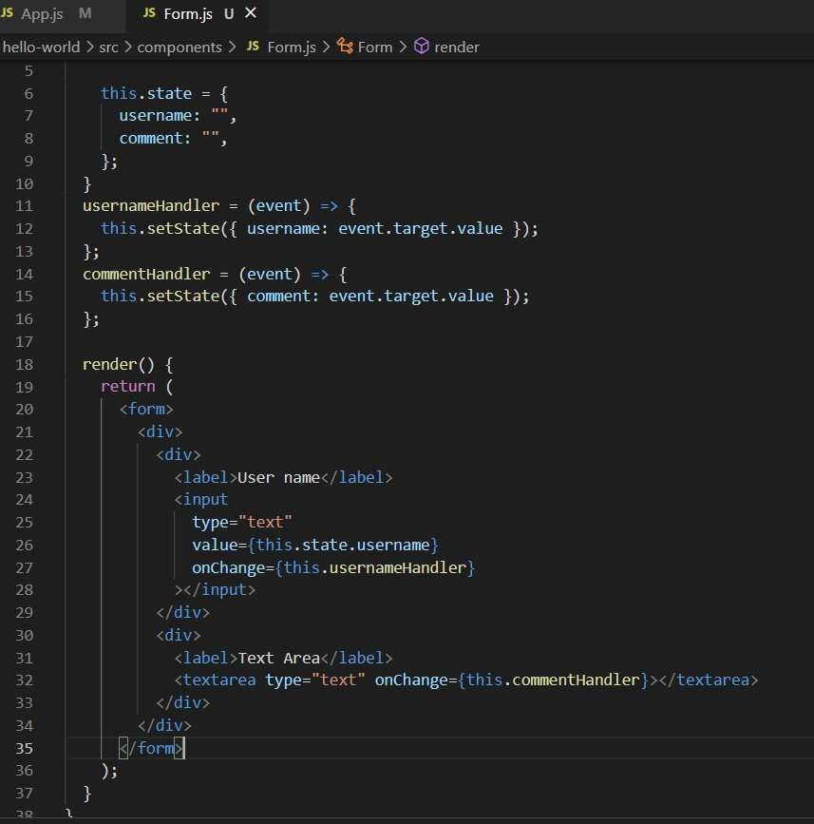

Now let’s handle the submit button.

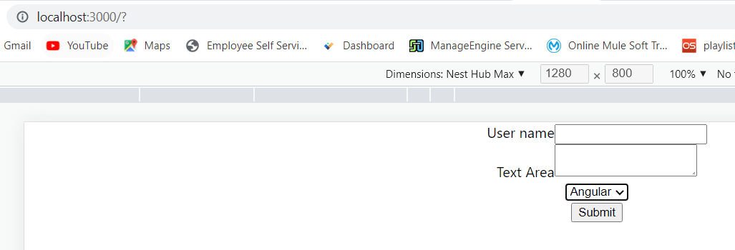

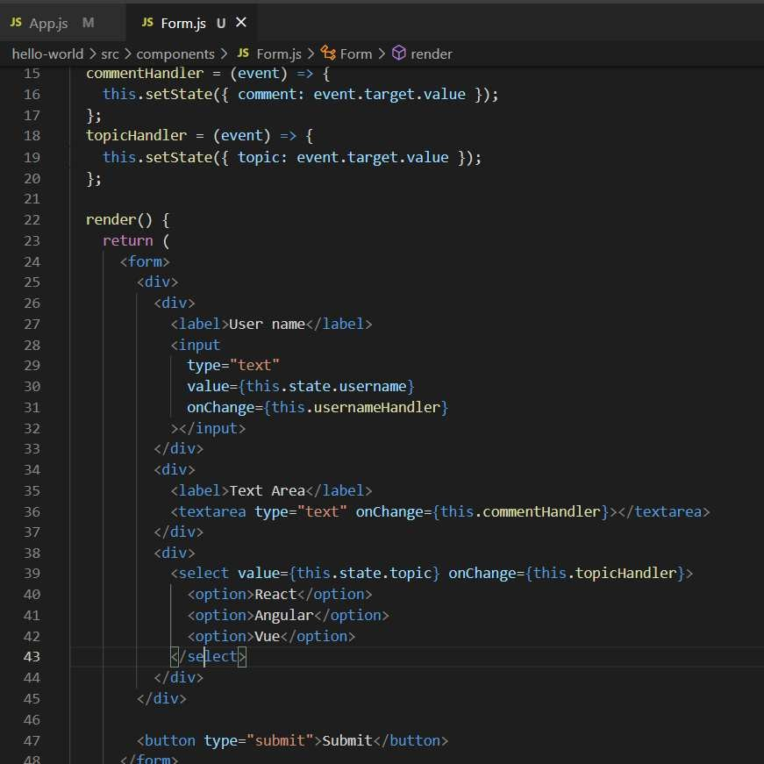

Now if you want to prevent that on submit button your page did not refresh then you can stop by using prevent Default.

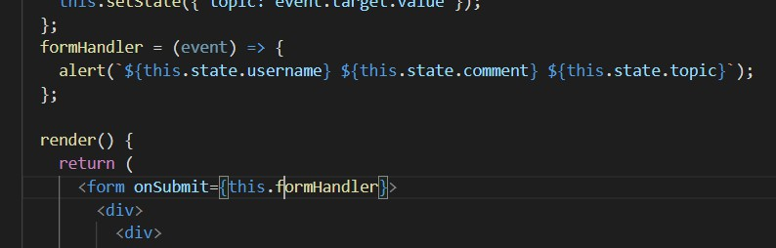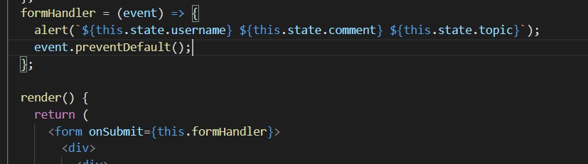

Compo⭲e⭲t Lirecycle Methods

It works with the class-based components but in the proposal of functional based components we can say that it works with that also.

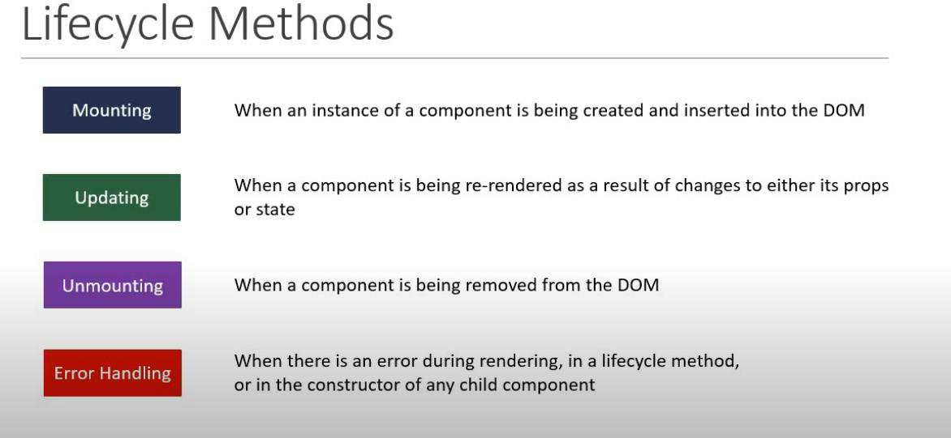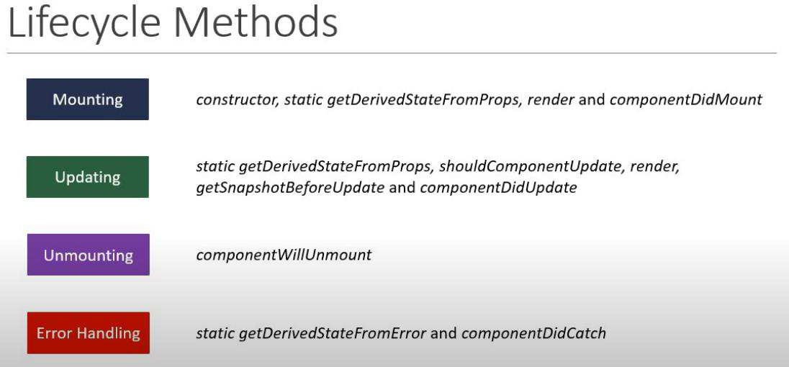

Compo⭲e⭲t Mou⭲ti⭲g Lirecycle Methods

Mounting Lifecycle Methods



A special function that will get called whenever a new component is created.

Initializing state

Binding the event handlers

Do not cause side effects. Ex: HTTP requests

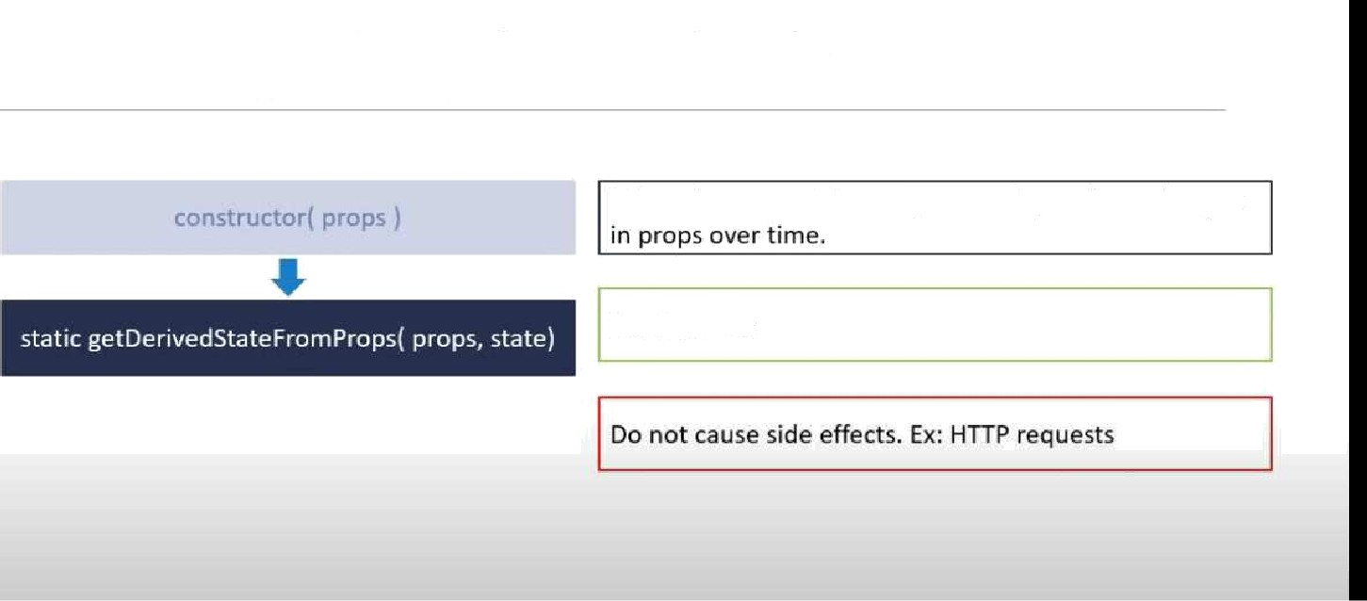

Mounting Lifecycle Methods

When the state of the component depends on changes

Set the state

## Mounting Lifecycle Methods

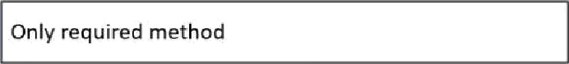

static BetDerivedStateFTomProps(props, state) Re d p te d e u n S

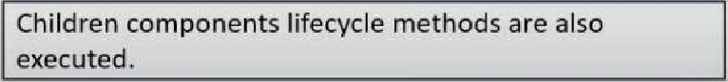

# Mounting Lifecycle Methods

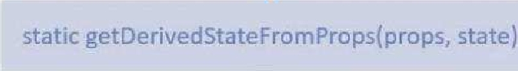

Involved immediateIyafI:er a component and all its

children components have been rendered to the DOA4.

Cause side effects. -x: Interact with the OOM or perform any ajax calls to load data.



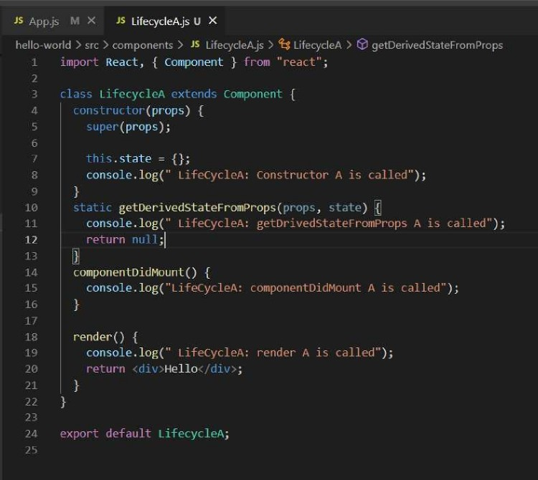

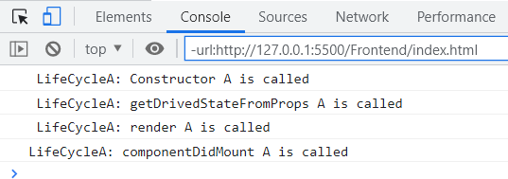

If you created one parent class and one child class so what is the execution of the flow

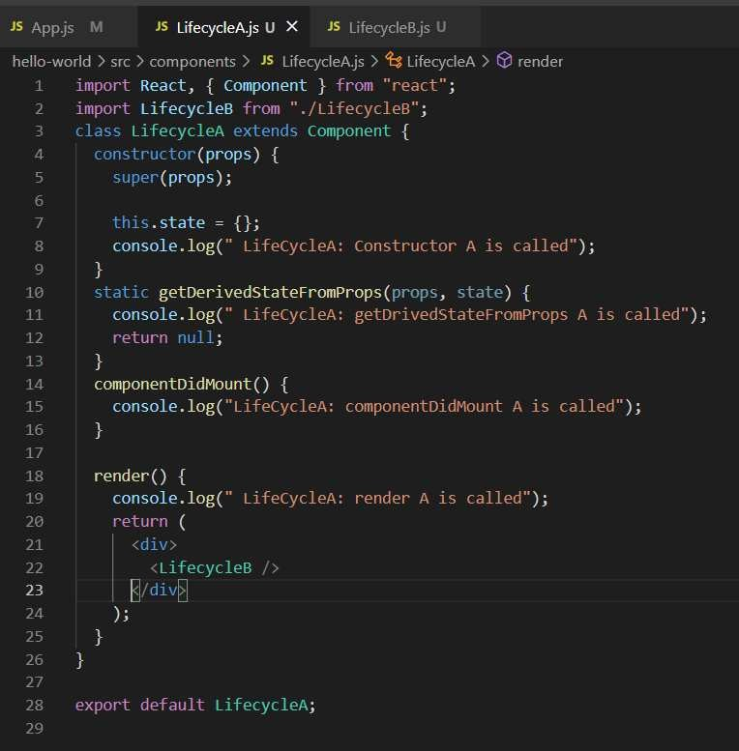

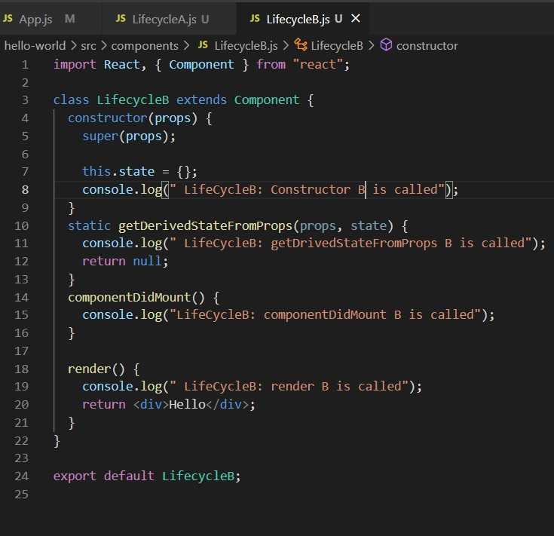

If you see when the render A is executing then it is calling the child process and the further execution is going. Moreover, the exact result is listed below.

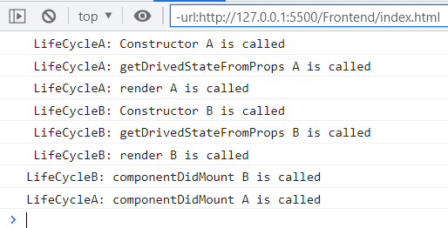

Compo⭲e⭲t Updati⭲g Lirecycle Methods

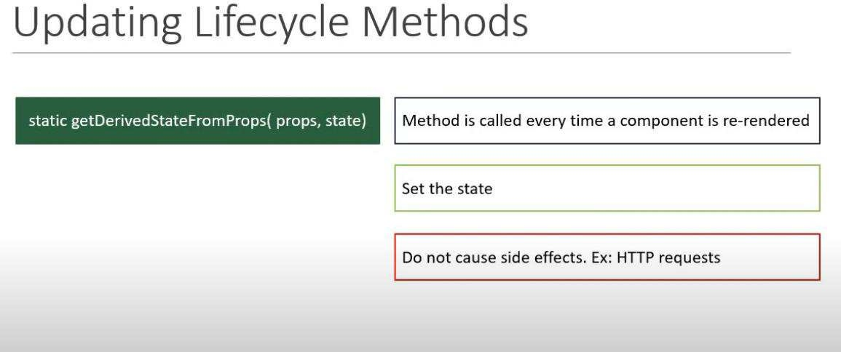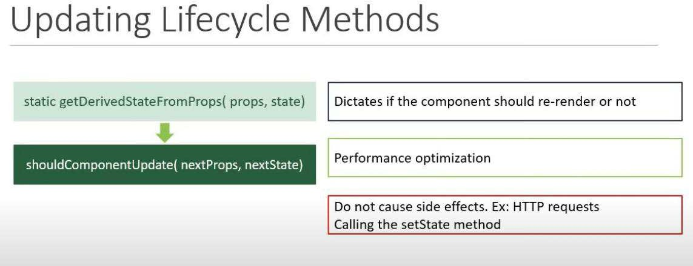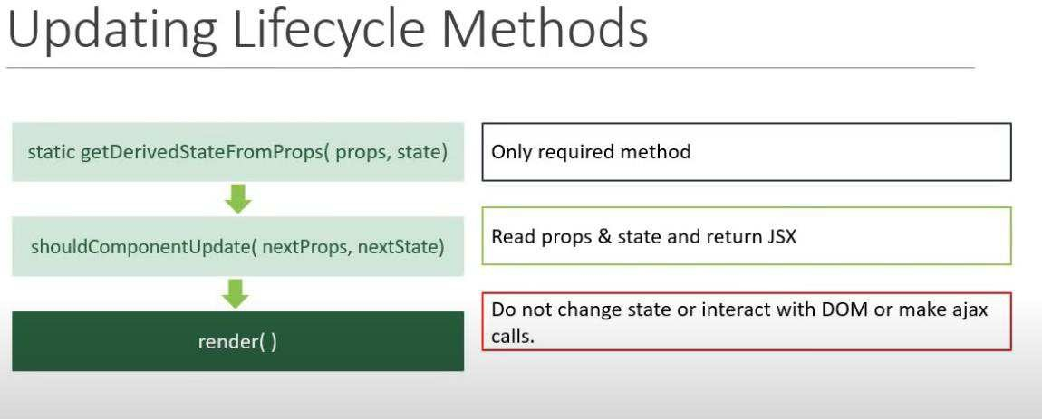

# Updating Lifecycle Methods

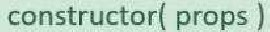

Called right before the changes from the virtual DOM are to be reflected in the DOM

sts”ticge Der'yedSiate'r•m t›.+•. .•‹ t

Capture some information from the DOM.

Method will either return null or returns a value..

Rig ill be passed as the third palametar to

é‹h.d..

Updating Lifecycle Methods

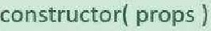

'render( )

Cause side effects

Called after the render is finished in the re-render cycles



hello-wo rid src com ponen ts " Li feeyeIeA js @ LiIeeyeIeA @ get SnapshotBe fareUpdate

>i > i i v >i pi•op y t

. s '



o o T . 1o8 "

o o T . 1o8 " ' ’

,

get nap hot B efo pdat -

enI dat e ) {

o o T . 1o8 "

”);

'

’

o o . "

.

-

'

o

I

,

Fn

8 I ni ved

o T . 1o8 "

'

o o T . 1o8 "

onC Ti ck= . an at change state

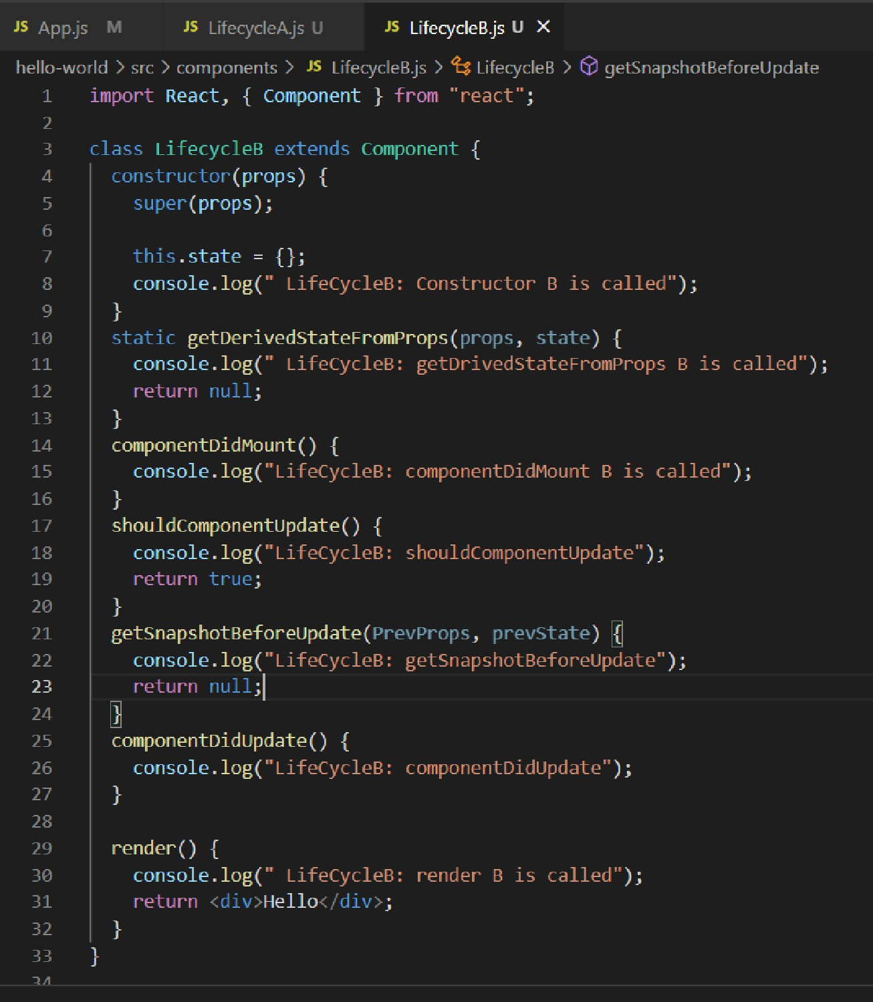

LifeCycleA: getDrivedStatePromProps A is called LifeCycleA: shouldComponentUpdate

LifeCycleA: render A is called

LifeCycleB: getDrivedStatePromProps B is called LifeCycleB: shouldComponentUpdate

LifeCycleB: render B is called LifeCycleB: get5napshotBeforeUpdate LifeCycleA: get5napshotBeforeUpdate LifeCycleB: componentDidUpdate LifeCycleA: componentDidUpdate

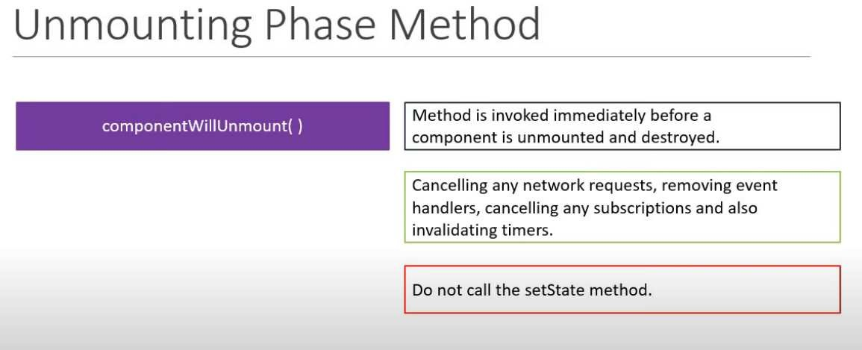

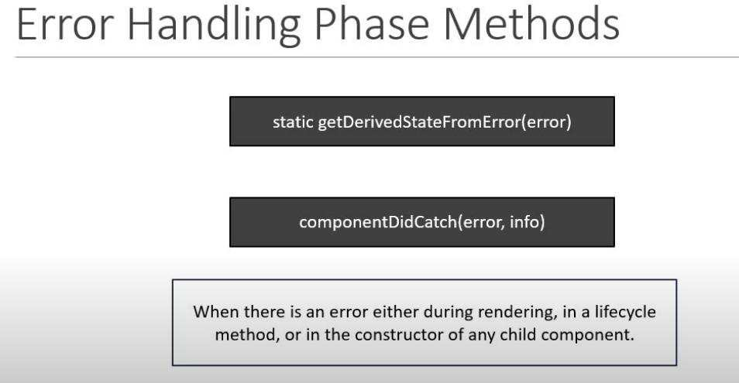

Iíagmc⭲ts

In the render method you have only one **div** present to the parent node and inside that node you can create other nodes and all the nodes is enclosed to one and when you write **React.Fragment** then create the individual component.

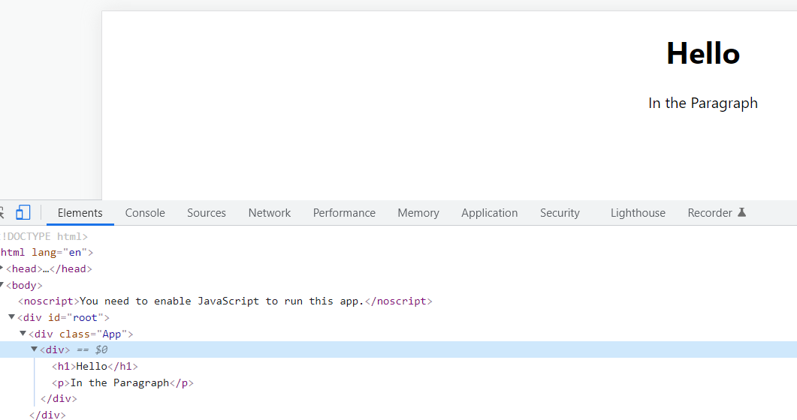

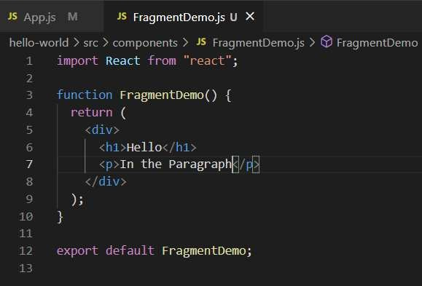

But what if we want to do render the components individual instead of a **div** then we can use Fragment.

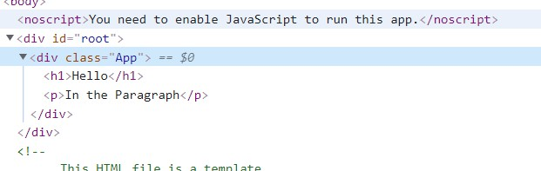

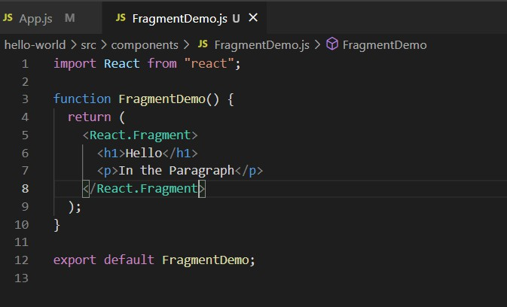

You can also replace the React following the Fragment part with the <> but the one limitation with that you cannot pass the key variable because it is used in case of map function.

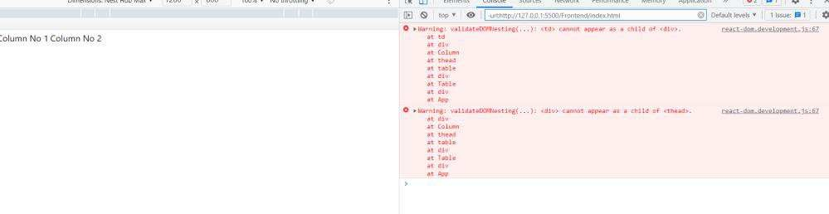

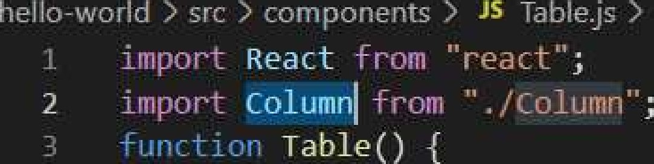

i1 d-fsi„_t Table;



JS Column.js U X

Column()

r

exiw’{ dr +>il Column;

Because there is no div element if the node is table head, then it must be inside td or tr We can solve this using the React and Fragment.

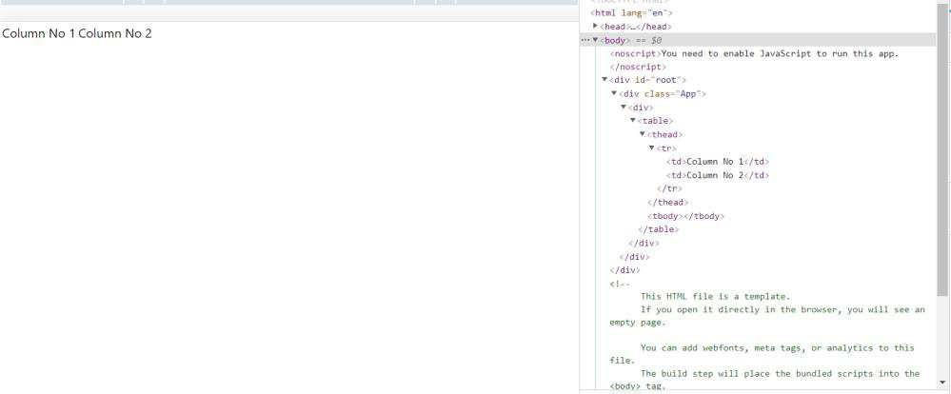

If you are working with the list then you can do the below code

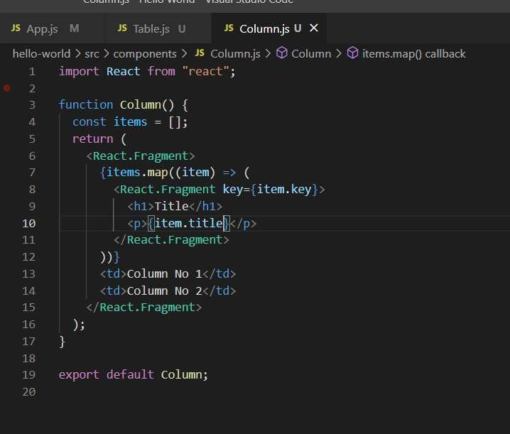

P"íc Compo⭲c⭲ts



There is no apparent change in regular and pure component. One difference is that for pure component if the value does not change, from the older than it will not re-render the method while in the class method its re-render.

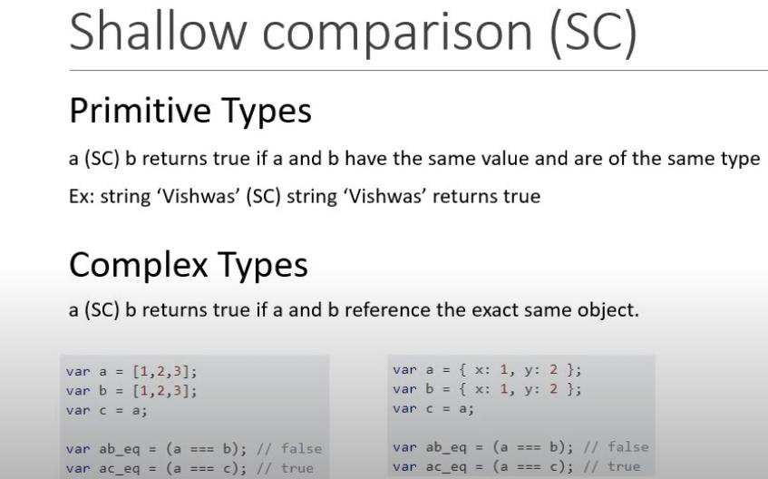

If the parent does not re-render, then the children component also not re-render. Always return object when working with the pure component.

## Summary

We can create a component by extending the PureComponent class.

A PureComponent implements the *shauldComponentUpdate* lifecycle method by performing a shallow comparison on the props and state of the component.

If there is no difference, the component is not re-rendered - performance boost.

It is a good idea to ensure that all the children components are also pure to avoid unexpected behaviour.

Never rñiJtate the state. Always retu.rn â qéw pbject that..réfId/cts. thé rié.w stâte:

#### Parent Component

Regular Component Muhammad Pure Component Muhammad

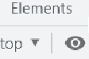

a e



,s

JS

i‹’‹,:::rt React, { Component, - ::‹ :: .- } 'r u ” e.‹(' ;

t‹ ›' rt PureComp '' -:u ”..'’P.!‹-e€r'!,”;

:i› rt RegComp '. '' " '"e-,‹-,!:: ';

r%’*:,'.’(-«.»),‹’”-. %!c›:ipt'’i:%›.’.

(props) {

(props);

.state =

|JdMle : ’ '’’c '‹9l#l%‹.. ",

componentDidMount() (

setlnterval(() {

'.setState(( name: ”' ‹.›-' :+1” });

}, 2000);

Parent Component

ñcgIo;j name= '' -.state.name P r Cnuj name=: -.state.name



JS RegCompjs U X J& ’ '’:1o › !' ’-

° i J: React, { Component } í. ü'i "n:zs: î ' ;

COnSOle.lOğ(”R- !Ju' l s c‹,L: d );

Regular Component ' ! .prop›.name’

;

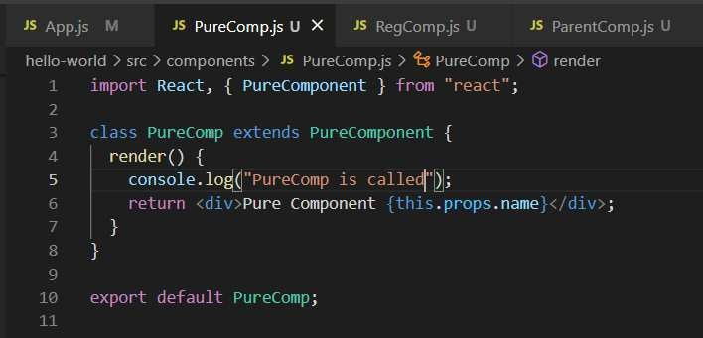

mcmo

If we want to achieve same functionality with the function-based component then we need to use memo. React

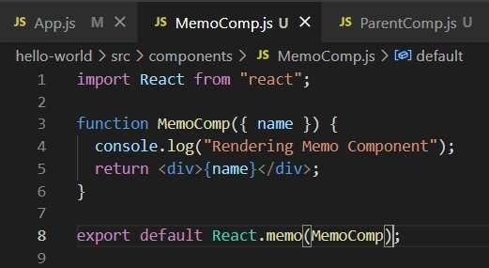

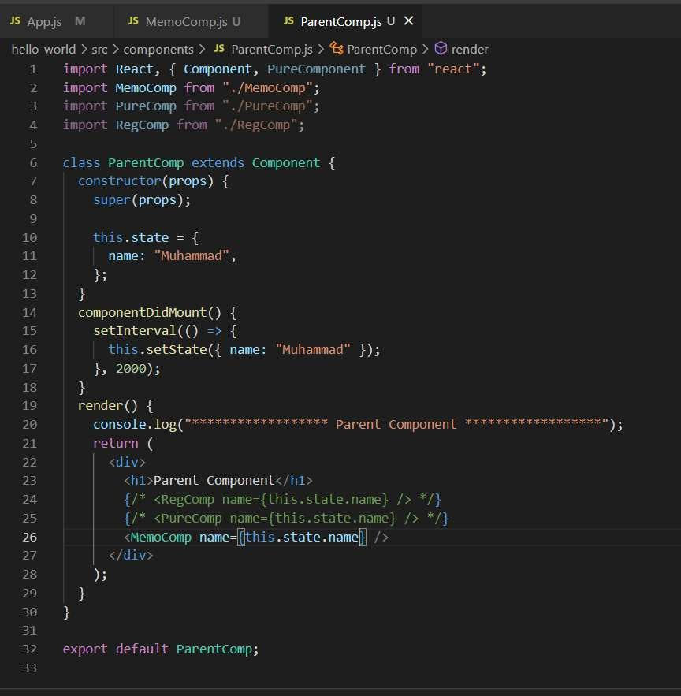

Rcrs

Accessing DOM nodes directly in react. You can focus on input node.

You can fetch data from input user.

One way is to use the create ref method. Other way is to use the call back refs



. in put

= a-r . r r eaI ReI ;

c OmpOn nt Dż

re

con

. log

Ț

.i npuI Re ) ;



. i nput Reł



üi I It Demo;



re

coøponentDidNount( (

I z : . input Rei. rurenI . ïocus/(/)İ; console . log( I° . s . i nputReI) ;

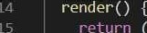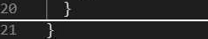

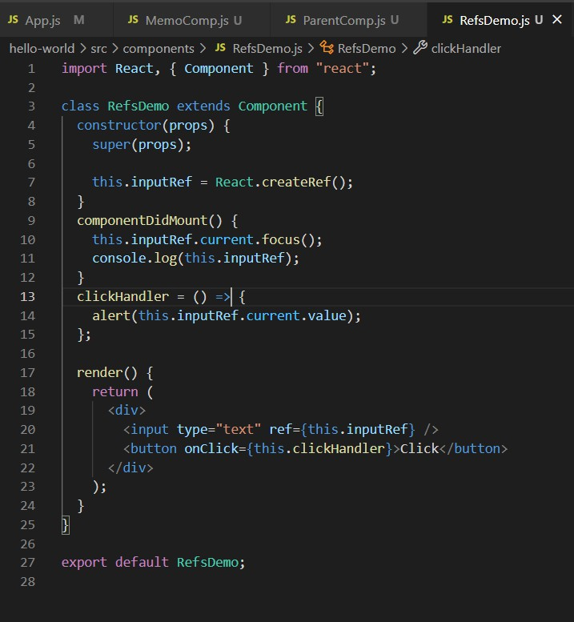

2nd Approach

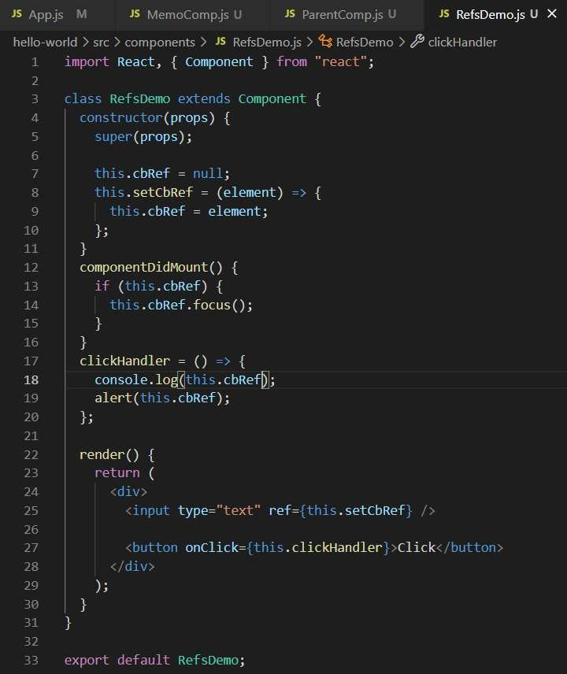

Rcrs with Class Compo⭲c⭲ts

If you want to do something like when you click on the button and the focus goes to the input field and you cannot use the component did mount.

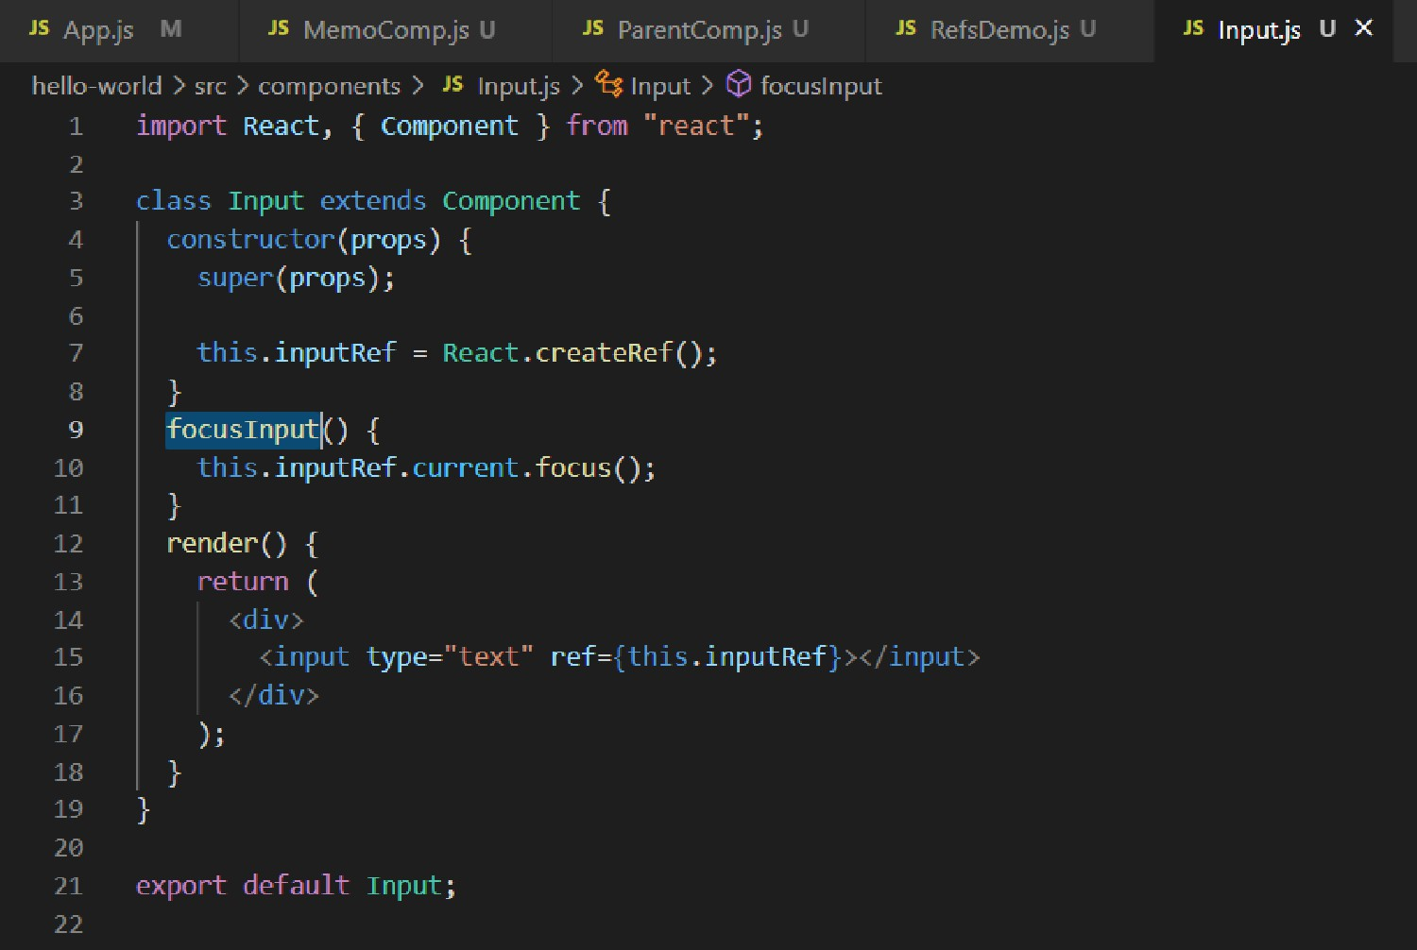

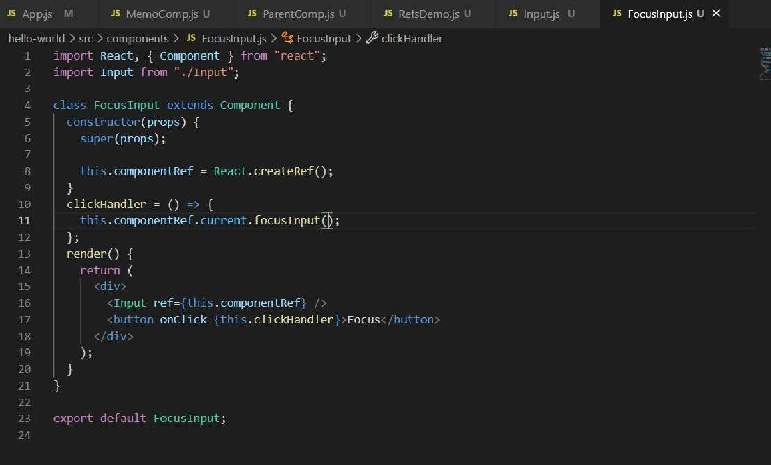

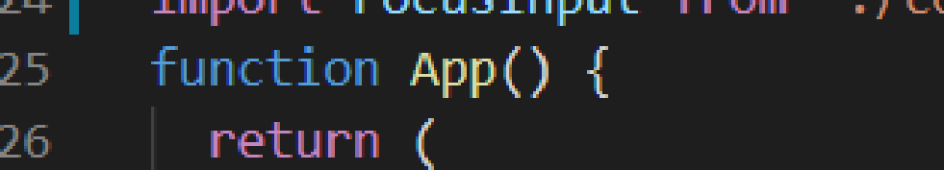

z8

Jim className="App"

FDCusInput

#### F cu

Ioíwaídi⭲g Rcrs

It is a process by which you pass your refs from parent component to its child component.

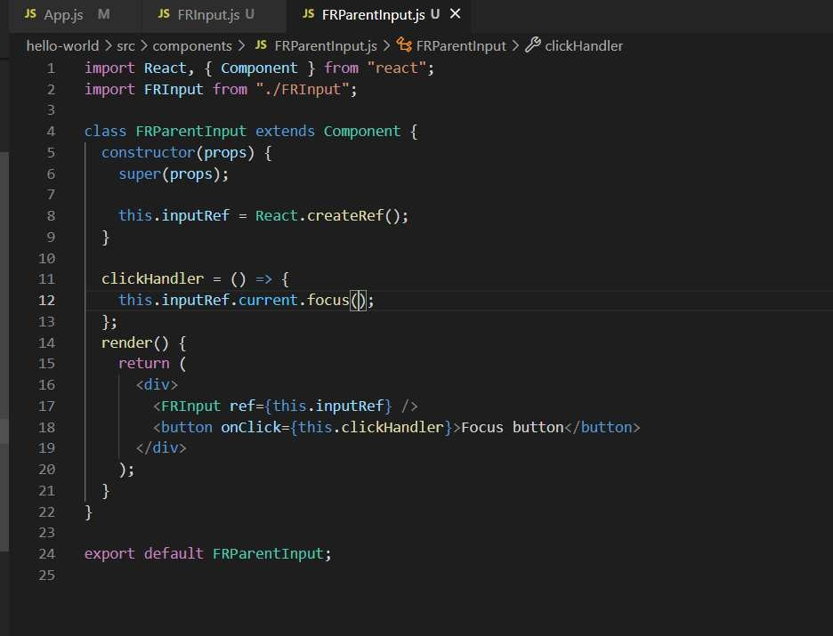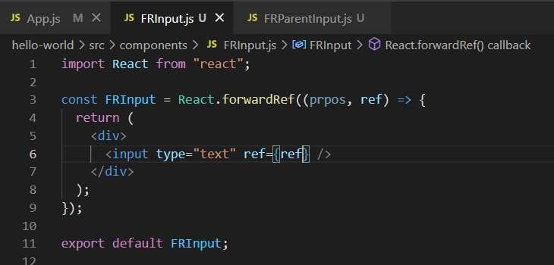

Poítals

You can create elements which are not under the **root** element and render those elements.

Portals have all the properties of the react component similarly. Below is the code how you can do that:

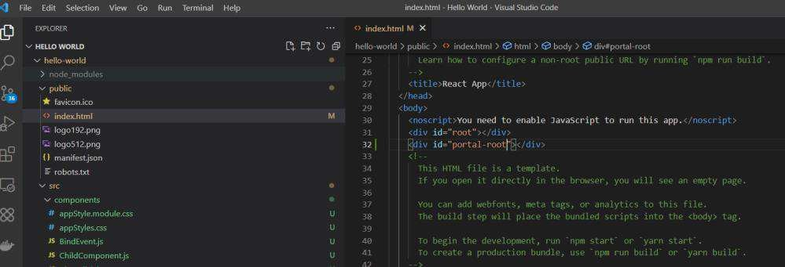

First you need to create the element because it needs a react element where it needs to render and the element which it really wants to render.

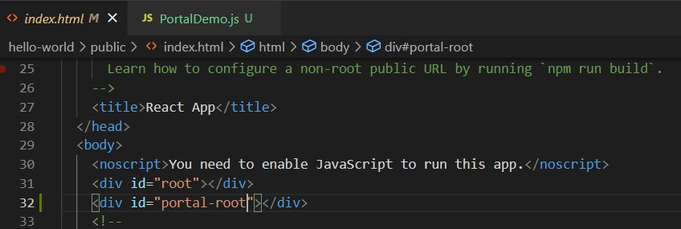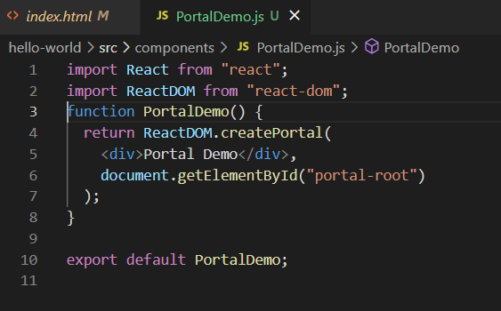

This is beneficial when you want to render outside the app node.

Eííoí Bo"⭲daíQ

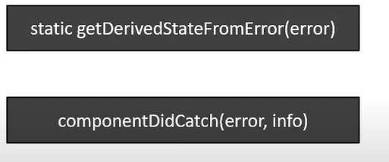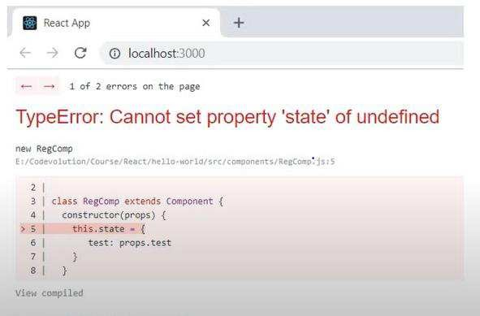

Because at this moment we can say that when something is wrong our whole application break so we

don’t want our application to break instead we want it shows the particular error instead.

It does not catch error which are under event handlers.

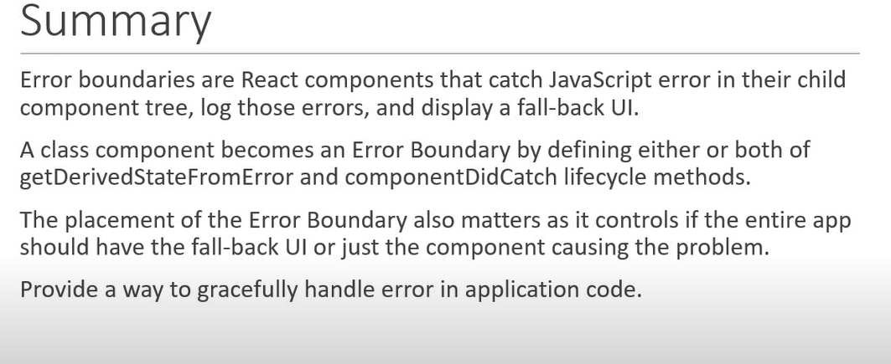

Let’s write the code to handle that

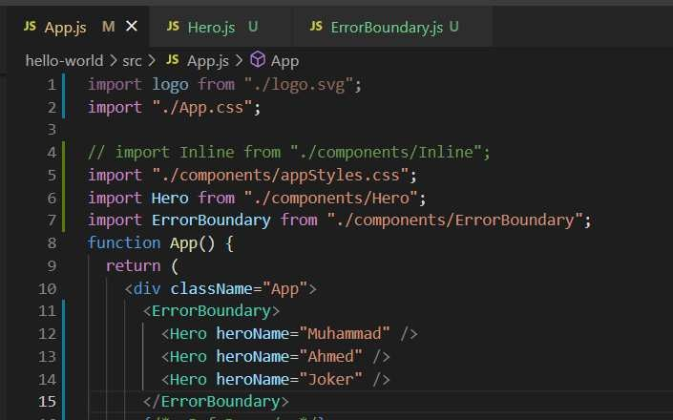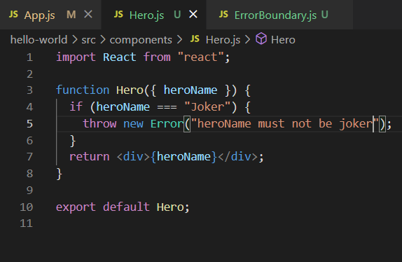

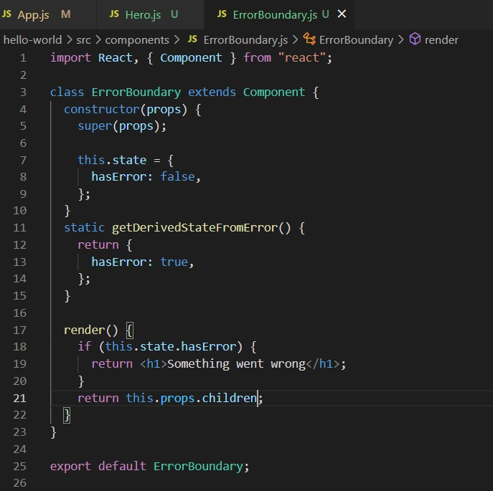

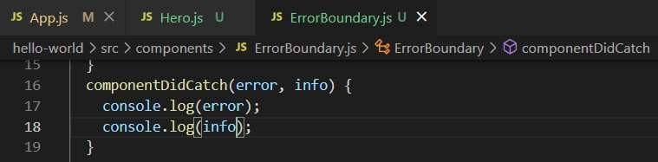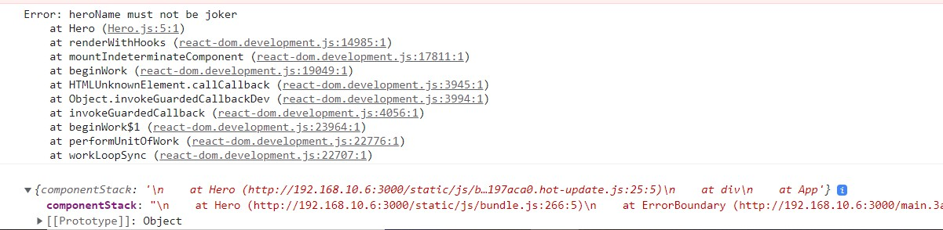

Higkcí Oídcí Compo⭲c⭲ts (Paít 1)

Concretely, **a** **higher-order** **component** **is** **a** **function** **that** **takes** **a** **component** **and** **returns** **a** **new** **component.**

##### Repeating functionality which the component used. So, how you can re-write the code that various component uses the same code

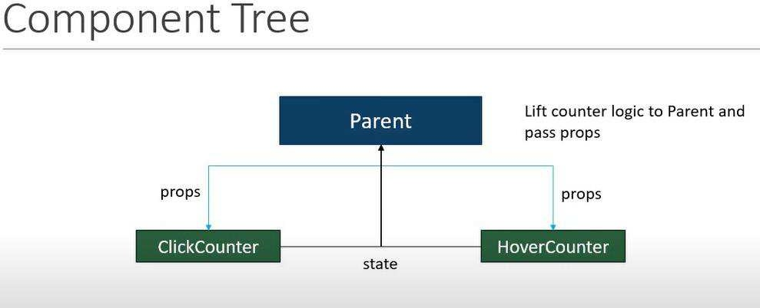

You can think of something like this what if we have some like the below one

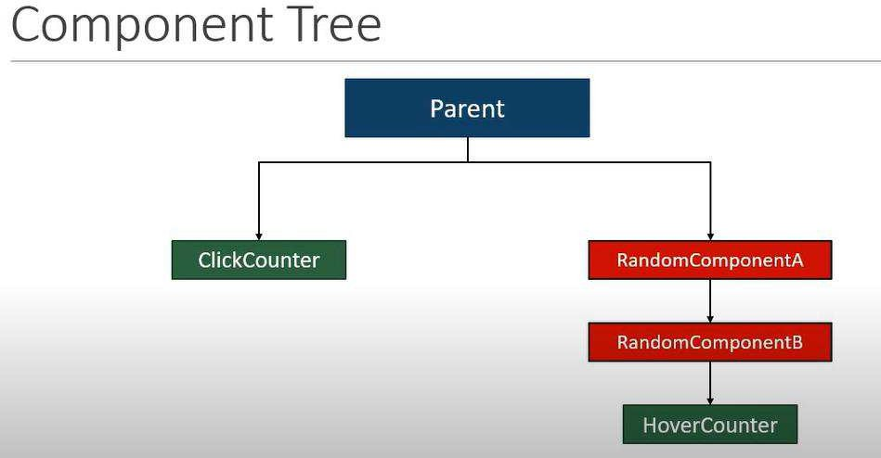

Below is the demo code for describing the functionality A basic counter functionality

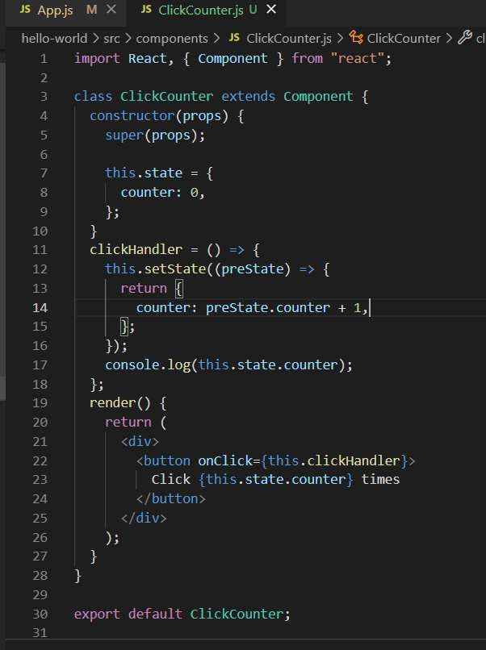

What If someone says that you need to achieve that some function below is that function

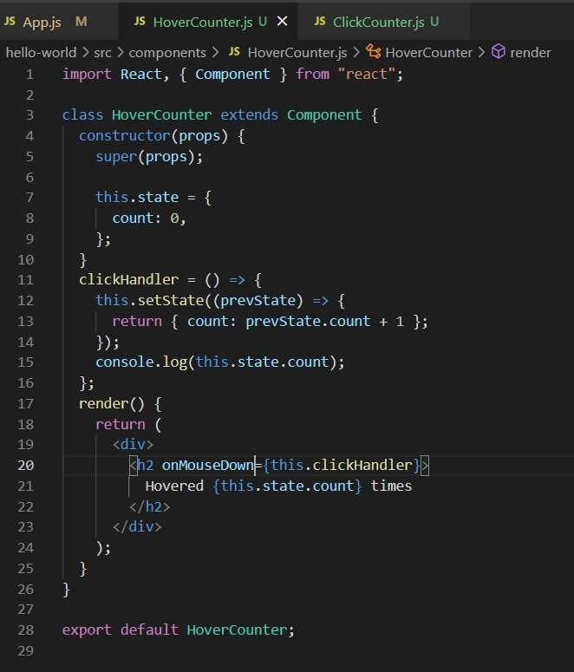

If the same code using various components, then how we can handle that this is how we can do that

Higkcí Oídcí Compo⭲c⭲ts (Paít 2)



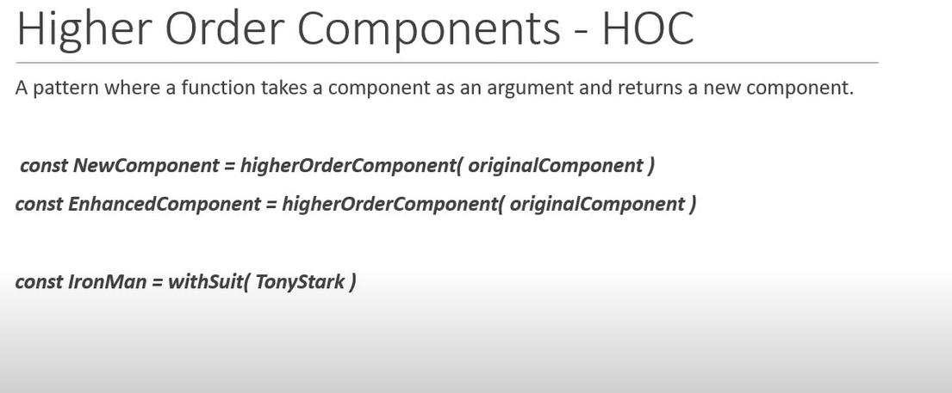



|  |
| --- |
| hello-wo Id s c com ponen ts ž ClickCou nTerşs ž @ CltckCoun te |
| ii poct React, { c oøponenI } łnoi "ce acI' ; |
| zmpant xit heount en Tnow ' . /uit hC ou nter ";  8 ż a s cì i c kcount en ext end s for onent |
| I nenden(ÿ ( |
|  |
|  |
| butt oi onChic k={I h z s . pnop s . in cr errentcount j |
| Cli¢k {I h z s . pnop s . count j times |
|  |
|  |
|  |
|  |
|  |



ex pant deTau żt xithcounten(c 1i c kc ount er} ;

ì.



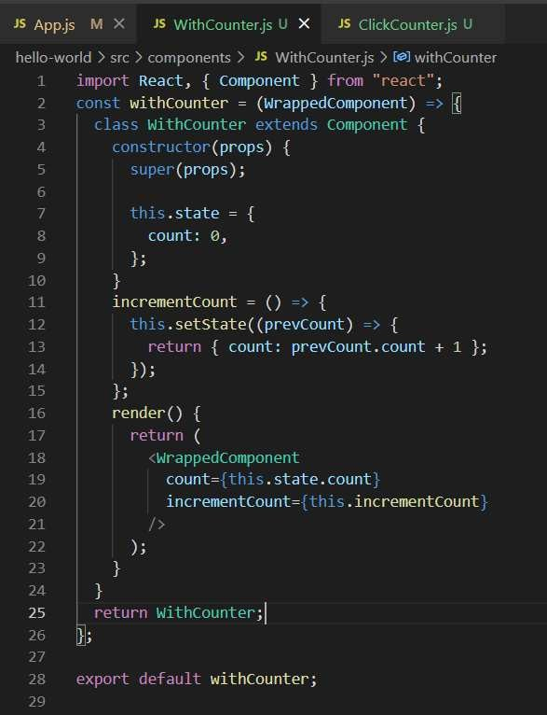

Higkcí Oídcí Compo⭲c⭲ts (Paít «)

Passing down the prop.

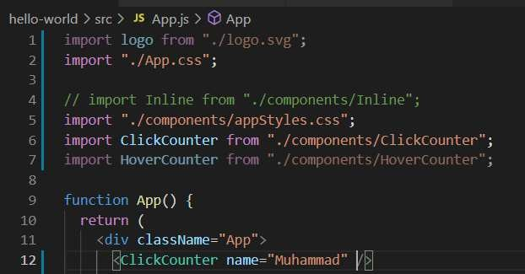

If you pass the prop and wants to use. If you want simply then it does not render

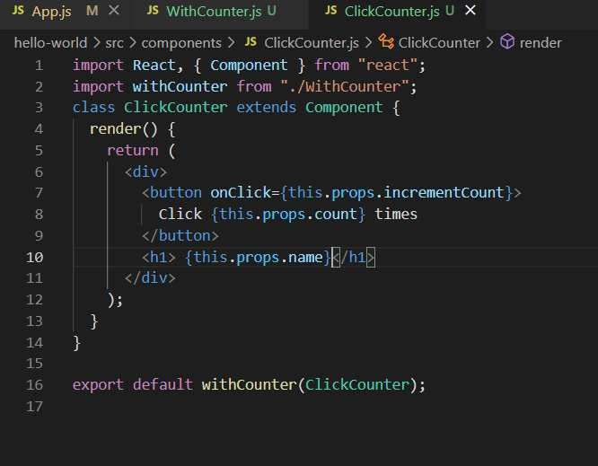

Basically, it passes the prop to the with counter and when it returns back then there is no prop so in order to do that, we need to return the prop from the with counter.

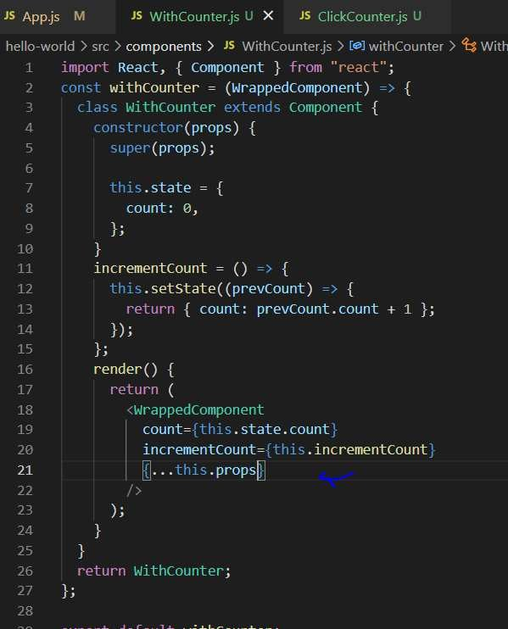

2nd thing

Passing parameters to the HOC function. We want to increment the counter by different number.

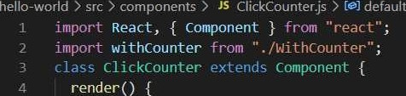

-' onik -eyoyi rewflnvv+

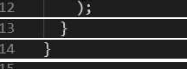

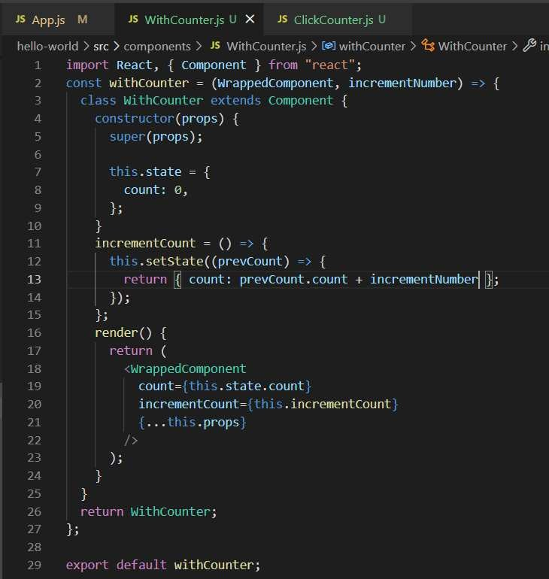

Rc⭲dcí Píops (Paít 1)

It a second method sharing the code between different components. **Render** **props** **pattern** it is also used for sharing the code between the components.



heIlo-wo rid src to mponen ts J* ñ IickCc'iJnterTwo¿s I @ Cli«kCou‹JIerT\\ a Q ine•e naentñounI

Talp¢ nt React, ( couponenI } Trod "ne‹act" ;

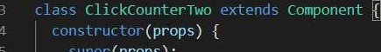

C 0 UIt I Ø,

inc ceøentcou nt = ( ) =› }

*"r' + .* setSt ate( (prevstate) = ›

re* u i•ia { count : prev State . count + a };

console . log( I i . state . cou nł );

render ( ) (

r -. :'i onC Tick= z : s . inc r ement Count ,

button cÏ icked r! ż . state . count

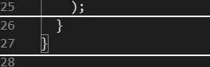

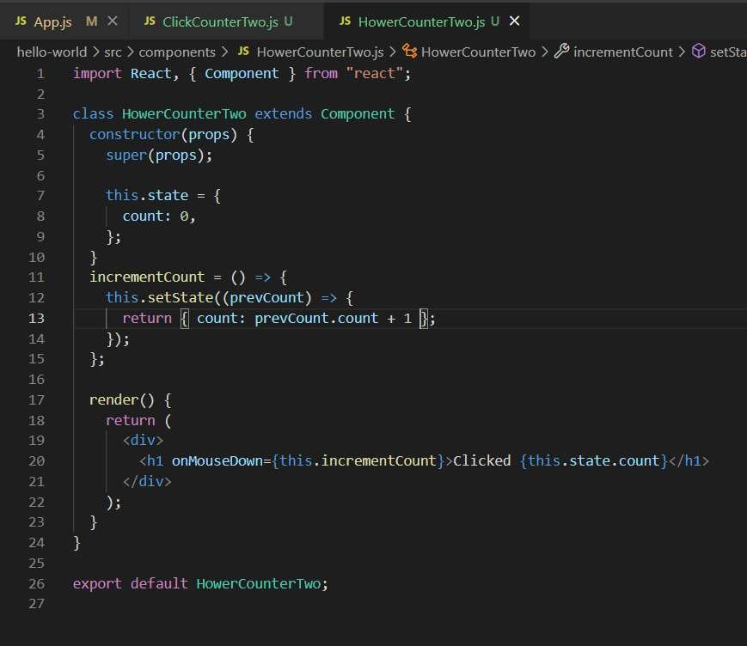

If you can see that the code is repeated **render** **props** **pattern**

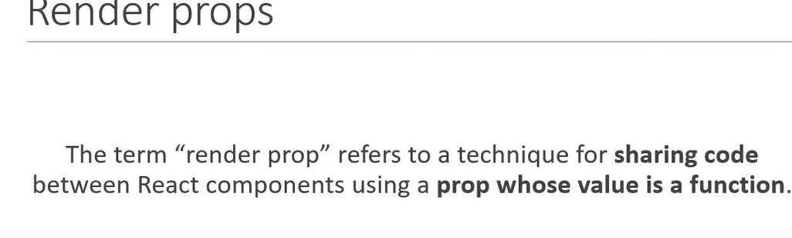

Let’s first consider a simple example

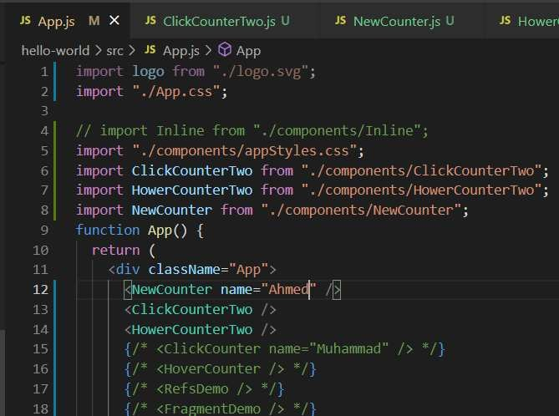

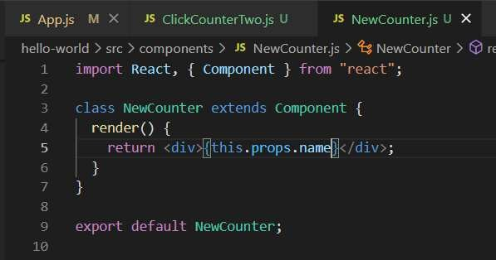

What if I want to get the same using the function

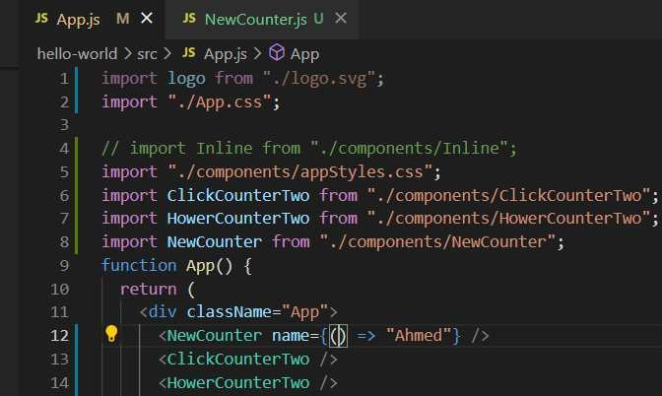

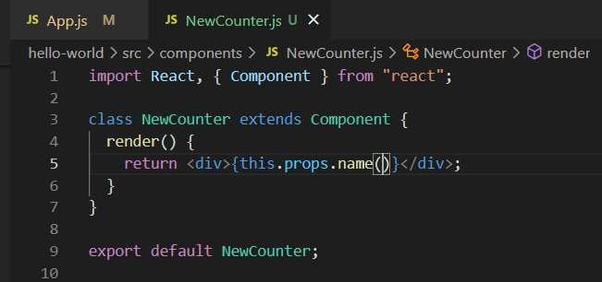

What if we want to pass a variable inside this

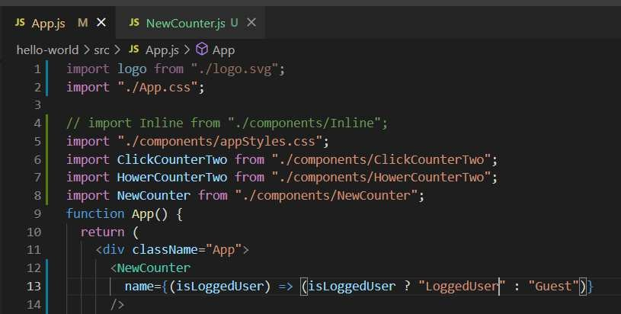

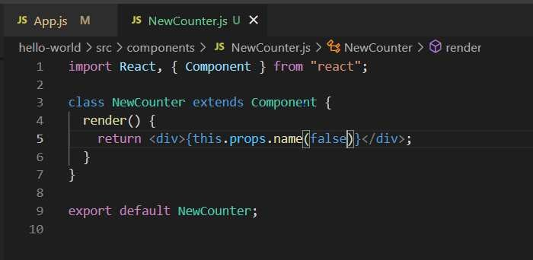

Similarly, the render prop is using the same concept and they are passing into the render.

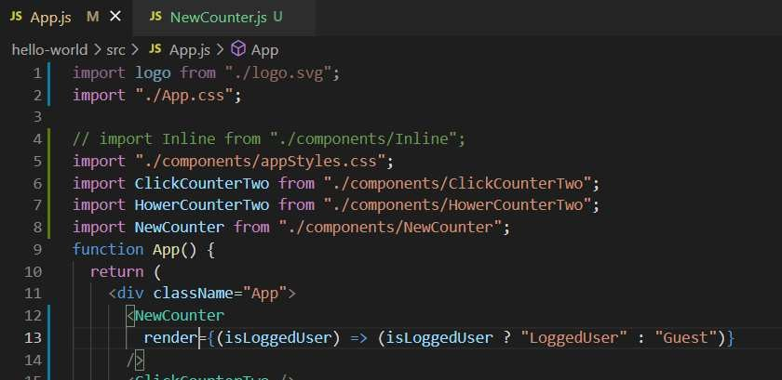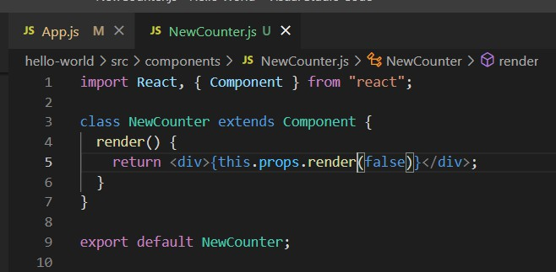

Now, if we want to apply the concept inside the code reusability.

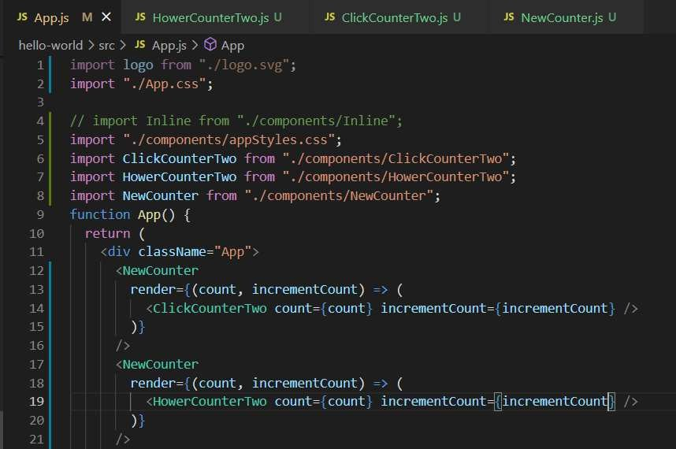

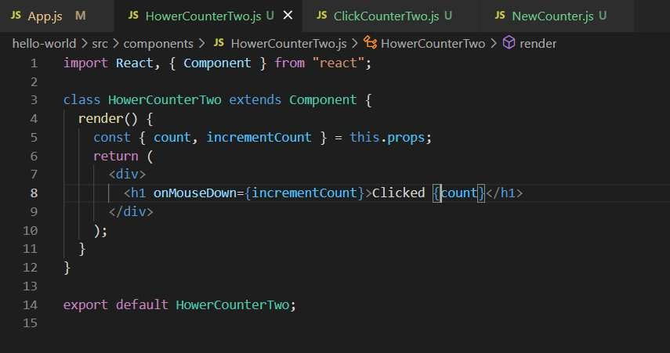

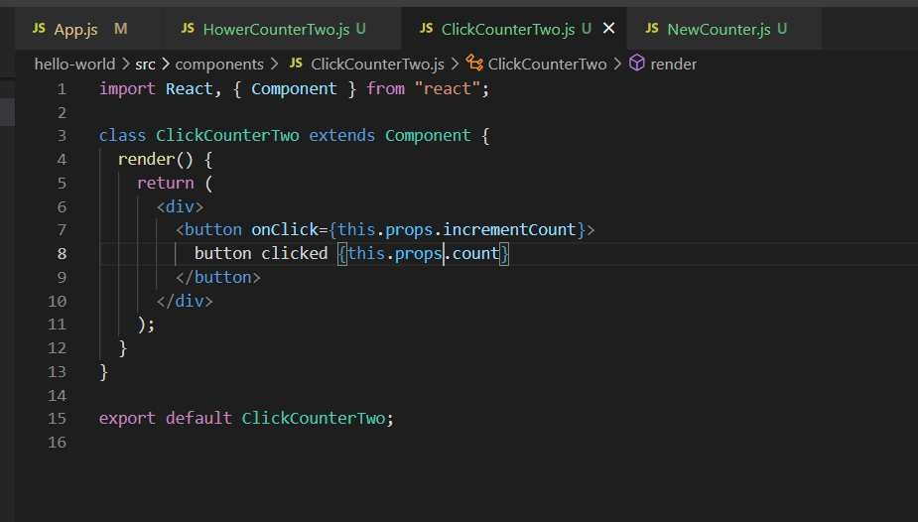

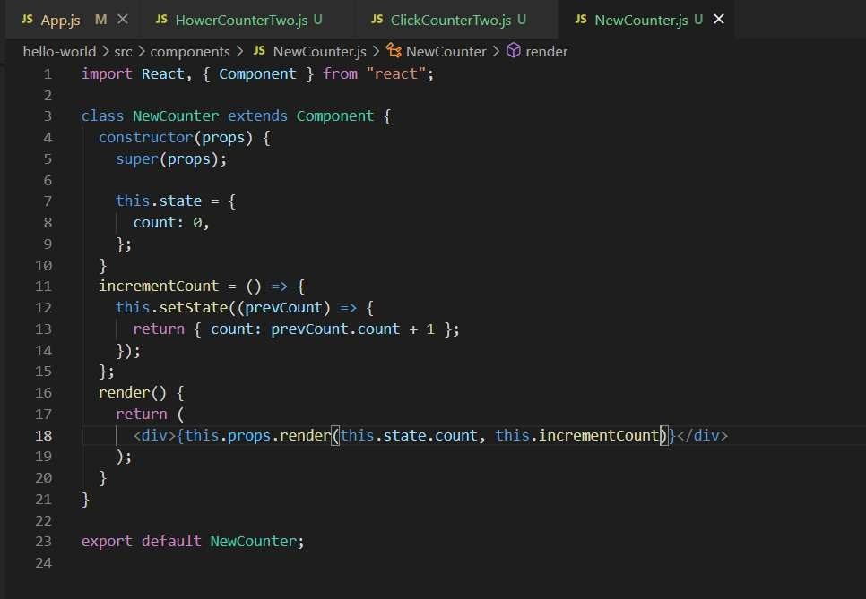

In some cases, you even did not use the render method instead you use the **children** directly.

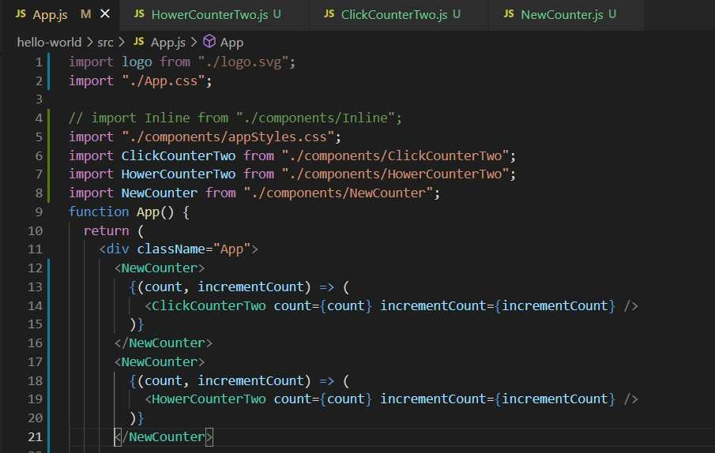

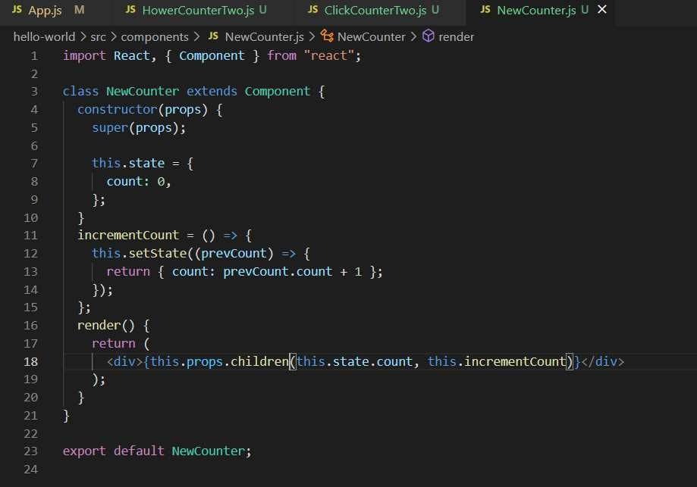

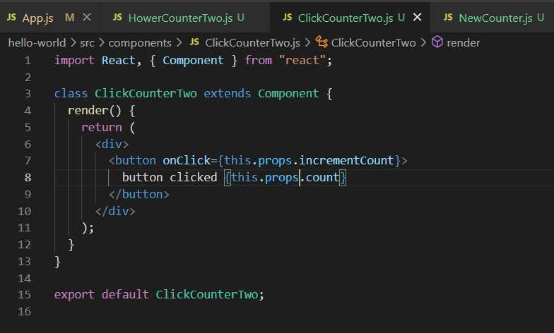

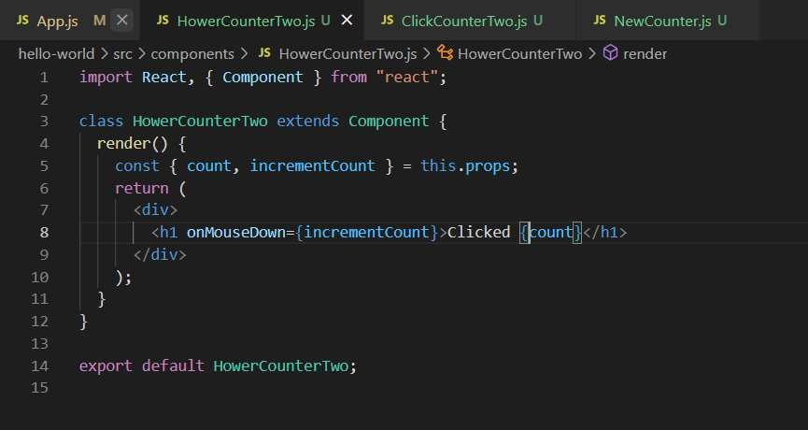

Co⭲tcxt (Paít 1)

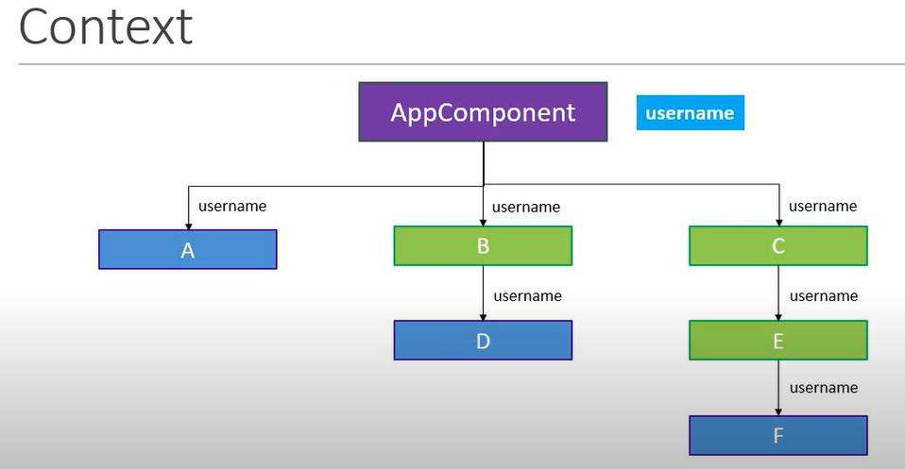

Let say if we want to use the username down in the A, D, F components which are present in the app component so what we need to do is passing the values from top to bottom by tree list but what if we want to pass towards the end of the component without traversing through the nodes. So, here is the solution we can use it by **context** concept in the react.

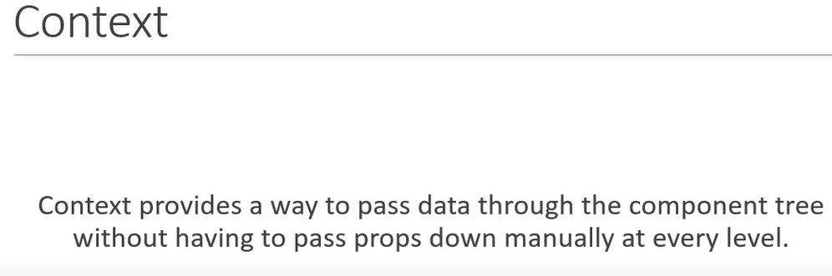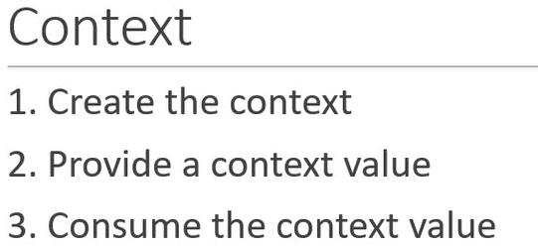

Below are the code for reference

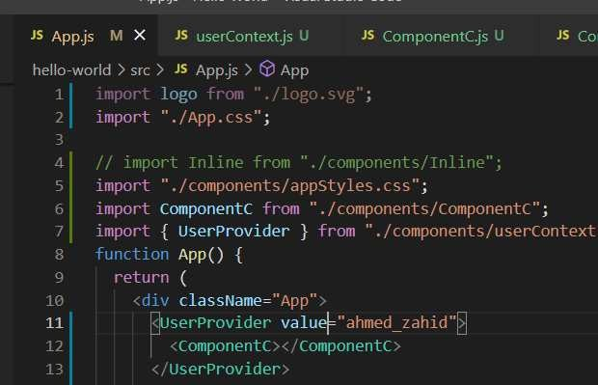

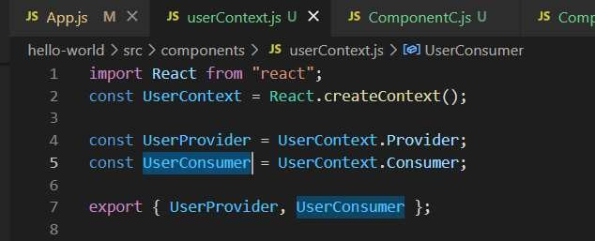

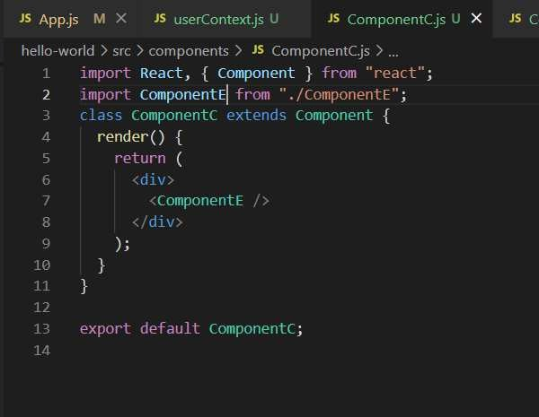

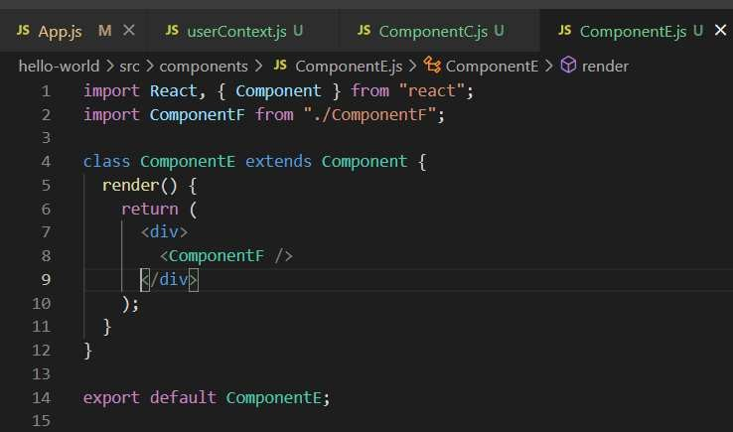

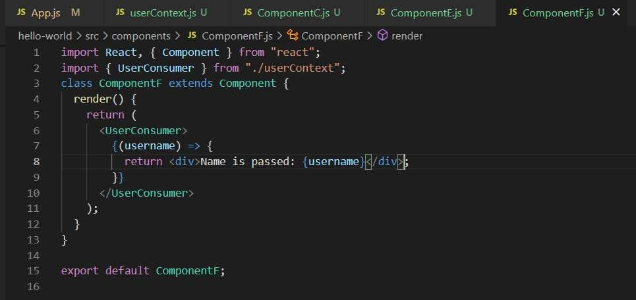

Co⭲tcxt (Paít «)

You can set the default value of the context

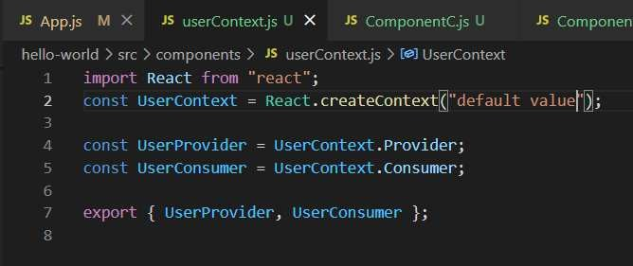

2nd is the context type property

It only works with class component

It works with single one component not multiple values but a number of times in your application you want to use them.

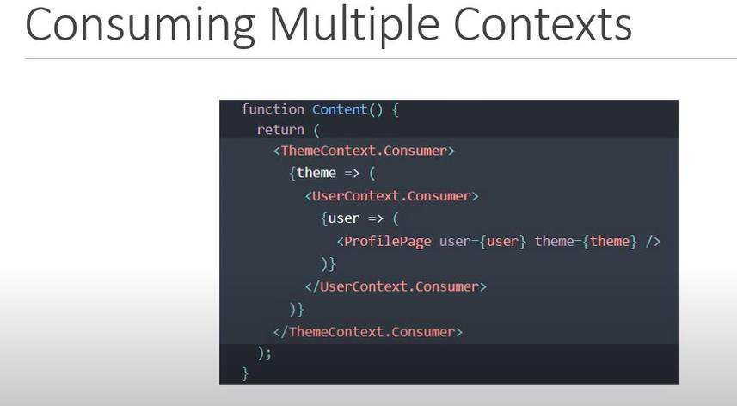

Now this is another way of accessing the value in the component

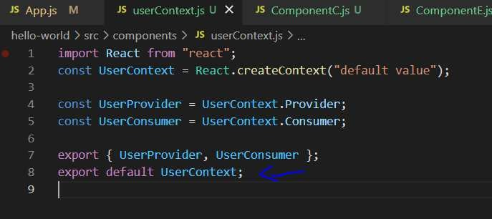

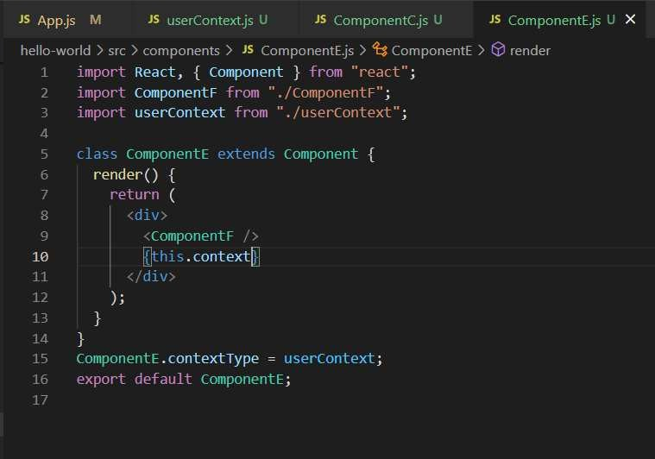

Or

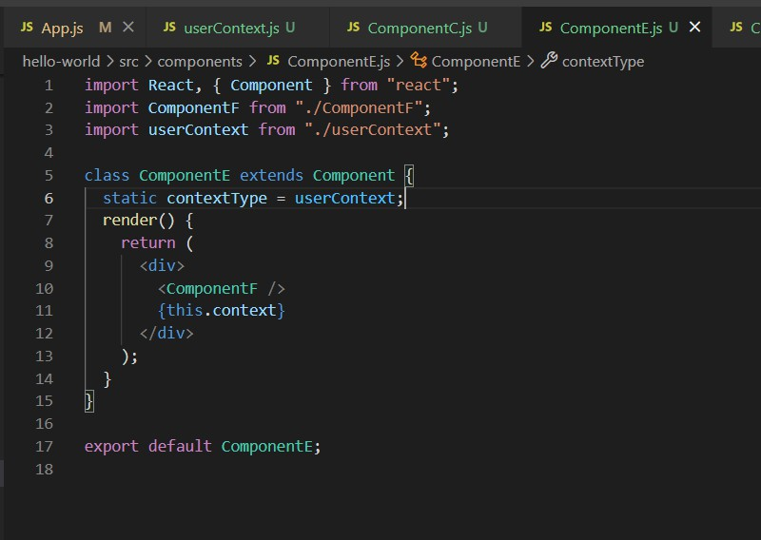

HľľP a⭲d Rcact

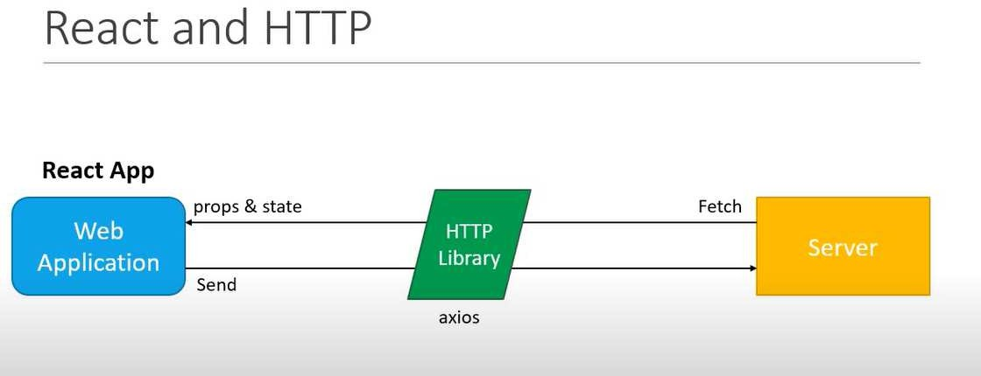



Installing the package and then you can see that package inside project folder.

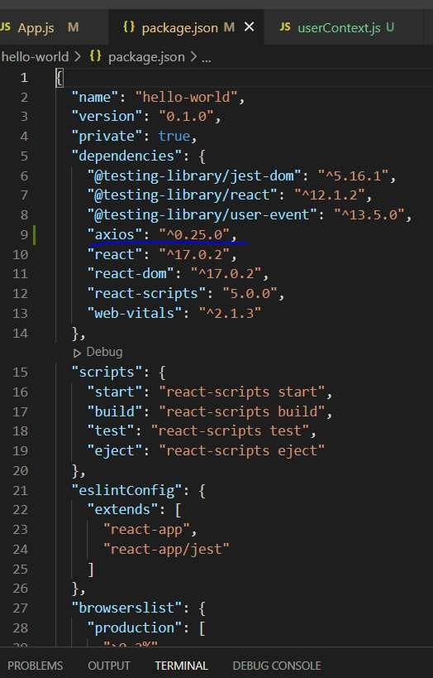

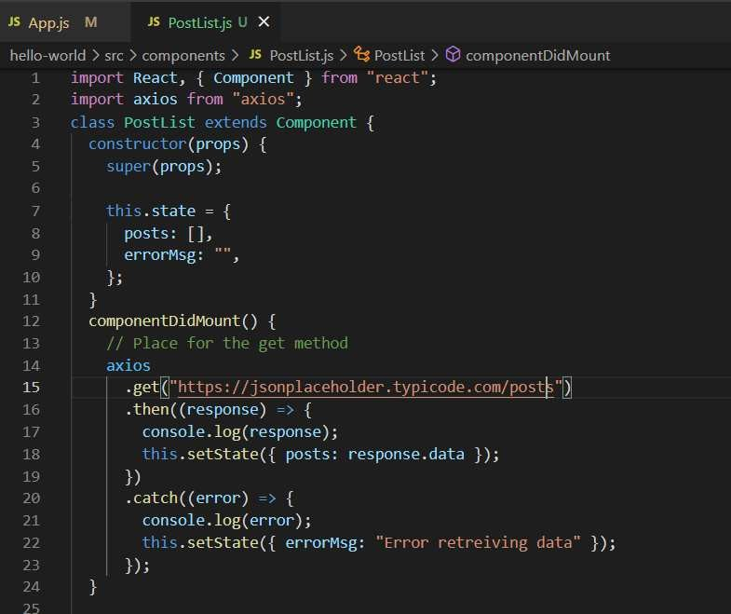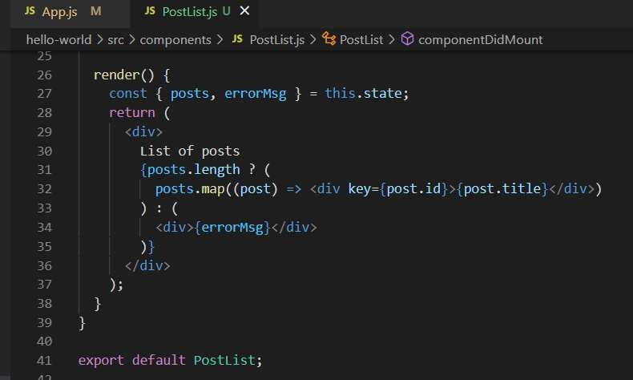HľľP GEľ Rcq"cst

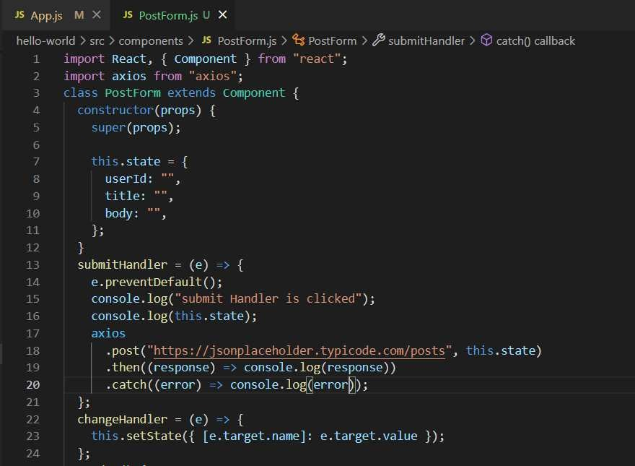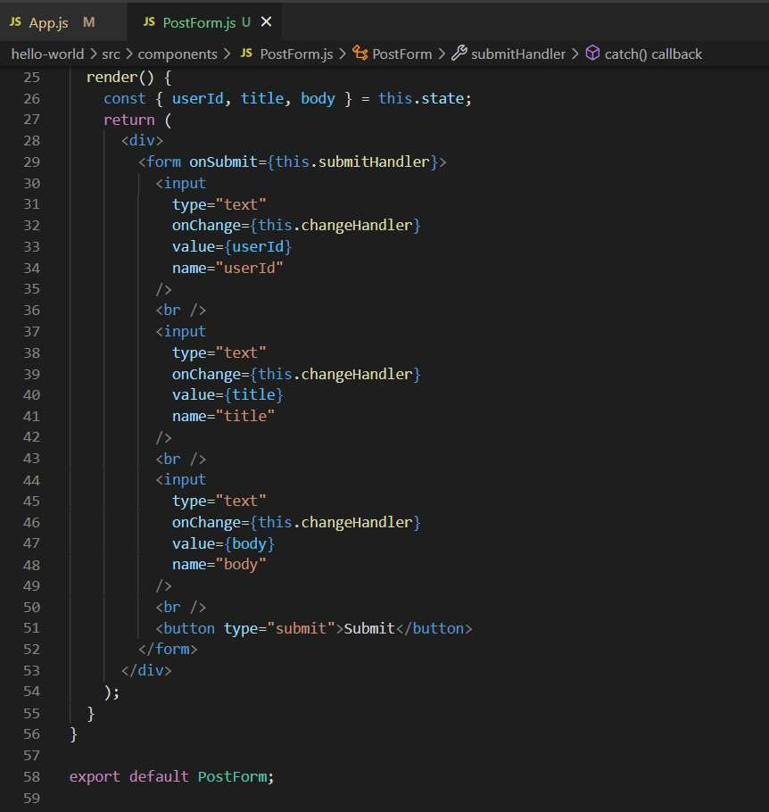HľľP Post Rcq"cst

### React Hooks

It is an important feature you can use basically you can use the stateful components or variable inside the react without using the **class.**

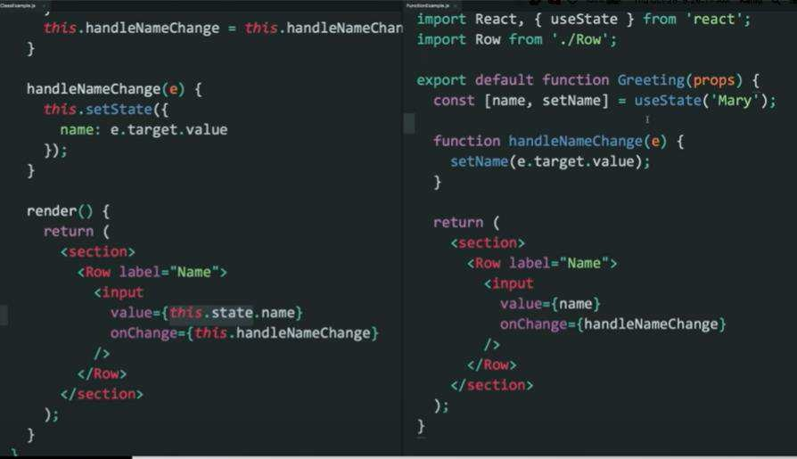

If you want to use two different variables.

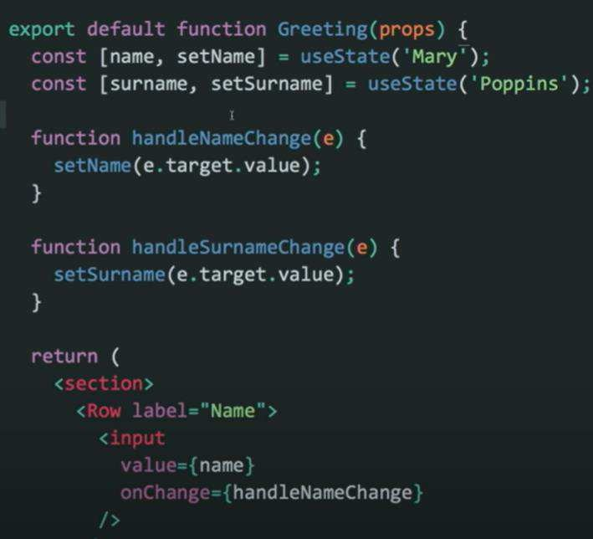

You can use the context inside the Hooks

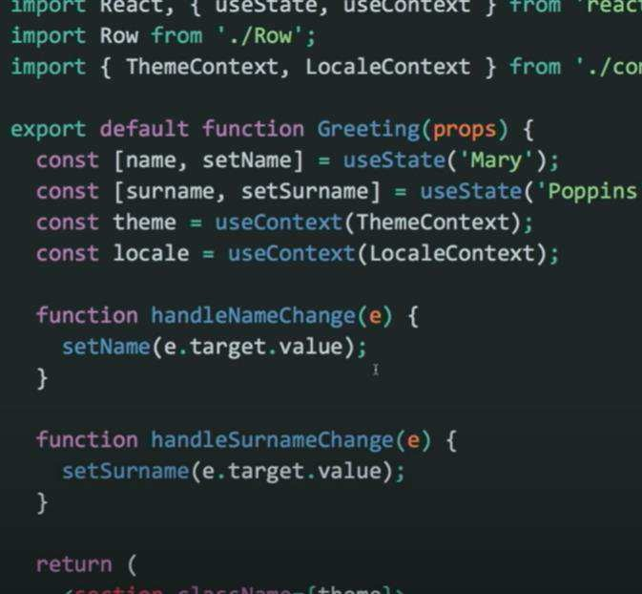

You cannot use **if** condition when working with the hooks it should be used in the upper level.

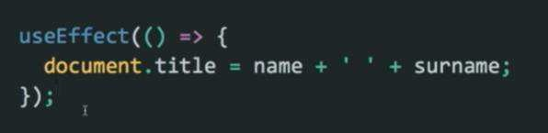

You can use **useEffect()** method if you don’t want to use the component did mount and component did

update it will do both the functionalities for you.

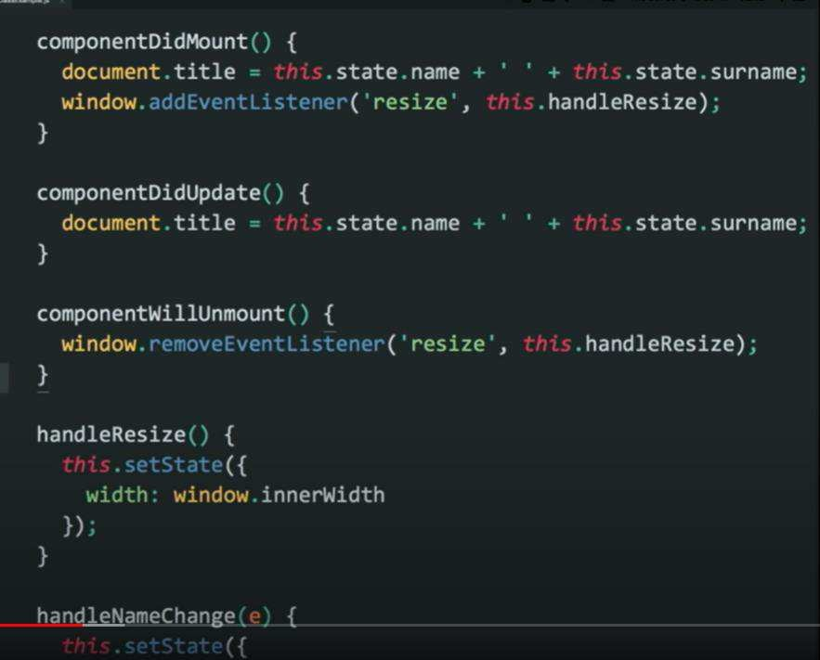

Let say if you want to update the value of the window which is changed over the period of time this will do

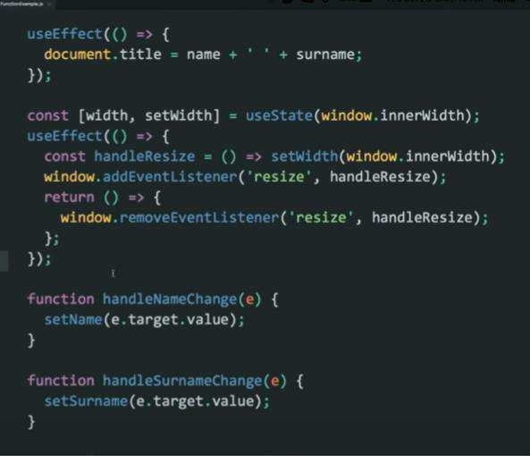

It will do the subscribe and unsubscribe both methods.

Hooks: it does not what is the life cycle of the class instead it is what your code is actually doing.

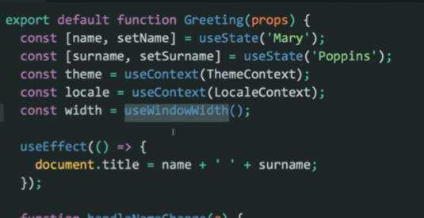

If you want to pass data from one function to another function then you can do that. These are called the custom hooks which are used **with** the following keyword.

Custom hooks are JavaScript functions.

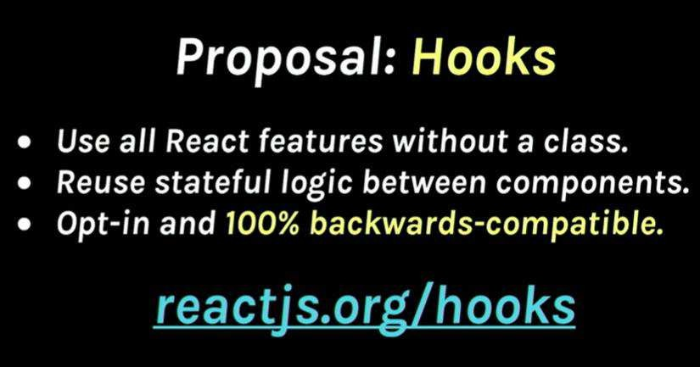

### Routers

Hooks

I⭲tíod"ctio⭲

Why Hooks?

Reason Set 1

Understand how *this* keyword works in JavaScript Remember to bind event handlers in class components

Classes don't minify very well and make hat reloading very unreliable

Why Hooks?

Reason Set 2

There is no particular way to reuse stateful component logic HOC and render props patterns do address this problem Makes the code harder to follow

There is need a to share stateful logic in a better way

##### Reason Set 3

Create components for complex scenarios such as data fetching and subscribing to events Related code is not organized in one place

Ex: Data fetching In componentDidM ount and componentDidUpdate

Ex: Event listeners — In componentDidM ount and componentWillUnmount



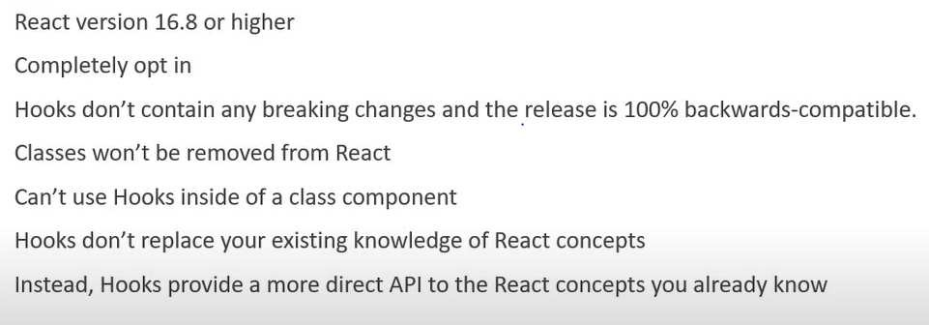

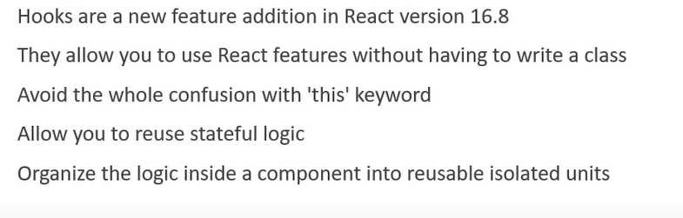

Rcact Hooks ľ"toíial - 2 - "scStatc Hook

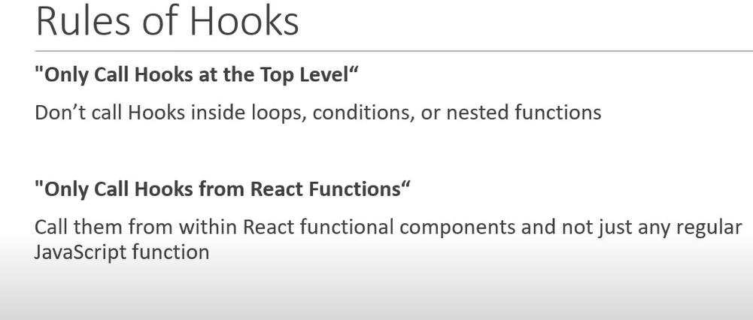

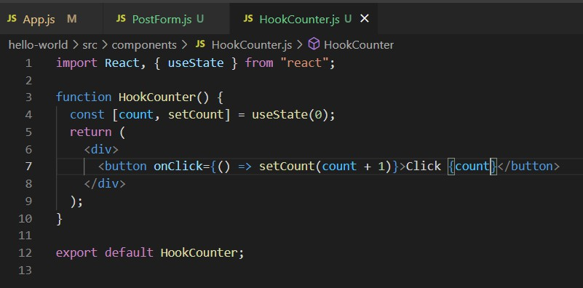

"scStatc witk pícvio"s statc

If you want to use the value of a variable then you need to pass that value as a function.

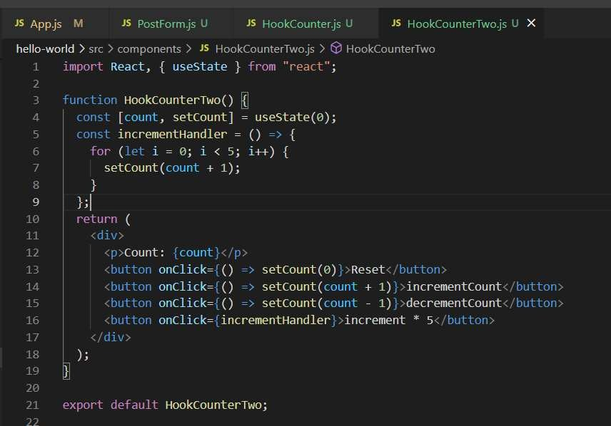

If you can see when you are doing the 5x then it does not do the five times instead it is doing one time so it is good practice if we are doing something using the previous state then we use the arrow function in order to update the value.

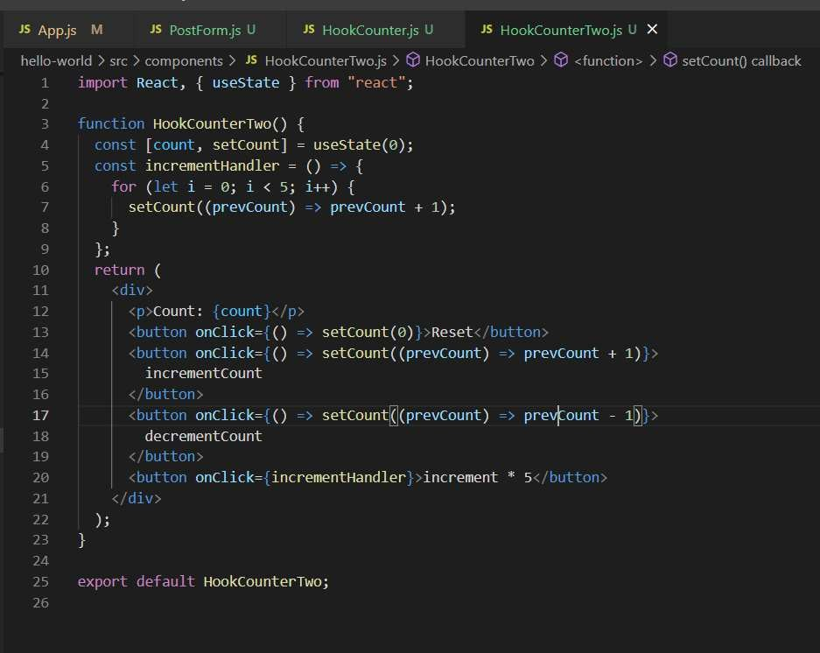

"scStatc witk objcct

Use state object can be a number, array, Boolean or object.

The object is not get updated when one entry inside object is updated while the other not because use state does not automatically merge and update the object.

Because the set state will merge the state in case of component while in case of use state it does not perform the both steps.

You can do it using the … it will tell that copy the whole object structure and when you copy the whole

structure then you can just update the particular value.

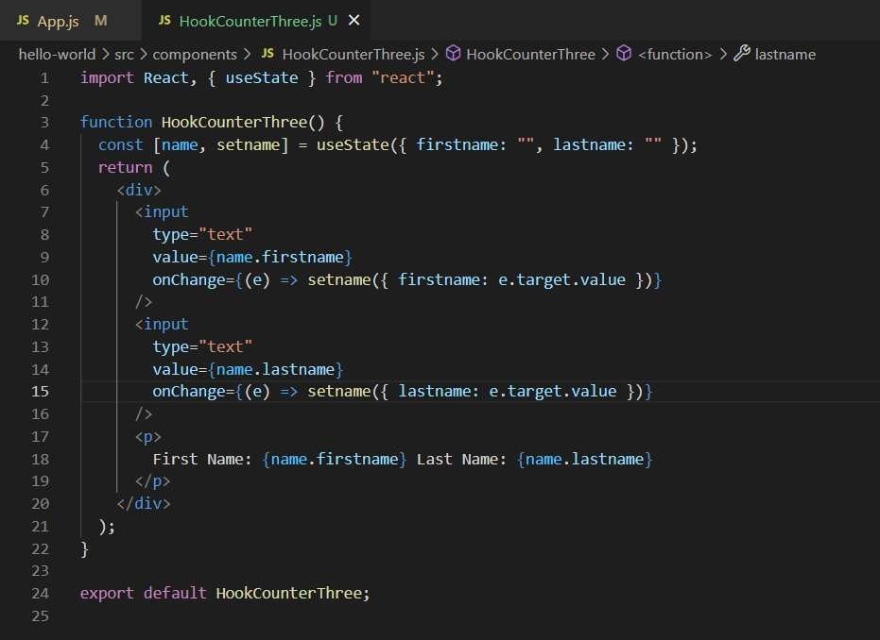

If you can see from the above example, it is clearly showed that the whole object is not updated and cannot merged in one so what is the possible solution for that it is you can use the object … decompression.

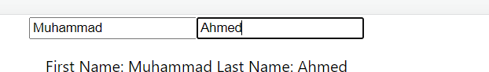

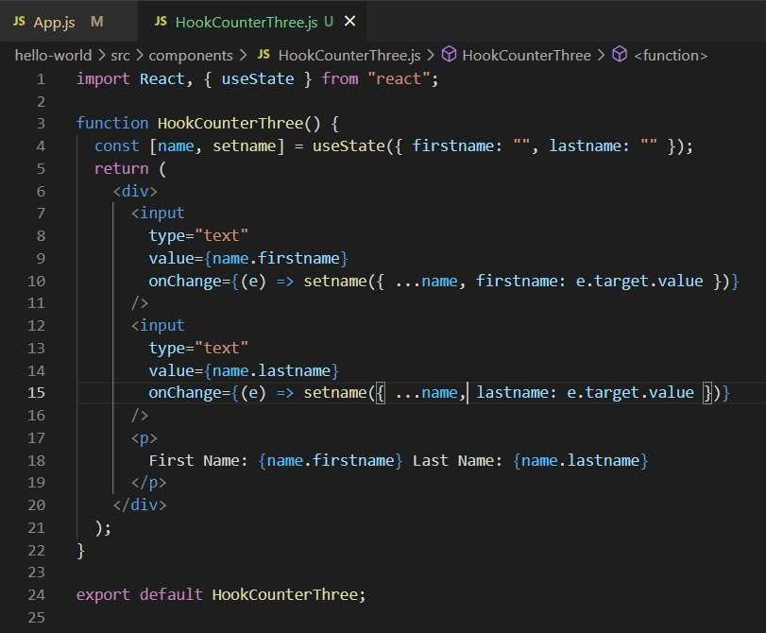

"scStatc witk aííaQ

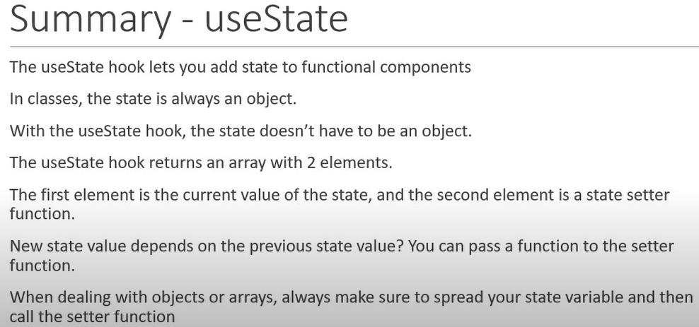

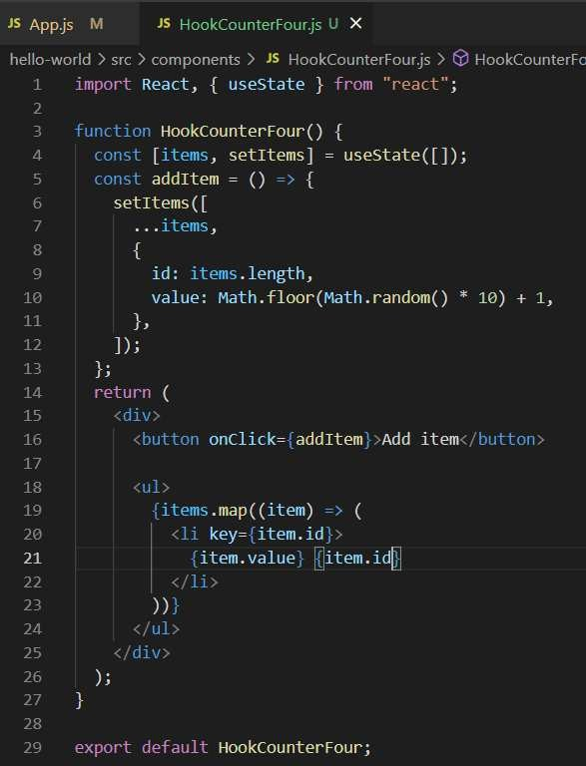

"scErrcct Hook

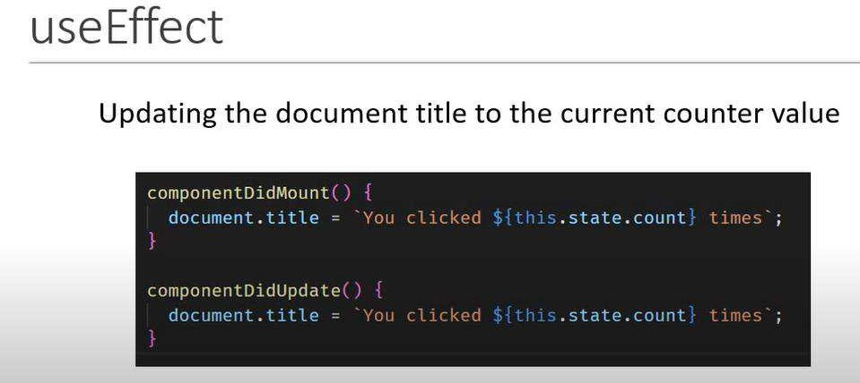

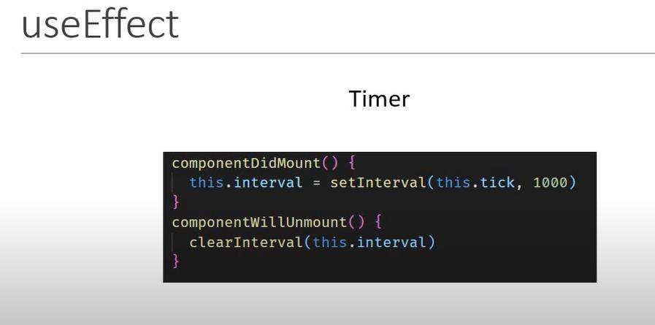

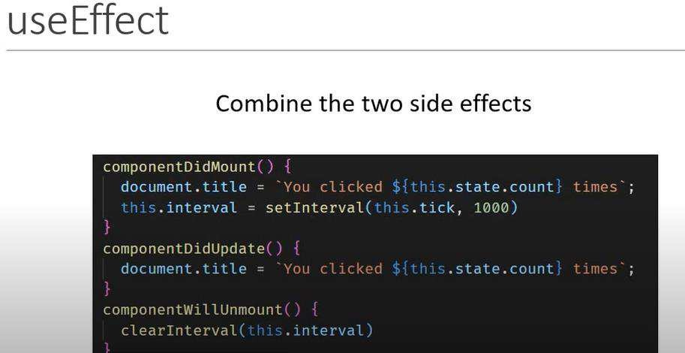

If you can see that the code is repeated two times for facilitate the same functionality what we can use if you want not to repeat the code.

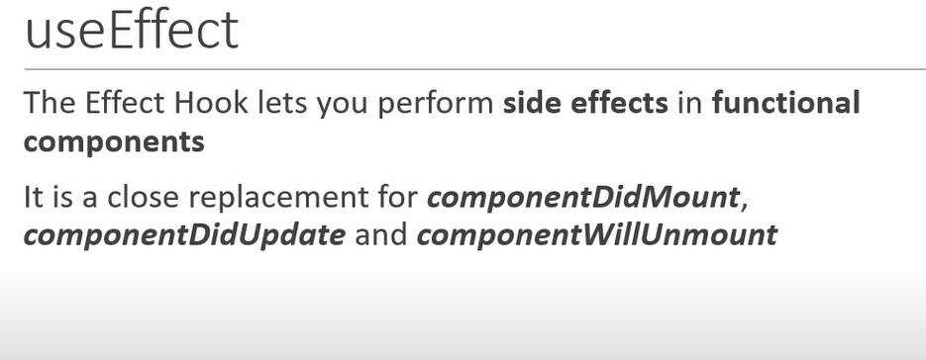

"scErrcct artcí íc⭲dcí

Use effect method is called after every render method. Just like the component did update.

###### Using class

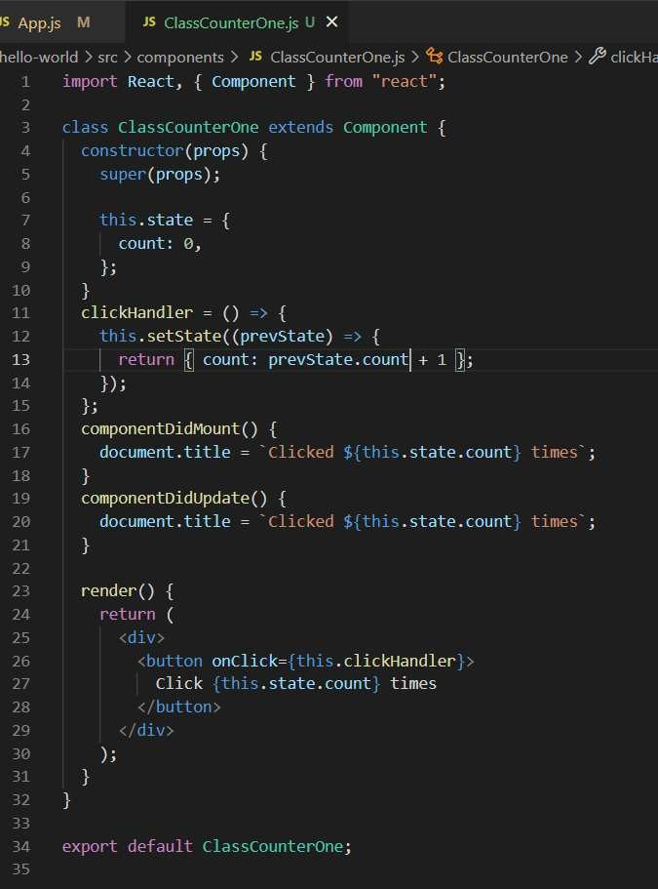

**Using** **hooks**

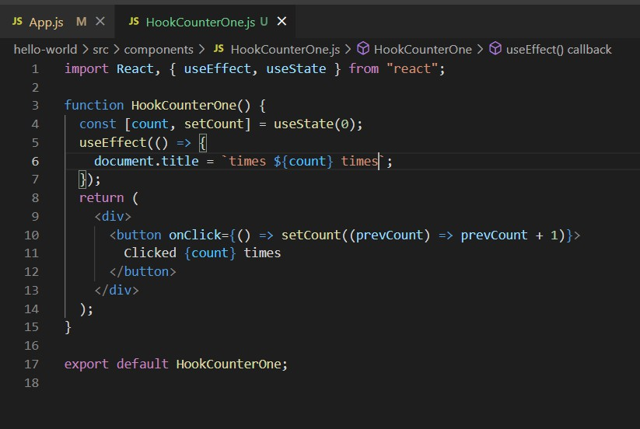

Co⭲ditio⭲allQ í"⭲ crrccts

We want to do something like that after render method the **use** **effect** is automatically called but you want to put a **condition** that the **use** **effect** is not called. We are passing an array [] it continuously checking the value whatever you are putting inside that.

Class Example

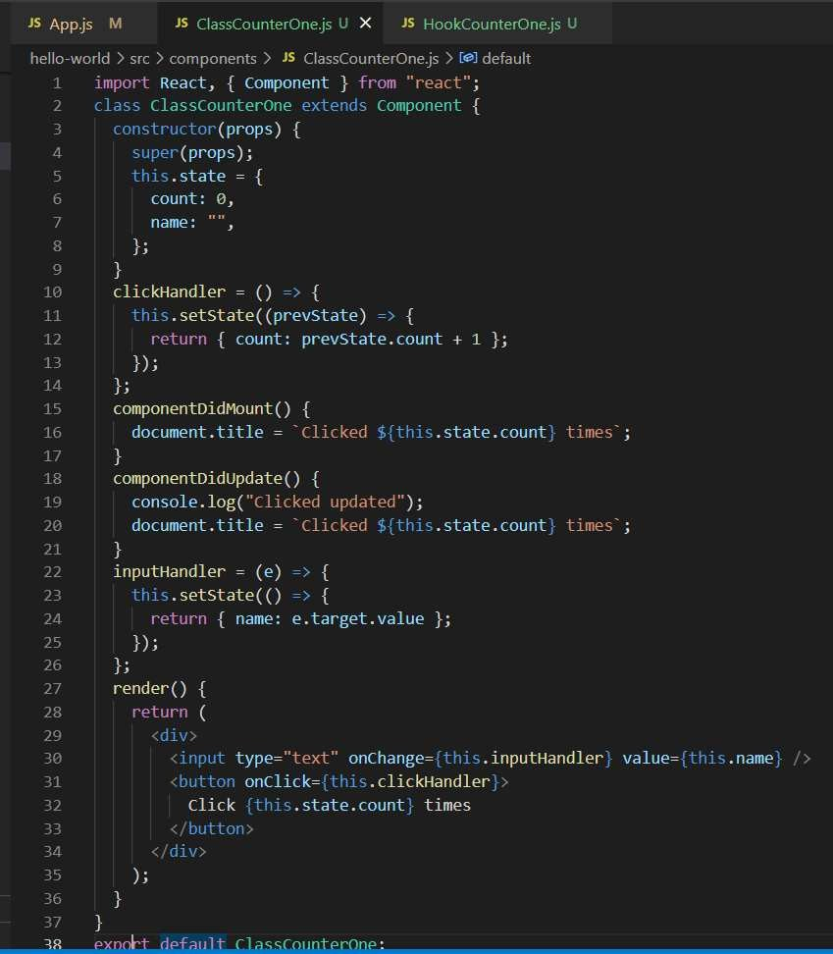

If you can see whenever the render method is called the component did mount is called while the code inside that function is only responsible for updating the value in the browser. So, we put a condition to that the render method not going to render each time.

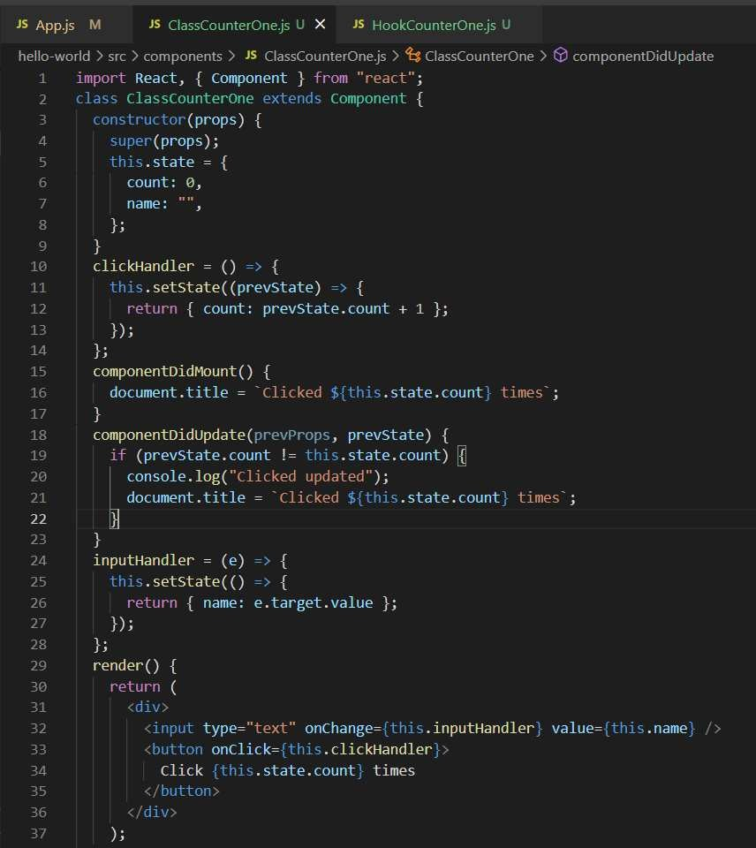

Now the above code having the condition reduce the effort on the application. Hook Example

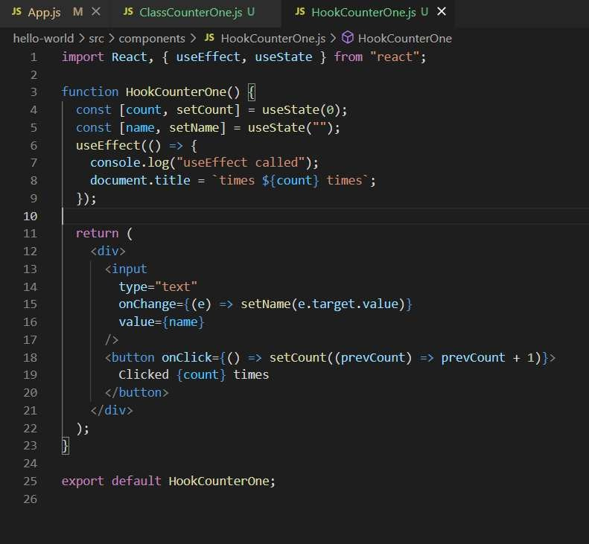

Every time the render method is called it automatically called the use effect method; we can avoid them using the condition which is need to be put inside the use effect method and it should be in array format and it continuously checking the variables if it gets changed then it called the method otherwise not.

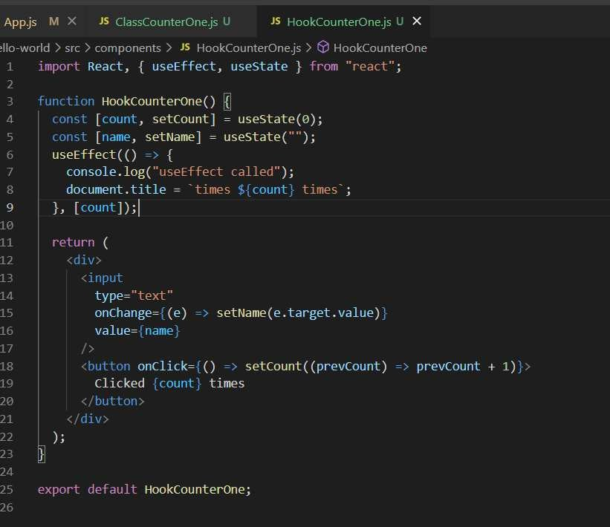

R"⭲ crrccts o⭲lQ o⭲cc

Basically, how we mimic the **component** **did** **mount** inside the functional component hooks. We can mimic by just using the [] square bracket and it will only bind it ones.

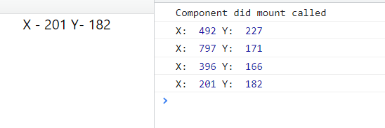

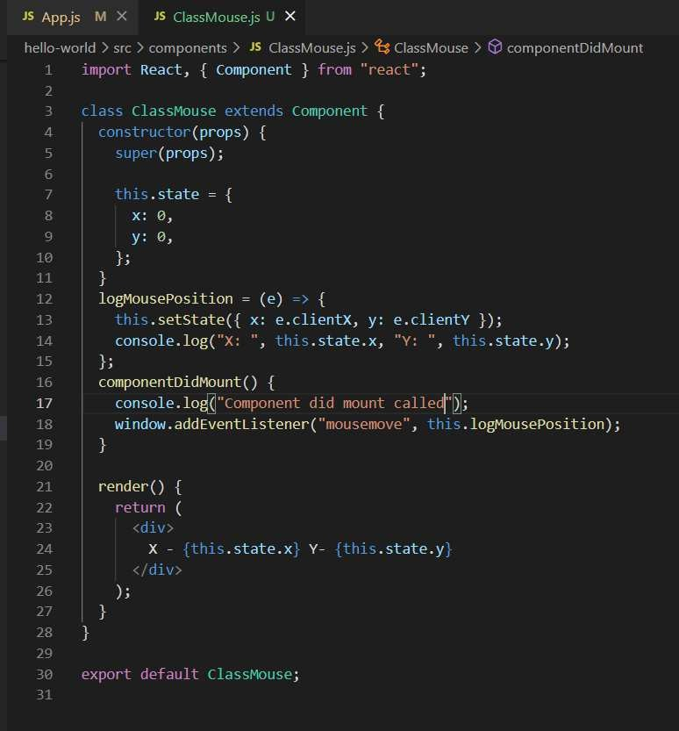

You can see the component did mount only called by ones. Let’s achieve the same functionality using

the use effect.

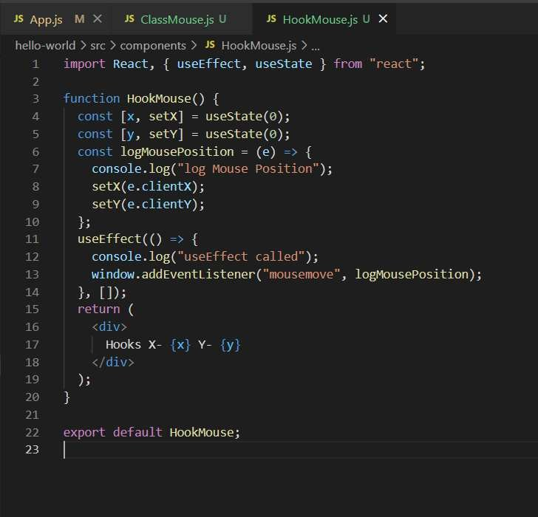

"scErrcct witk clca⭲"p

How to use component will unmount inside use effect. You use just return from the use effect it will serve a component did unmount.

It means when the component not an individual instead if the component is fully removed from the DOM, then the remove component method is automatically called.

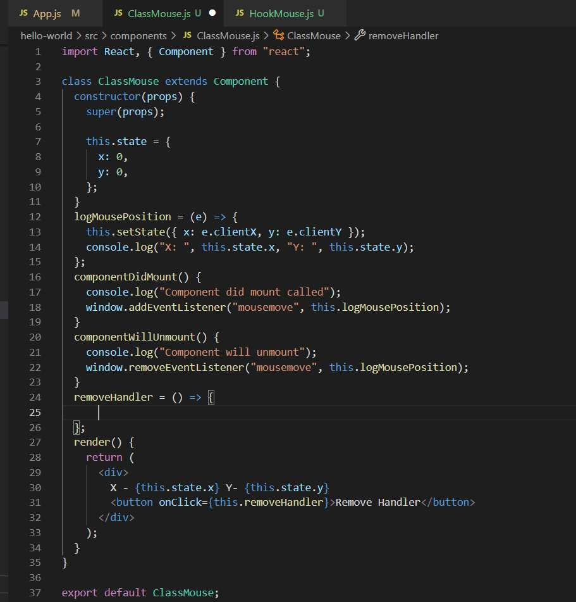

And in case of hooks, we put the code in the use effect and we put inside the return method.

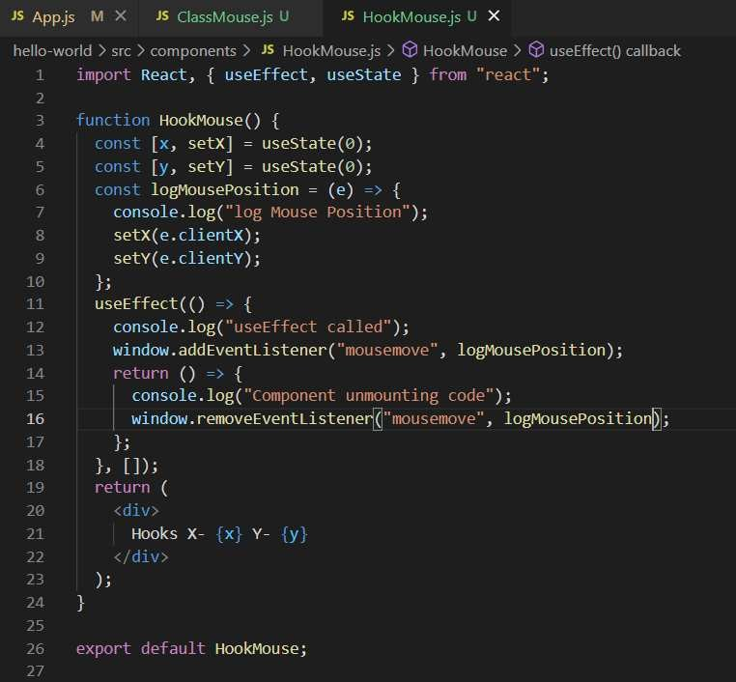

"scErrcct witk i⭲coíícct dcpc⭲dc⭲cQ

###### Increment auto value by one with class component

**Hook** **Component:**

You can use the arrow function inside the tick method as it increments using the previous properties or you can put the value inside the [] where it continuously looking into the value update.

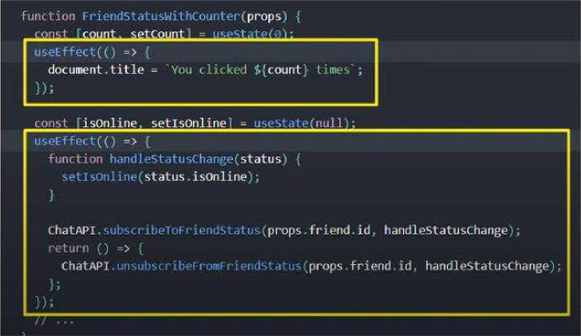Multiple useEPects



JS App.js M

JS Inte' vz!ClassCa int=.i.js !

heIIe-world src components J5 |ntervalCla5s?Dunterjs 7 Le°J default

?a goi°t React, ( Component } T‹'cii "neac I" ;

z' i..state = (

count: 0,

.

._

componentDidMount() {

i-his.interval = setInterval(=.r: .tick, 1000);

t-

componentWillUnmount() { clearInterval(zL's.interval);

'.’

':

tick = () =› (

ziis.setState(( count: r’ds.state.count + I });

Now, let's replicate the above code using the Hooks

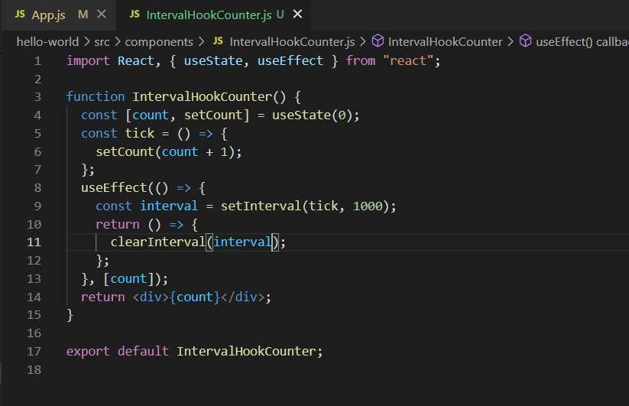

Or you can use previous counter and then increment.

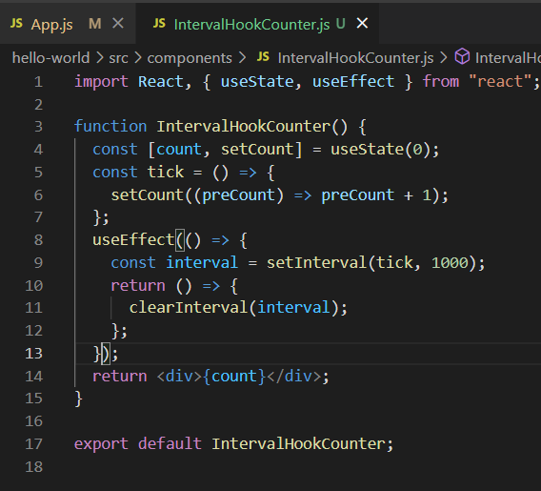

Ictcki⭲g data witk "scErrcct Paít 1

When you enter

**npm** **install** **axioms** then it installed the package.

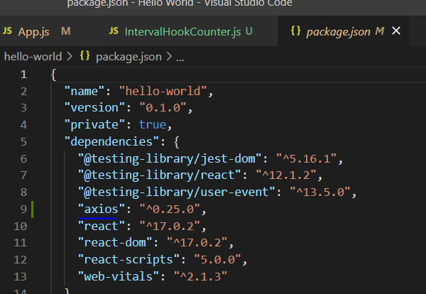

Empty dependency list **[]** specify that it will works as a document did mount.

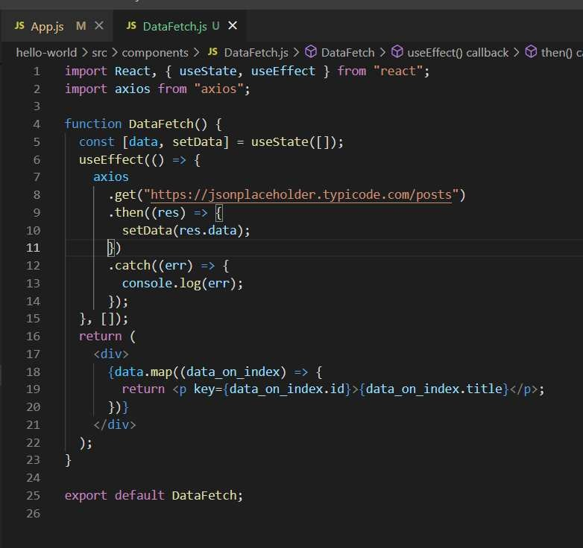

Ictcki⭲g data witk "scErrcct Paít 2

|  |  |  |  |  |  |
| --- | --- | --- | --- | --- | --- |
|  | | | | | |
| heIlo -to old s rc Coun pane n s I J* Data let:h j z ir pa i°t React, { us est aI e, useEif zir pai°t axios I ro'ii "ax fo s "; |  | I  ecI | Oa laFetch  } I i oiil "n+a‹ I" ; |  |  |
| ' o Dat aFet ch( ) (  z i)— [d ata, s etData = usest at e { }) ;  ¢ n— [d ata id , setDat aI d = useStat e( 2§ ; useE TTect( () = ( | | | | | |
| . get(  setDat a( res . data) ;  ' COFSOT9 . lOg(er r) ;  }, [data Tfi ] ) ;  changeHandIe r = (e) = setDataI d . target . value) ;  -’ } i  .’.' net ui°ri |  |  |  | _ | ) |
| -'| .i— onChange= changeHand1er value= dat a ż‹J  data . t it1e | | | | | |
|  | | | | | |



expo i°t \1et auI Ł Dat aFet ch;

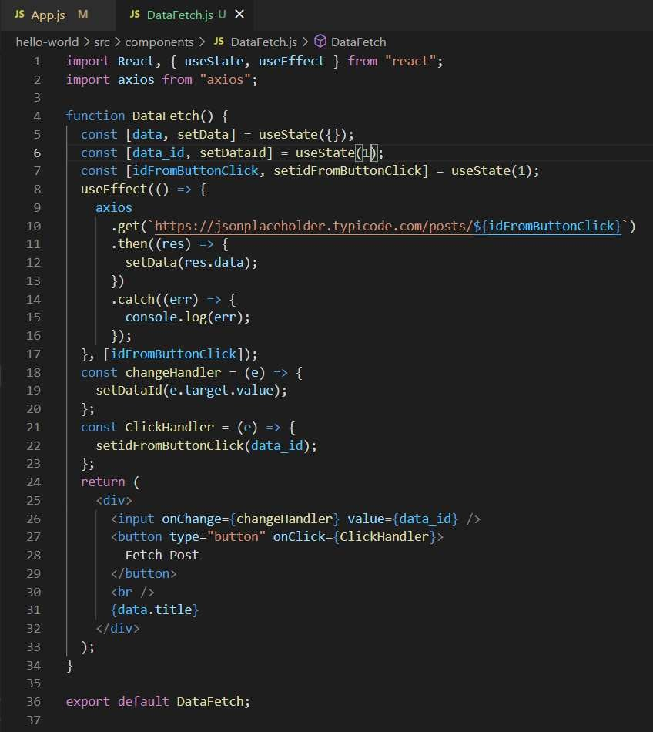Ictcki⭲g data witk "scErrcct Paít «

"scCo⭲tcxt Hook Paít 1

If you want to pass the prop by not passing using the tree travel instead directly then you need to use context.

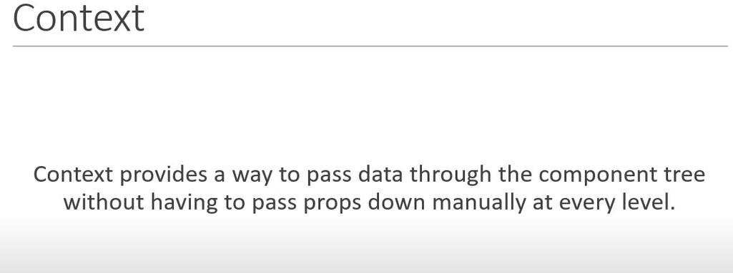

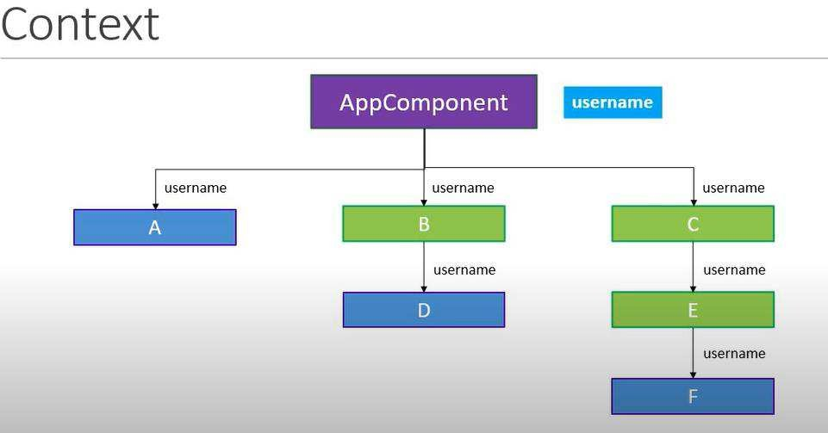

"scCo⭲tcxt Hook Paít 2

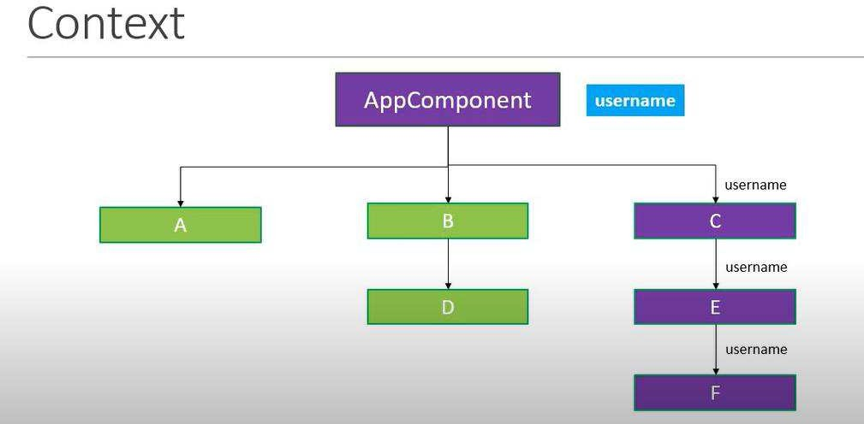

First, we save the particular value inside a constant and then we wrap them inside the higher tree and then finally we include that component and then use that.

If you want to pass more than one value then you need to create another one and the process repeats. There must be a better way to consume those.

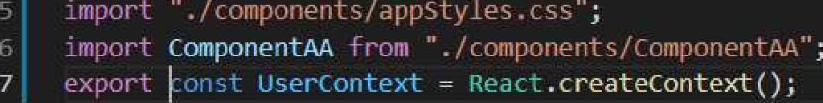

App() (

’ Li' 1 (

c)assNaoe=".''.q/'

ù’ f Fi1i‹l Xt: . I' l’^''.. £\! ! Va lUe' "i 1!. i’. iì!i'' <J.?!"

“ IIii+* !’. i' L•-

’ 'q •- r” ’- '”' r ‹’n'..' ' '8 -zr'

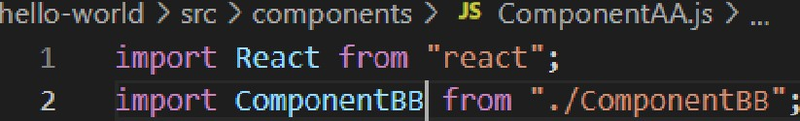

ComponentAA() (

Cont pmnewt BB

export defau.t ComponentAA;



hellc-world ) src ) :crnponents ) JS uoonentBb]s )

i«lport React from ”react' ;

2 i«lqort ComponentCC frog ' ./ConponentCC";

ComponentBB() {

ConlponentCC

export default ComponentBB;

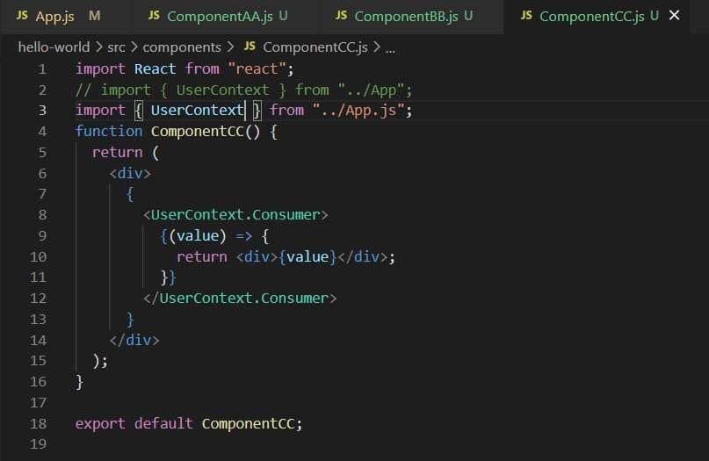

Let’s pass 2nd value and see what happens.

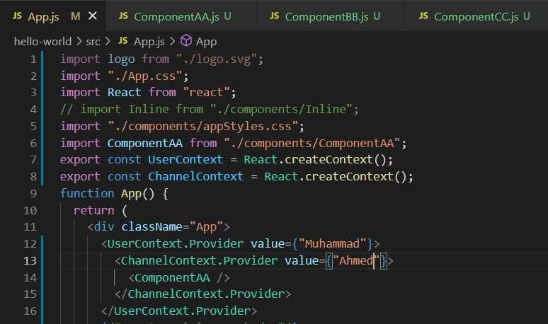



J»çcrt React Ü’iP ’ ’ew.:t";

) *

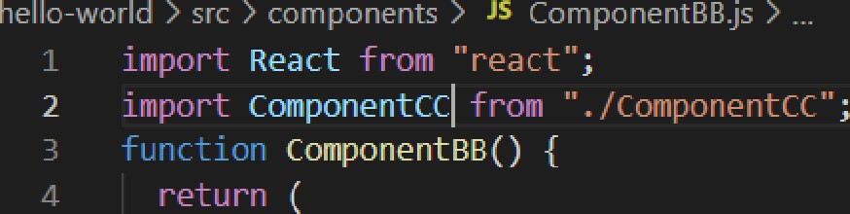

*8 App.js FI

) *

expoi°t ùe+ault ConponenteB;

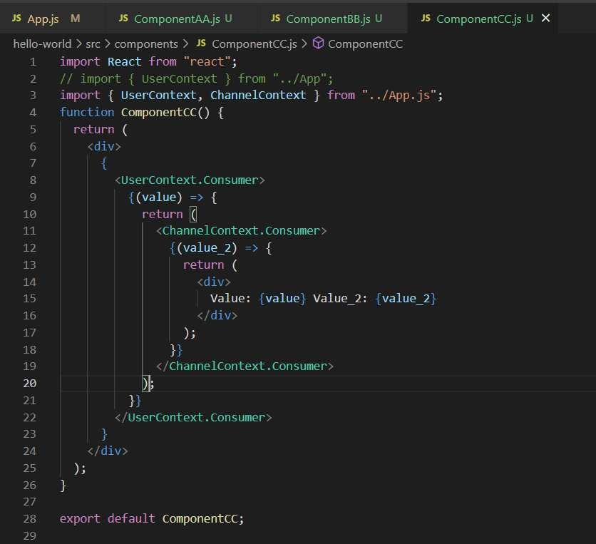

"scCo⭲tcxt Hook Paít «

Let’s make our code cleaner.

You can use them by calling the **use** **Context** from the react library and then rap them inside this.

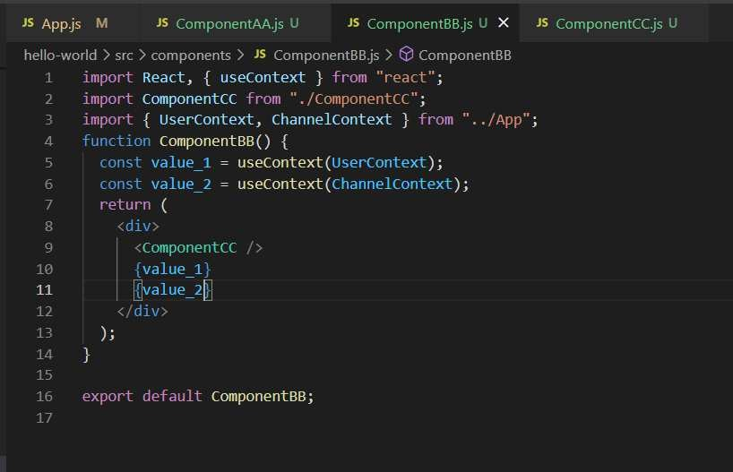

This is the more generic and good way of consuming the use Context variables.

"scRcd"ccí Hook

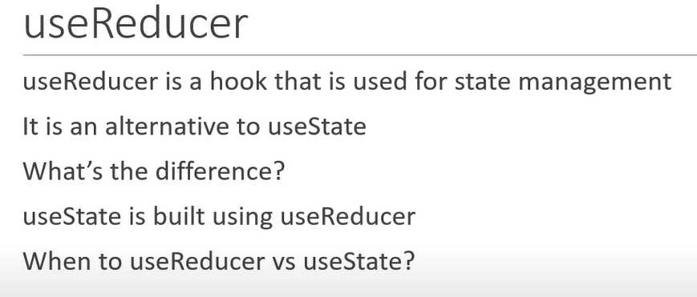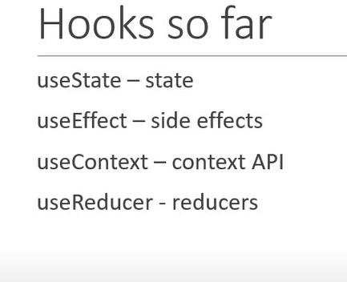

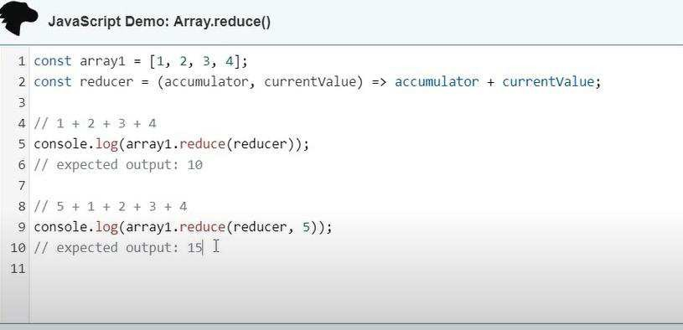

It takes two parameters inside the function; the first parameter is the function and the second parameter is for the initial value.

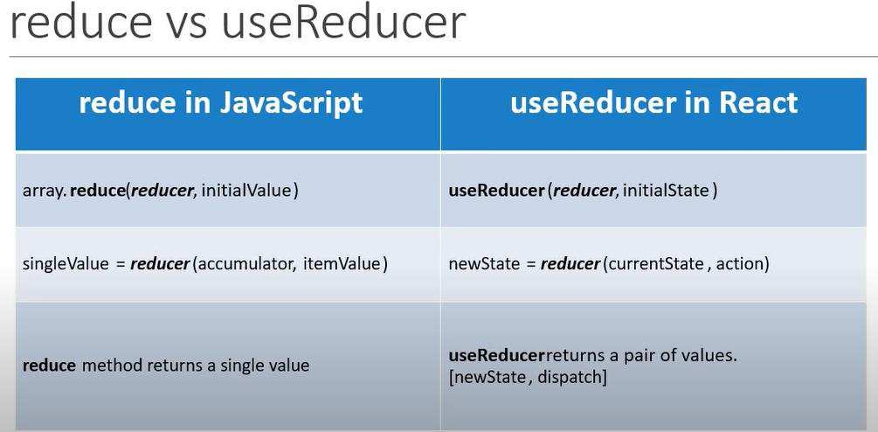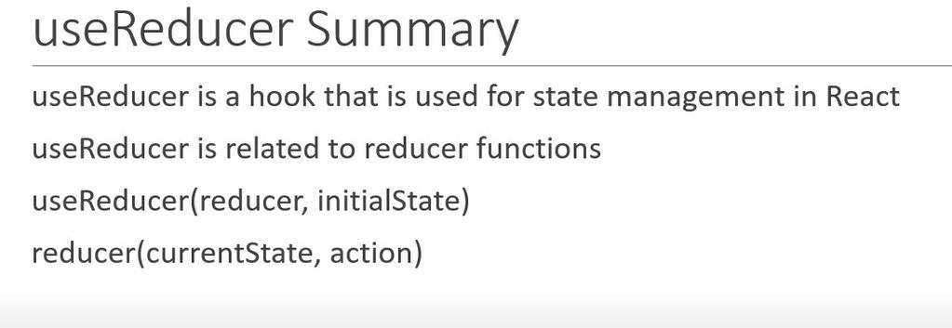

"scRcd"ccí (simplc statc & actio⭲)

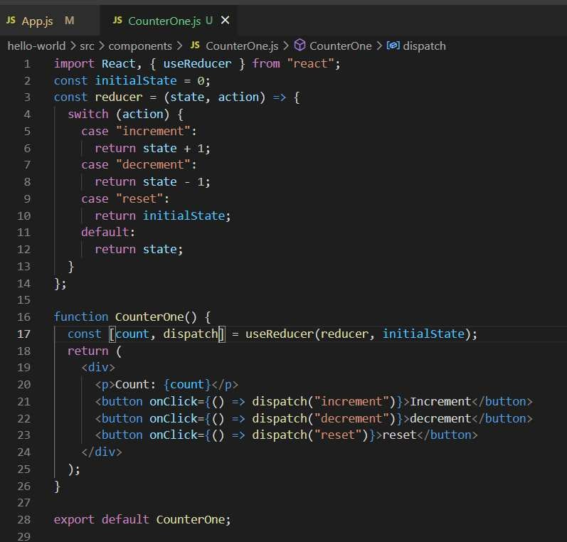

Let me explain to the above code what’s going on there. **Use** **Reducer** function takes two inputs: the first one is the **function** and the second one is the **initial** **state**. Initial state is because it needs to start a starting value and the function needs what action is to be performed and also the variable used inside the function tracks the output because the value is saved in the return value so that’s all for the use reducer according to this example.

"scRcd"ccí (complcx statc & actio⭲)